Why do your Silver DofE?
It is hard to list all the benefits of achieving your Silver Award, so here’s a quick snapshot. You’ll…
- Have lots of fun!
- Get healthier and happier
- Meet incredible people and make lasting friendships
- Have amazing new experiences
- Find talents and passions you didn’t know you had
- Gain skills that employer’s value, which you can use on your CV
- Become more confident and independent
- Challenge yourself on a 3 day/2 night Silver expedition in more remote and wild country
- Stand out from the crowd in university and job applications
- Make memories that will last a lifetime
………and it can all be done irrespective of the Covid pandemic!

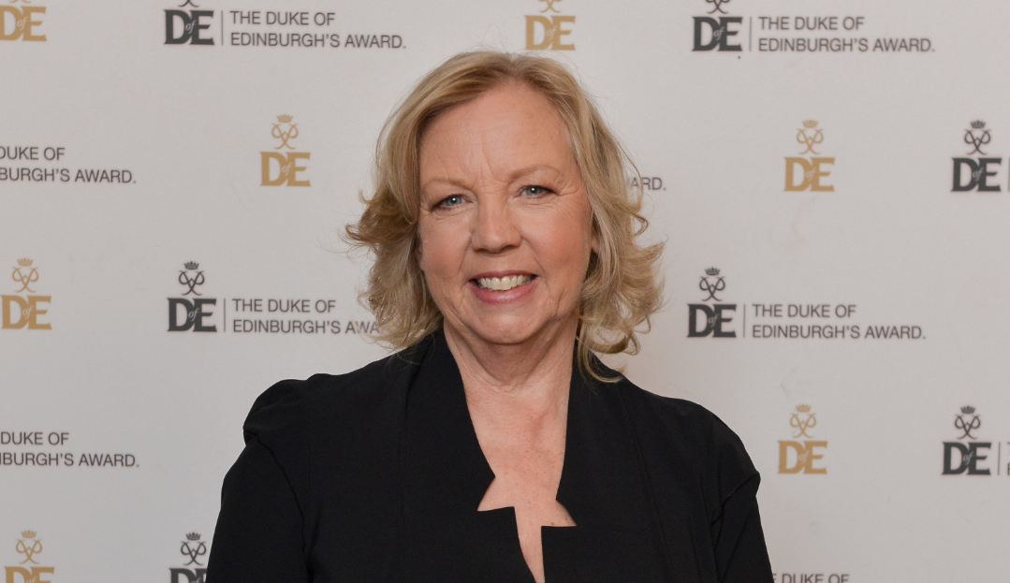
‘Life doesn’t naturally happen, you’ve got to get involved. What better way to do that than do your DofE?! As an employer I want to work with people who have a range of skills and can see things through’.
Deborah Meaden – Entrepreneur and Dragon’s Den panel member

