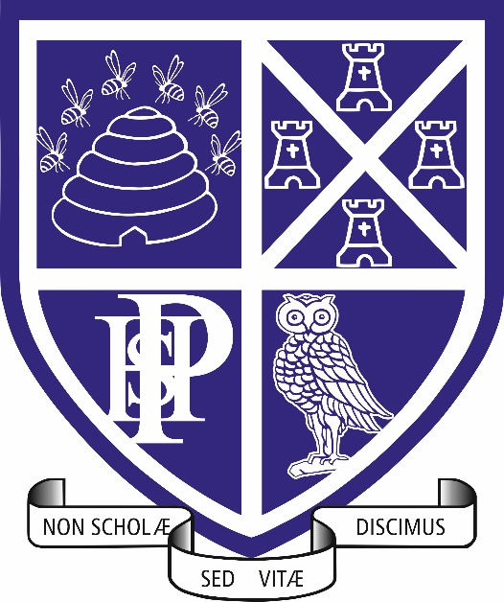

Curriculum and Progression Overview
Sociology
Plymouth High School for Girls

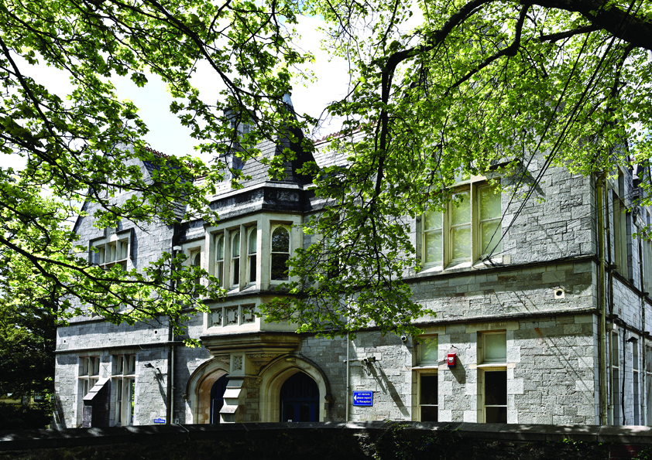

contents
- The Curriculum
  - Intent
  - Implementation
  - Impact
  - Student voice
- Curriculum and assessment overview
- Feedback and Assessment system

Intent
The A-level Sociology curriculum aims to equip students with a deep understanding of societal structures, institutions, and issues through the lens of key sociological theories and research. By exploring topics such as education, families, crime, and religion, students develop critical thinking skills, cultural awareness, and the ability to evaluate complex social phenomena. The curriculum fosters an appreciation of diversity and inequality, encouraging learners to challenge assumptions and engage with real-world issues. Through analysis, debate, and research, students are prepared for higher education and careers that require a nuanced understanding of human behaviour and social change.
Implementation
Throughout Key Stage 5, we want our students to experience success in Sociology and develop the confidence to take risks, ask questions and explore new ideas and perspectives.
Teaching and Learning will establish and ensure:
- A positive attitude to Sociology as a compelling subject in which all students gain success and enjoyment

- Sociological understanding through the explicit use of sound learning objectives and the establishment of a clear learning journey

- The ability in students to express themselves fluently, to talk about the subject with confidence, using Sociological language and concepts

- Effective questioning and opportunities for discussion

- The provision of clear next steps in order to progress

- Opportunities for students to improve their work
- Effective support to include an open-door policy for students to obtain one to one support, in addition to using classrooms on Microsoft Teams

All sociology lessons will incorporate the RESPECT curriculum.

The expectations around retrieval and salient slides (including reference to De Bono thinking hats) are embedded within the teaching and learning. Retrieval slides should include (particularly in Year 13) reference to material from throughout the two-year course.

Students are actively involved in every part of the lesson, with a clear focus on pace and challenge. There is an expectation of the use of a wide range of questioning techniques, beyond whole class and targeted questioning, such as think, pair, share, open-ended questioning and discussion.

Impact
The A-Level Sociology curriculum has a significant impact on students by fostering critical thinking, social awareness, and analytical skills. It introduces learners to key sociological theories, research methods, and real-world issues such as inequality, education, crime, and the family. Through exploring these topics, students gain a deeper understanding of the social structures that shape individuals' lives and societal outcomes.
This curriculum encourages students to critically evaluate the world around them, questioning norms, power dynamics, and the influence of social institutions. By developing these skills, students are better equipped to engage in informed debates about pressing social issues, promoting social awareness and empathy.
Additionally, the A-Level Sociology curriculum develops transferable skills such as those of analysis, evaluation, research and communication. These skills are valuable not only for further academic study but also for careers in fields like social research, education, public policy, and community work. The curriculum also helps students understand diversity and promotes inclusivity, essential for thriving in multicultural societies.
Overall, the A-Level Sociology curriculum empowers students to become thoughtful, informed citizens, prepared to contribute to social change and critically engage with the world around them.
Assessment for Learning strategies are used on a regular basis. Formative and summative assessment will be used in the learning & teaching process:
- To share learning objectives and success criteria clearly with students

- To assess understanding through skilful questioning within lessons

- To give students clear and regular feedback in both verbal and written form

- To assist learners and teachers to identify the next steps in the learning process which will ensure progression

- To engage in the process of self and peer assessment

- On-going classwork and homework will be the main source of evidence, available through observation of:

- Oral questioning and discussion

- Tasks within the lesson, both those completed individually and those completed collaboratively

- Students’ written work and assessments

Use of AI
As part of our ongoing commitment to innovation and improving learning outcomes, Plymouth High school for girls is exploring the use of Artificial Intelligence (AI) tools to support teaching and learning. This includes trialling AI-assisted marking tools, which can help provide timely and consistent feedback to students. Please be assured that all AI tools used are carefully selected to meet data protection standards and any use of student work is handled with care. While AI may assist in the marking process, all final assessments and feedback are reviewed by teachers to ensure accuracy and fairness. We are committed to keeping you informed and welcome any questions you may have about this approach.

Student Voice
Our curriculum design means that students are regularly exposed to examination material, and they are given opportunities for student led revision, so all students have an active role in shaping their assessment preparation journey.
Review of formal and informal assessments gives a strong platform for students to understand their next steps and for teachers to react appropriately to the specific needs of the group or individual. Support and extension are provided as required.
Formal student voice via Microsoft Teams will be collected, to ensure that opinions on the delivery of the course as well as policies for thinking, learning and assessment can be voiced and then acted upon.
Microsoft Teams is used consistently to upload lesson materials and guidance, but also to allow students to provide ad hoc feedback via discussion in the classroom feed.

Feedback and Assessment system
Students are assessed at the end of each module. Each assessment comprises of a number of past exam questions. Furthermore, previous examination questions are used in homework and timed essay assessments. Students are assessed toward the end of each year using mock papers that take the form of a past paper.
Written feedback is provided on larger homework pieces. Students are expected to act on this feedback and are often encouraged to rewrite a piece if they have not met the required level. Verbal feedback is given regularly in lessons, while the department operates an open-door policy to encourage all students to utilise opportunities for 1:1 support outside of the lesson.

Year 1: Topics

Families and Households
  - The relationship of the family to the social structure, economy and state policies
  - Changing patterns of marriage, cohabitation, divorce and child bearing
  - Sociological perspectives on the family
  - Demographic trends in the UK since 1900
  - Childhood
  - Power and control within the home

Education
  - Differential educational achievement according to social class, gender, and ethnicity
  - The role and functions of the education system
  - Educational policies and equality of opportunity
  - Relationships and processes within schools

Research Methods
- The distinction between primary and secondary data
- Qualitative and quantitative data and methods
- Sources of data including questionnaires, interviews, participant and non-participant observation, experiments, documents and official statistics
- Practical, Ethical and Theoretical considerations in Sociological Research
- The relationship between positivism and interpretivism and sociological methods

Research Methods in Context: the application of research methods to the study of education.

Year 2: Topics

Crime and Deviance
  - Crime, deviance, social order and social control
  - The social distribution of crime and deviance by ethnicity, gender and social class
  - Recent patterns and trends in crime
  - Sociological theories of crime
  - Globalisation and crime; green crime; human rights and state crimes
  - Crime control, surveillance, prevention and punishment; victimisation; the role of the criminal justice system

Research Methods in Context: the application of research methods to the study of crime and deviance

Beliefs in Society
  - Religion, science and ideology
  - Religion as a force for social change and/or social stability
  - Religious organisations including cults, sects, denominations, churches and New Age movements; their beliefs and practices
  - The relationship between different social groups and religious beliefs
  - The significance of religion and religiosity in the contemporary world

Sociological Theory and Methods
- Consensus, conflict, structural and social action theories
- The concept of modernity and postmodernity in relation to sociological theory
- The nature of science and the extent to which Sociology can be regarded as scientific
- The relationship between theories and methods
- Debates about subjectivity, objectivity and value freedom
- The relationship between Sociology and social policy
- Research methods as Year 1

Exam Board: AQA
Course Code: 7192
Qualification Type: A-Level
Assessment Structure:
  - Paper 1: Education with Theory and Methods (33.3% of A-level, 2 hours)
  - Paper 2: Topics in Sociology (33.3% of A-level, 2 hours)
  - Paper 3: Crime and Deviance with Theory and Methods (33.3% of A-level, 2 hours)

Assessment Objectives (AOs)
- AO1: Demonstrate knowledge and understanding of sociological theories, concepts, evidence, and research methods.
- AO2: Apply sociological theories, concepts, evidence, and research methods to a range of issues.
- AO3: Analyse and evaluate sociological theories, concepts, evidence, and research methods to make judgements and draw conclusions.

