

Curriculum
The Sciences
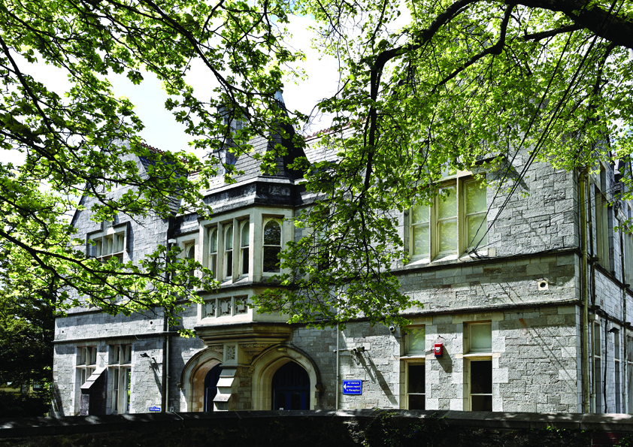

contents
The Curriculum
  - Intent: mastering the 10 big ideas in science
  - Implementation: organising our curriculum in order to master the 10 big ideas
  - Impact: how do we know our students are progressing on this journey?

The Curriculum
- Intent: mastering the 10 big ideas

Forces | Electromagnetism
Energy | Waves
Matter | Reactions
Earth | Organisms
Ecosystems | Genes

Our curriculum is an ambitious seven-year programme, gradually leading to the mastery of ten big scientific ideas. These big ideas and their accompanying skills, (like those in English literature, English language and mathematics), have been carefully chosen as those most important to support our students in becoming global citizens who can think for themselves.
Scientific thinking remains at the heart of innovation and new technologies. It is an evidence-based approach which has cured diseases, designed planes that fly and has allowed us to predict the properties of chemical elements and compounds. Scientific thinking is indifferent to ideas that lack evidence and is comfortable rejecting existing ideas in the face of new information. Scientific innovation also increases the complexity of our lives and presents moral and ethical questions: just because we can, should we? Is this the right thing to do? Does this do more harm than good?
Thinking remains at the heart of our teaching and learning approach too and we have high expectations of our students. Science teachers use retrieval practice and a variety of thinking tools to ensure there is appropriate pace and challenge for students. Learning always concludes with a review of the salient points. These priorities are summarised by the RESPECT approach: retrieval, expectations, salient, pace, expectations, challenge and thinking tools.
Our students’ views are vital in shaping how we do things. Our team of sixth form Science Captains organise a variety of activities and events to enthuse our younger students, as well as seeking their views on their science learning in the hopes of shaping our curriculum in future years.
Our students face a world full of information; much of it of questionable scientific accuracy. Therefore, it is our intention to equip our students, not only with a body of useful scientific knowledge, but to instil an evidence-based approach to their daily lives, where they can think in order to scrutinise fact from fiction.
We hope this flexible and sceptical outlook allows them prosper in our rapidly changing world – no matter what it may demand of them.

What is mastery?
We believe that there are three aspects to the mastery of scientific ideas:
- Learning a body of core knowledge
- Demonstrating understanding of that knowledge
- Practising a set of skills that support that knowledge
These three aspects of mastery are of equal importance and we believe that their consideration and development will lead to a successful experience for our students. We also believe that these big scientific ideas are worth mastering for their own sake.

What do we mean by ‘knowledge’?
Our curriculum sees ‘knowledge’ as the crucial details of an idea or concept, which must be committed to memory for convenience, and serve as a bridge to acquire even more knowledge. Core scientific knowledge will likely include:
- Statements of fact, definitions and important numerical constants
- General rules that show patterns
- Agreed laws, principles and explanations that are well-tested and predictive
- Processes that have a particular sequence
- Models and metaphors to help explain concepts
- Key language and terminology so students can share their knowledge with others

What do we mean by ‘understanding’?
Students demonstrate understanding when they move beyond simply recalling knowledge that has been rehearsed and memorised. To understand concepts and ideas means that students can use their knowledge ways that are not indicated in the programme of study or specification. Understanding can be demonstrated by:
- Recognising previously learned concepts within unfamiliar contexts
- Applying learned concepts to provide explanations for unfamiliar phenomena
- Making links between discrete scientific contexts
- Suggesting solutions to problems that are unfamiliar using existing knowledge
- Making judgements of new ideas based on existing understanding
- Using data from unfamiliar investigations to draw conclusions

What do we mean by ‘skills’?
We have defined skills as certain capabilities that rest upon a student’s knowledge which are bettered with practice. Some skills are transferrable to other subjects and activities, others are uniquely science-specific. We have distilled six key skills of importance:
- Scientific thinking, to include how theories change over time
- Scientific enquiry, including how to devise a valid experiment
- Scientific analysis, including using maths and statistics to interpret collected data
- Scientific communication, including usage of standard rules and conventions, such as units
- Practical competencies, including appropriate techniques for measuring mass or pH
- Mathematical skills, such as changing the subject of an equation

- Implementation: organising our curriculum in order to master the 10 big ideas
Unifying our various curricula around these ten big ideas serves to remind both teachers and students that scientific knowledge is not just a long list of discrete facts and theories, but a series of interconnected explanations for our world.
In periodically revisiting these ideas, the level of challenge increases:
- Newer, more complex processes and ideas are added – sometimes appearing to contradict previous simpler explanations
- The skillset changes from a ‘describe and explain’ approach to one of analysis and scrutiny
- The mathematical demands increase, from simple arithmetic to the use of natural logarithms and statistical analysis
- The apparatus and techniques become more expert, from acquiring their first Bunsen burner licence to distillation and heating under reflux.
As each idea is revisited, the big idea is strengthened and reinforced. Their knowledge and skills becoming ‘baked in’.

Inclusion in Science
Our Science curriculum from Years 7–13 is designed to be inclusive, ensuring all students can learn successfully and confidently. We recognise that strong scientific literacy, numeracy skills and positive outcomes help students succeed both in education and beyond.
We use evidence-informed teaching strategies and adapt our curriculum, resources and delivery to meet students’ needs through:
- Teacher guidance and student profiles to support learners with SEND, EAL and other individual needs.
- Adaptations to lessons and curriculum content where learning gaps or specific needs are identified.
- Consistent use of school systems to promote belonging, reward, success and disruption-free learning.
- Structured lessons and clear routines that help all students feel safe, supported and ready to learn.
- Targeted intervention and support to strengthen numeracy and scientific understanding across Key Stages 3 and 4.
- Additional support for disadvantaged students, including curriculum adaptations, close monitoring, personalised feedback, parental communication and practical support where needed.
- Regular quality assurance, training and collaboration within the Science team to ensure inclusive practice and high-quality teaching.
We maintain high expectations for all students and use research-informed approaches, including effective feedback, independent study support and regular retrieval of key knowledge, to help every learner achieve their potential.

USE OF AI
As part of our ongoing commitment to innovation and improving learning outcomes, Plymouth High school for girls is exploring the use of Artificial Intelligence (AI) tools to support teaching and learning. This includes trialling AI-assisted marking tools, which can help provide timely and consistent feedback to students.
Please be assured that all AI tools used are carefully selected to meet data protection standards and any use of student work is handled with care. While AI may assist in the marking process, all final assessments and feedback are reviewed by teachers to ensure accuracy and fairness.
We are committed to keeping you informed and welcome any questions you may have about this approach.

The charts below show the sequencing of knowledge and skills from Year 7 to Year 13.

Implementation: development of knowledge and understanding
 | Key Stage 3 |  |  | Key Stage 4 |  | Key Stage 5
Big idea | Year 7 | Year 8 | Year 9 | Year 10 | Year 11 | Year 12 | Year 13
Forces | 1.1 Speed  1.2 Gravity | 1.3 Contact forces  1.4 Pressure |  |  | P8 Forces in balance  P9 Motion  P10 Force and motion  P11 Force and pressure | 2P Mechanics | 6P Further mechanics  12P Gravitational fields
“By the end of the year…” | ...students will have gained an introductory working knowledge of forces, building on basic ideas from KS2. This will have included how forces arise, and how they change the motion of objects. They should have also started to understand speed, and how to tell the story of a journey with a graph. | …students will have started to secure their knowledge of forces to have included pressure in fluids and should be able to relate it to floating and sinking. They should also have developed their understanding of solid objects exerting pressure on one another. |  |  | …students will have begun mastering the big idea of forces by having revisited gravity, motion, friction and pressure at a higher level. They should have deepened their understanding of how forces through Newton’s Three Laws of Motion | …students will have developed a more advanced mastery of forces by significantly increasing their existing knowledge and understanding of motion beyond KS4. Better known as mechanics, their understanding should now include use of a number of additional kinematics equations. | …students will have further mastered forces with the introduction of circular motion, the concept of ‘impulse’ as part of Newton’s second law and angular momentum. Their understanding of gravity should now include a number of new equations including that for V_{grav} for a radial gravitational field.
Electro-  magnetism | 2.1 Voltage and resistance  2.2 Current | 2.3 Electromagnets  2.4 Magnetism |  | P4 Electric circuits  P5 Electricity in the home | P15 Electromagnetism | 3P Electric circuits | 7P Electric and magnetic fields
“By the end of the year…” | ...students will have gained an introductory working knowledge of electromagnetism, building on basic ideas from KS2. This will have included the concepts of current, resistance, charge and potential difference. They should have also appreciate everyday uses of electricity in household appliances. | … students will have developed their knowledge of electromagnetism to include electromagnets, how to change their strength and some of their uses. They should also have developed their understanding of magnetic fields, both as a model and in real contexts, like the Earth. |  | …students will have further developed their knowledge of electromagnetism by revisiting electricity at a greater depth. A more quantitative approach has resulted in them committing the following formulae to memory: V = I R, Q = I t, P = V I, P = I² V, E = P t, and E = Q V and the efficiency rating of household appliances. | …students will have begun mastering the big idea of electromagnetism by having revisited the construction of electromagnets. They should have deepened their understanding of the 3D magnetic field and the motor effect. The should also be able to use the equation F = B I l. | …students will have developed a more advanced mastery of electromagnetism by significantly increasing their existing knowledge beyond KS4. Their understanding should now include the ability to derive equations, to sketch, recognise and interpret I-V graphs for a range of components and understand new quantities like emf and resistivity. | …students will have developed a more advanced mastery of electromagnetism by significantly increasing their existing knowledge beyond KS4. Their understanding should now include the measurement of electric field strength using E = F/Q as well as a range of additional new equations, including F = B q v sin using existing knowledge of Fleming’s left-hand rule from KS4.

Energy | 3.1 Energy costs  3.2 Energy transfer | 3.3 Work  3.4 Heating and cooling | 9.P.1 Conservation and dissipation of energy  9.P.2 Energy transfer by heating  9.P.3 Energy resources |  |  | 3.4C Enthalpy changes  3.5C Reaction rates and equilibrium (qualitative) | 5.1C Rates of reaction and equilibrium (quantitative)  5.2C pH and buffers  5.3C Enthalpy, entropy and free energy  9P Thermodynamics
“By the end of this year…” | ...students will have gained an introductory working knowledge of energy, building on basic ideas from KS2. This will have included how energy is costed and the introduction of the kilowatt hour . They should have also started to understand different energy pathways, including useful and wasted energy . | …, students should have developed their knowledge of energy to include ‘work done’ and transferring energy between stores. Students will have also developed their understanding of different ways to stop energy transfer through friction and conduction. | …students will have developed their knowledge of energy by revisiting energy use. They should have deepened their understanding to include efficiency calculations, and complex ways of generating electricity. |  |  | …students will have developed a more advanced mastery of energy by significantly increasing their existing knowledge beyond KS4. Their understanding should now include a more advanced understanding of internal heat content, or enthalpy. | …students will have developed a more advanced mastery of energy by significantly increasing their existing knowledge beyond KS4. Their understanding should now include a highly quantitative approach to thermodynamics, including pV = NkT, pV = 1/3 Nm<c>, L = AT⁴
Waves | 4.1 Sound  4.2 Light | 4.3 Wave effects  4.4 Wave properties |  |  | P12 Wave properties  P13 EM waves  P14 Light | 5P Waves and the particle nature of light | 13P Oscillations
“By the end of this year…” | ...students will have gained an introductory working knowledge of waves, building on basic ideas from KS2. This will have included distinguishing between transverse and longitudinal waves, in the context of light and sound respectively. They should have also started to understand ideas like transmission, refraction and reflection . | … students will have developed their knowledge of waves, including a greater number of contexts, the energy they transfer and their interactions with surfaces and materials. Students will have also developed their ability to model waves, to predict their behaviour, uses and dangers. |  |  | …students will have begun mastering the big idea of waves by having revisited the transverse and longitudinal wave. They should have deepened their understanding by learning about EM waves and the EM spectrum, recognising light as an example. | …students will have developed a more advanced mastery of waves by significantly increasing their existing knowledge beyond KS4. Their understanding should now include the evaluation of wave and photon models of EM radiations. | …students will develop an advanced mastery of waves by studying and analysing oscillations. Their understanding should now include simple harmonics and the use of key equations, including ω = 2 π f a and T = $2π\sqrt{\frac{l}{g}}$
Sequencing rationale: | Simple physical principles → complex interactions |  |  | Simple physical principles → complex interactions |  | Simple physical principles → complex interactions

 | Key Stage 3 |  |  | Key Stage 4 |  | Key Stage 5
Big idea | Year 7 | Year 8 | Year 9 | Year 10 | Year 11 | Year 12 | Year 13
Matter | 5.1 Particle model  5.2 Separating mixtures | 5.3 Elements  5.4 The periodic table | 9.C.1 Atomic structure  9.C.2 The periodic table [cont.]  9.C.3 Structure and bonding | P6 Molecules and matter  P7 Radioactivity | C11 Polymers  C12 Chemical analysis | 2.1C Atoms, compounds, molecules and equations  2.2C Amount of substance  2.4C Electrons, bonding and structure  3.1C The periodic table and periodicity  3.2C Group 2 and the halogens  4.1C Basic concepts  4P Materials | 8P Nuclear and particle physics  11P Nuclear radiation
“By the end of this year…” | ...students will have gained an introductory working knowledge of matter, building on basic ideas from KS2. This will have included a simple look at particles. They should have also started to understand basic separation of mixtures. | …students will have started to secure their knowledge of matter by classifying particles into different groups and periods. They should also have developed their understanding compounds that are not easily separable. | …students will have started to secure their knowledge of matter to have included isotopes of elements. They should also have developed their understanding of different bonding types . | …students will have further developed their knowledge of matter by revisiting pressure and energy transfer, developed in Big Ideas 1 and 3. They should have deepened their understanding of isotopes to include radioactivity. | …students will have begun mastering the big idea of matter by having revisited covalent bonding. Here, they apply this to more complex contexts like polymerisation. | …students will have developed a more advanced mastery of matter by significantly increasing their existing knowledge beyond KS4. Their understanding should now include complicated contexts, but also a more quantitative approach, using n=v/24 and PV=nRT. Students should also be able to describe the electronic configuration of matter. | …students will develop an advanced mastery of matter by significantly increasing their existing knowledge and understanding of radioactivity from KS4. Their understanding should now include analysis of daughter elements and readily use the unit, Sievert.

Reactions | 6.1 Metals and non-metals  6.2 Acids and alkalis | 6.3 Chemical energy  6.4 Types of reaction |  | C4 Chemical calculations  C5 Chemical changes  C7 Energy changes | C8 Rates and equilibrium  C10 Organic reactions | 2.3C Acid-base and redox reactions  4.3C Alcohols and haloalkanes  4.4C Organic synthesis | 5.4C Redox and electrode potentials  6.1C Aromatic compounds  6.2C Carbonyl compounds  6.3C Carboxylic acids and esters  6.4C Nitrogen compounds  6.5C Polymers  6.6C Organic synthesis
“By the end of this year…” | ...students will have gained an introductory working knowledge of reactions, building on basic ideas from KS2. This will have included simple behaviours and properties of metals and non-metals. They should have also started to recognise the presence of acids and alkalis in our lives. | …students will have started to secure their knowledge of reactions by classifying reactions into groups, such as decomposition or combustion. They should also have developed their understanding of conserving energy. |  | …students will have further developed their knowledge of reactions by revisiting previous ideas but with a quantitative perspective. They should have deepened their understanding to include concepts like the mole and bond enthalpy. | …students will have begun mastering the big idea of reactions by having revisited reaction rates, or ‘chemical kinetics’ as they will now call it. They should have deepened their understanding of carbon compounds to include organic chemistry. | …students will have developed a more advanced mastery of reactions by significantly increasing their existing knowledge beyond KS4. Their understanding should now include new, more complicated contexts and new calculations like the equilibrium constant (K_{c}) and Hess’s Law. They will consider combinations of previously understood groups of molecules, such as haloalkanes. | …students will develop an advanced mastery of reactions by significantly increasing their existing knowledge and understanding from KS4 and Year 12. Their understanding should now include multi-stage calculations, novel molecules and groups. More advanced calculations are introduced, such as K_{a} and pK_{a}

Earth | 7.1 Earth structure  7.2 Universe | 7.3 Climate  7.4 Earth’s resources |  | C6 Electrolysis | C9 Crude oil and fuels  C13 The Earth’s atmosphere  C14 The Earth’s resources  C15 Using our resources  P16 Space | 4.2C Hydrocarbons  4.5C Analytical techniques | 5.5C Transition elements  6.7C Chromatography and spectroscopy (NMR)  10P Space
“By the end of this year…” | ...students will have gained an introductory working knowledge of Earth, building on basic ideas from KS2. This will have included the different layers of the Earth . They should have also started to understand Earth’s location within the Solar System and Universe . | …students will have started to secure their knowledge of Earth to have included the ways we exploit materials from the Earth . They should also have developed their understanding of the resulting anthropological environmental effects like climate change. |  | …students will have further developed their knowledge of Earth by revisiting our need for resources. They should have deepened their understanding to include more complex means of extraction, including the use of electricity. | …students will have begun mastering Earth as a big idea by having revisited resource use once more through the context of man-made composite materials, lifecycle assessments, as well as new technologies. Students also examine the evolution of Earth’s atmosphere. | …students will have developed a more advanced mastery of Earth by significantly increasing their existing knowledge beyond KS4. Their understanding should now include the carbon chemistry of hydrocarbons, including standard nomenclature. Students will have evaluated anthropogenic impacts on the chemistry of the atmosphere | …students will develop an advanced mastery of Earth by significantly increasing their existing knowledge and understanding to include the introduction of complex metal ions and ligands. Also students will become familiar with methods for identifying unknown materials.
Sequencing rationale |  | Fundamentals → materials → the Earth |  | Fundamentals → materials → the Earth |  | Fundamentals → materials → the Earth

Organisms | 8.1 Movement  8.2 Cells | 8.3 Breathing  8.4 Digestion | 9.B.1 Cell structure and transport  9.B.2 Cell division  9.B.3 Organisation and the digestive system | B4 Organising animals and plants  B5 Communicable diseases  B6 Preventing and treating disease  B7 Non-communicable disease  B10 The nervous system  B11 Hormones  B12 Homeostasis |  | 2.1B Cell structure  2.2B Biological molecules  2.3B Nucleic acids  2.4B Enzymes  2.5B Membranes  2.6B Cell division  3.1B Gas exchange  3.2B Animal transport  3.3B Plant transport  4.1B Communicable diseases | 5.1B Communication and homeostasis  5.2B Excretion  5.3B Neuronal communication  5.4B Hormonal communication  5.5B Plant and animal responses
“By the end of this year…” | ...students will have gained an introductory working knowledge of organisms, building on basic ideas from KS2. This will have included looking inside organisms at how their skeleton and muscles work together. They should have also started to examine the building blocks of living things: cells | …students will have started to secure their knowledge of organisms to have included how cells work together to form tissues, organs and organ systems. They should also have developed their understanding of nutrition and health in order to keep the body functioning. | …students will have developed their knowledge of organisms by revisiting cells, tissues and organ systems in greater depth, to include both animal and plant examples. They should have deepened their understanding to include the biological molecules found in food and how cell specialisation occurs. | …students will have significantly broadened and deepened their knowledge of organisms by revisiting health and disease. Students will have learned about the differences between communicable and non-communicable diseases, as well as the function of the immune system. Students will also examine in depth the various risk factors for NCDs. They will have also learned how the body coordinates its internal environment. |  | …students will have developed a more advanced mastery of organisms by significantly increasing their existing knowledge beyond KS4. Their understanding should now include complex biochemistry and detailed processes of exchange and transport. Immunity is discussed at far greater depth. | …students will develop an advanced mastery of organisms by significantly increasing their existing knowledge and understanding of… from KS4. Their understanding should now include complex processes that explain how coordination of the body’s systems is carried out. The relationships between cells is examined at an expert level.

Ecosystems | 9.1 Interdependence  9.2 Plant reproduction | 9.3 Respiration  9.4 Photosynthesis |  | B8 Photosynthesis  B9 Respiration | B16 Adaptation, interdependence and competition  B17 Organising an ecosystem  B18 Biodiversity and interdependence | 4.2B Biodiversity | 5.6B Photosynthesis  5.7B Respiration  6.5B Ecosystems  6.6B Populations and sustainability
 | ...students will have gained an introductory working knowledge of ecosystems, building on basic ideas from KS2. This will have included a basic idea about how different organisms interact with each other in different ways, predators and prey, mating and competition. They should have also started to understand how plant species reproduce. | …students will have started to secure their knowledge of ecosystems to have included how energy is transferred between organisms and the environment. They should also have developed their understanding of two major energy pathways: photosynthesis and respiration. |  | …students will have further developed their knowledge of ecosystems by revisiting the transfer of energy during photosynthesis and respiration. They should have deepened their understanding to include symbol chemical equations, and more complex cell biology. They will also examine quantitative factors that affect the rates of these reactions. | …students will have begun mastering the big idea of ecosystems by having revisited the concept of interdependence. They should have deepened their understanding inter- and intraspecific forms of competition. The predator-prey relationship is also examined as well as the importance of biodiversity and conservation. | …students will have developed a more advanced mastery of ecosystems by significantly increasing their existing knowledge beyond KS4. Their understanding should now include complex quantitative measures of biodiversity, such as the Simpson’s Index of Diversity, and also statistical tools like standard deviation, t-testing, and correlation coefficients. Conservation efforts are classified as in situ and ex situ | …students will develop an advanced mastery of ecosystems by significantly increasing their existing knowledge and understanding of photosynthesis and respiration from KS4. Their understanding should now include highly complex biochemistry and advanced intra-cellular structural detail. Students will have studied specific examples of global conservation efforts

Genes | 10.1 Variation  10.2 Reproduction | 10.3 Evolution  10.4 Inheritance |  |  | B13 Reproduction  B14 Variation and evolution  B15 Genetics and evolution | 4.3B Classification and taxonomy | 6.1B Cellular control  6.2B Patterns of inheritance  6.3B Manipulating genomes  6.4B Cloning and biotechnology
“By the end of this year…” | ...students will have gained an introductory working knowledge of genes, building on basic ideas from KS2. This will have included identifying the ways in which people and organisms are different. They are also introduced to human reproduction. | …students will have started to secure their knowledge of genes including how gradual changes in DNA can lead to evolution. They should also have developed their understanding of how features are passed to offspring. |  |  | …students will have begun mastering the big idea of genes by having revisited evolution and inheritance. They should have deepened their understanding by examining how natural selection can select for particular adaptations and using quantitative analysis to predict the characteristics of offspring. They will have also explored different systems of classification | …students will have developed a more advanced mastery of genes by significantly increasing their existing knowledge beyond KS4. Their understanding should now include a detailed genetic and molecular analysis of the two differing classification systems used. | …students will develop an advanced mastery of genes by significantly increasing their existing knowledge and understanding of inheritance from KS3 or 4. Their understanding should now include a variety of different genetic processes that activate genes as well as changing the pattern of inheritance, such as epistasis, codominance and linkage.
Sequencing rationale |  | Us → populations/global  Visible/tangible → abstract/counterintuitive |  | Small → Big  Fundamental → Complex  Single cells → multi → populations |  | Small → Big  Fundamental → Complex  Single cells → multi → populations

Implementation: development of skills
Skill | Year 7 | Year 8 |  | Year 9 | Year 10 | Year 11 | Year 12 | Year 13
Scientific  thinking | 2.13 Estimate risks  2.14 Examine consequences  2.15 Review theories  2.16 Interrogate sources |  |  |  | WS1.1 How theories change over time  WS1.2 Use models  WS1.3 Appreciate the power and limitations of science, including arising ethics  WS1.4 Applications and implications of scientific ideas  WS1.5 Evaluate risks and consider how risk is perceived  WS1.6 Recognise the importance of peer review |  | HSW1 Use theories, models and ideas to develop scientific explanations  HSW2 Use knowledge and understanding to pose scientific questions, define scientific problems, present arguments and scientific ideas  HSW7 Know that scientific knowledge and understanding develops over time  HSW9 Consider applications and implications of science and evaluate their associated benefits and risks  HSW10 Consider ethical issues in the treatment of humans, other organisms and the environment  HSW11 Evaluate the role of the scientific community in validating new knowledge and ensuring integrity
By the end of the year… | …students will be able to use key words like risk and hazard, identify groups that can be positively or negatively harmed by an action, can explain what is meant by a theory and know what bias means |  | …students will be able to identify risks and hazards, can consider environmental implications of actions, will appreciate how ideas have changed and can check information for bias | …students will be able to suggest how investigations can be made safe, can evaluate choices in terms of benefit and harm, can explain why theories take time to change and can articulate the benefit of peer review
 |  |  |  |  | …students will have revisted ideas about scientific thinking, but will also increasingly evaluate models for scientific ideas and consider ethical dilemmas that arise. Contexts will have included: cost effectiveness of additions to greenhouses, modelling giant covalent structures and the development of atomic structure, | …students will be able to consider scientific thinking in a variety of more complex biological, chemical and physical contexts, including: evaluating different brain procedures, considering the properties of thermosetting and thermosoftening polymers and advancing astrophysics ideas like dark matter and dark energy.
 |  |  |  |  |  |  | …students will master scientific thinking in a variety of highly technical and advanced biological, chemical and physical contexts, including the impacts of international conservation legislation | …students will master scientific thinking in a variety of highly technical and advanced biological, chemical and physical contexts, including acceptance of the delocalised benzene  model by the scientific community in light of  supporting experimental evidence.

Skill | Year 7 |  |  | Year 8 | Year 9 | Year 10 | Year 11 | Year 12 |  | Year 13
Scientific enquiry |  | 2.9 Collect data  2.10 Devise questions  2.11 Plan variables  2.12 Test hypotheses |  |  |  | WS2.1 Use scientific theories and explanations to develop hypotheses  WS2.2 Plan experiments  WS2.3 Use of appropriate techniques for an experiment  WS2.4 Appropriate and safe use of apparatus  WS2.5 Collection of representative samples  WS2.6 Make and record observations |  | HSW3 Use appropriate methods, including ICT to answer scientific questions and solve scientific problems  HSW4 Carry out experimental and investigative activities, including appropriate risk management
By the end of the year… |  | …students will be able to use key words like control group, independent variable, hypothesis and prediction. | …students will be able to choose ranges and intervals for data collection, ask questions in the form: “how does.. change over time?” , identify control variables and conclude whether a hypothesis was correct. |  | …students will be able to explain why having a large range or many readings leads to accurate data, whether a given question can be investigated, why some variables are uncontrollable, and what to do if conclusions do not agree with predictions.
 |  |  |  |  |  | …students will have revisited ideas about scientific enquiry, but will also increasingly evaluate the appropriateness of selected techniques. Students will also have taken greater control over method planning. Contexts in Year 10 will have included investigating antibiotics, preparation of a pure, dry salt from an insoluble oxide, and determining the specific heat capacity of a material. | …students will be able to consider scientific enquiry in a variety of more complex biological, chemical and physical contexts, including: investigating factors affecting reaction times, the analysis and purification of water samples, and determining the suitability of apparatus used to measure frequency, wavelength and wave speed in a ripple tank. | …students will master scientific enquiry in a variety of highly technical and advanced biological, chemical and physical contexts, the use of appropriate sampling techniques, or using Quickfit apparatus for reflux. | …students will further master scientific enquiry in a variety of highly technical and advanced biological, chemical and physical contexts, including investigating photosynthetic pigments with thin layer chromatography or using qualitative analysis to distinguish aldehydes and ketones.
Scientific analysis |  | 2.1 Analysing patterns  2.2 Discuss limitations  2.3 Draw conclusions  2.4 Present data |  |  |  | WS2.7 Evaluate methods and suggest improvements  WS3.1 Presenting observations and other data using appropriate methods  WS3.2 Translating data from one form to another  WS3.3 Using maths and statistics to analyse  WS3.4 Estimating uncertainty  WS3.5 Identifying trends and patterns and drawing conclusions  WS3.6 Presenting reasoned explanations based on hypotheses  WS3.7 Being objective, and evaluating data |  | HSW5 Analyse and interpret data to provide evidence, recognising correlations and causal relationships  HSW6 Evaluate methodology, evidence and data, and resolve conflicting evidence
By the end of the year… |  | …students will be able to use key words like outlier, experimental error, primary data, and be able to perform simple calculation and read from a variety of charts and graphs. | …students will be able to select relevant data and process it, suggest improvements to experiments, draw simple conclusions from data, and construct line graphs. |  | …students will be able to appreciate how anomalous data can obscure patterns, identify potential sources of random and systematic error, identify further questions for investigation, and explain choices of graph. |  |  | …students will include a focus on resolving apparent conflicting evidence in their mastery of scientific analysis in a variety of highly technical and advanced biological, chemical and physical contexts, such as factors affecting permeability of phospholipid bilayers and balancing safety, rate and economics in the Haber process. | …students will further master scientific analysis in a variety of highly technical and advanced biological, chemical and physical contexts, including evolutionary concepts and an understanding of when K_{a} approximations break down.
 |  |  |  |  |  | …students will have revisited ideas about scientific analysis, but will have also explored simple ideas of uncertainty and objectivity. This will have been in a range of contexts including: investigating osmosis in plant tissue, determining of reacting volumes of strong acids, and measuring reaction times. | …students will be able to consider scientific analysis in a variety of more complex biological, chemical and physical contexts, including: investigating phototropism in plants, and investigating factors affecting acceleration.

Skill | Year 7 |  |  | Year 8 |  | Year 9 | Year 10 |  |  | Year 11 | Year 12 |  | Year 13
Scientific communication |  | 2.5 Communicate ideas  2.6 Construct explanations  2.7 Critique claims  2.8 Justify opinions |  |  |  |  |  | WS3.8 Communicating investigations in paper-based and electronic reports  WS4.1 Use scientific terminology  WS4.2 Recognise the importance of scientific quantities and their origin  WS4.3 Use SI units and IUPAC nomenclature  WS4.4 Use standard prefixes and powers of ten for orders of magnitude  WS4.5 Interconvert units  WS4.6 Use appropriate numbers of significant figures |  |  |  | HSW8 Communicate information and ideas in appropriate ways using appropriate terminology  HSW12 Evaluate the ways in which society uses science to inform decision making.
By the end of the year… |  | …students will be able to use writing styles that suit a particular audience, make clear distinctions between facts and opinion, and use key words like evidence, claim, reasoning. | …students will be able write about ideas clearly and correctly, develop explanations, and can check evidence for accuracy. |  | …students will be able to suggest ideas for better communication, explain why explanations are more believable when supported with data, can evaluate a claim with evidence, and identify ways in which different opinions could both be valid. |  |  |  |  |  |  | …students will include a focus on how society is influenced by scientific innovations in their mastery of scientific communication in a variety of highly technical and advanced biological, chemical and physical contexts, such as vaccination programmes and use of spectroscopy for drug monitoring |  | …students will further master scientific communication in a variety of highly technical and advanced biological, chemical and physical contexts, such as evaluating the potential impacts of interrupting ecological succession or the correct use of rate equations in chemistry.
 |  |  |  |  |  |  |  | …students will have revisited ideas about scientific communication, but will have also explored standardised rules and procedures like SI units, table and graph conventions and IUPAC nomenclature for chemicals and the required physics equations. | …students will be able to consider scientific communication in a variety of more complex biological, chemical and physical contexts, including the required practical investigations.

Skill | Year 7 | Year 8 | Year 9 | Year 10 | Year 11 | Year 12 | Year 13
Practical competency | - heat a measured volume of water until almost boiling, having selected and used appropriate equipment  - obtain and record a clearly focused image of a microscopic object  - find out at regular intervals the temperature of water being heated and tabulate observations to reveal the pattern  - separate ingredients from mixtures using appropriate techniques such as evaporation, filtration, chromatography and magnets  - measure the speed of a moving object using appropriate equipment  - measure changes in the pH of solutions using indicators  - carry out practical procedures using instructions without guidance and in a calm fashion with due regard to the safety of others  - observe and investigate a range of chemical reactions using equipment appropriately  - build electrical circuits using various components and measure current and voltage using an ammeter and voltmeter  - build an electrical circuit based upon a range of circuit diagrams |  |  | - Use of appropriate apparatus to make and record a range of measurements accurately, including length, area, mass, time, temperature, volume of liquids and gases, and pH  - Safe use of appropriate heating devices and techniques including use of a Bunsen burner and a water bath or electric heater  - Use of appropriate apparatus and techniques for the observation and measurement of biological changes and/or processes.  - Safe and ethical use of living organisms (plants or animals) to measure physiological functions and responses to the environment  - Measurement of rates of reaction by a variety of methods including production of gas, uptake of water and colour change of indicator.  - Application of appropriate sampling techniques to investigate the distribution and abundance of organisms in an ecosystem via direct use in the field  - Use of appropriate apparatus, techniques and magnification, including microscopes, to make observations of biological specimens and produce labelled scientific drawings  - Use of appropriate techniques and qualitative reagents to identify biological molecules and processes in more complex and problem-solving contexts including continuous sampling in an investigation |  | See individual documentation.

Skill | Year 7 | Year 8 | Year 9 | Year 10 | Year 11 | Year 12 | Year 13
Mathematical skills | 7.1 Arithmetic and number  • Recognise and use decimal numbers  • Use ratios, fractions and percentages  • Make estimates from simple calculations  7.2 Handling data  • Calculating means, modes and medians  • Construct and interpret bar charts  • Use a scatter diagram to identify correlations between two variables  • Understand sampling  • Make order of magnitude calculations  7.3 Algebra  • Understand and use the symbols:  =, <, >  • Substitute numerical values into simple algebraic equations using appropriate units for physical quantities  • Solve simple algebraic equations  7.4 Graphs  • Translate information between graphical and numeric form  • Plot two variables from data  • Determine the slope and intercept of a linear graph  7.5 Geometry and trigonometry  • Use angular measures in degrees  • Calculate areas of triangles and rectangles, surface areas and volumes of cubes |  |  | Additionally:  7.1 Arithmetic and number  - Recognise standard form numbers  7.2 Handling data  - Appropriateness with significant figures  - Construct and interpret frequency diagrams and histograms  - Understand simple probability  7.3 Algebra  - Understand and use the symbols:  <<, >>,  and ~  - Change the subject of an equation  7.4 Graphs  - Understand that y = mx + c represents a linear relationship  - Determine the slope and intercept of a linear graph  - Draw and use the slope of a tangent to a curve as a measure of the rate of change  - Understand the physical significance of the area between a curve and the x-axis and measure it by counting the squares  7.5 Geometry and trigonometry  - Visualise and represent 2D and 3D forms including 2D representations of 3D objects |  | Additionally:  M0 Arithmetic and number  - Recognise and make use of appropriate units in calculations  - Use calculators to find and use power, exponential and logarithmic function  M1 Handling data  - Select and use a statistical test  - Understand measures of dispersion, including standard deviation and range  - Identify uncertainties in measurements and use simple techniques to determine uncertainty when data are combined  M2 Algebra  - Use logarithms in relation to quantities that range over several orders of magnitude  M4 Geometry and trigonometry  - Calculate circumferences, surface areas and volumes of all regular shapes
Sequencing rationale | Decimals → standard form and indices → logarithms  Formatting of charts/graphs → appropriateness of graphs → statistical analysis

- Impact: how do we know that our students are progressing on this journey?
Feedback and assessment: attempting to measure impact and allowing students to reflect
Curricular impact is difficult to fully quantify. We must look to a range of student attributes and abilities, some of which are easily measured, others less so.
Examples of indications that our curriculum has successfully impacted our students’ progress include:
- Students who can discuss big scientific ideas with a fluency that is appropriate for their curriculum level. Core pieces of knowledge are easily recalled.
- Students who can recognise knowledge in complicated contexts or scenarios they are unacquainted with.
- Students who are shrewd, judgemental sceptics who possess an evidence-based approach to scientific ideas.
- Students who can successfully transfer mathematical skills into scientific contexts and use them to solve problems.
- Students who are at ease in the laboratory environment and can use standard apparatus and techniques appropriately.
Day-to-day informal assessment is one way to review impact and comes in many forms, including: questioning, discussion, as well as looking at class work and homework.
Written assessments in the form of tests are an easy way to quantify our curriculum’s impact. We accept that exams are an important reality for both students and our school, however, we are conscious of not making them the sole purpose of our work, nor do we believe that excessive exam coaching is a good use of curriculum time. With this in mind, we limit formal assessment to just six activities per subject per year. Examples and timings are noted in the Assessment Overview.
All of our assessments have a formative nature to them and are used as opportunities to evaluate current understanding. Guided by teacher comments throughout, students are invited to reflect upon what went well and where improvements could be made. Institutional ‘end of year’ assessments which are inherently summative are still used as a formative exercise.
The simple template below features on the front of all assessments:

Student reflection
www

Ebi

Students’ notes in their exercise books will be reviewed and acknowledged for completeness and effectiveness during lesson time.
Impact beyond the curriculum
Though inherently extra-curricular, our enrichment activities also contribute to our intentions and have valued impact. The sciences offer a number of opportunities, not limited to the following:
- Membership of Team Hummingbird is highly inclusive and allows for the development of:
  - Knowledge and understanding of big ideas like Energy, Electromagnetism and Forces
  - Subject-specific skills, such as trial and error and the scientific method.
  - Cultural capital, such as inter-personal skills and teamwork, making friends with shared interests, an interest in protecting our environment.

- Trips, visits and events, including:
  - Ecology, environment, and sustainability at the Eden Project
  - Visits to Wembury Marine Centre for A level Biology population sampling
  - Visits to the National Marine Aquarium
  - Visits to Plymouth University, e.g. Electron Microscopy, and medical visits.
  - Medicine Day, a linked event with partner schools where medical professionals discuss careers in medicine

Reviewing the impact of our curriculum
Annually we review our curriculum to ensure that our intentions continue to be realised. In the summer term, the sequencing of knowledge and our assessment scheme are both discussed and where necessary modified to more closely align to our intent.
Quality assurance is also used to measure the visibility of our intentions and ensure that they are being implemented in the way we hoped. Quality assurance includes:
- Annual lesson observations
- Review of students class work
- Drop-ins
- Student surveys
- Student focus groups
Where we find our intentions are not being implemented, we will seek to refine our practice, or where necessary look again to our intentions and assess their suitability.

Assessment overview

CURRICULUM & ASSESSMENT OVERVIEW: SCIENCES (BIOLOGY, CHEMISTRY, PHYSICS)
 | Autumn 1 | Autumn 2 | Spring 1 | Spring 2 | Summer 1 | Summer 2
Year 7  (KS3) | Topic(s):  Lab safety  Forces  - Gravity  - Speed  Electromagnetism  - Voltage and resistance  - Current  Assessment 1  See Example 1 | Topic(s):  Energy  - Energy costs  - Energy transfer  Waves  - Sound  - Light  Matter  - The Particle model  Assessment 2 | Topic(s):  Matter  - Separating mixtures  Reactions  - Metals and non-metals  - Acids and alkalis  Assessment 3 | Topic(s):  Earth  - Earth structure  - The Universe  Organisms  - Movement  Assessment 4 | Topic(s):  Organisms  - Cells  Ecosystems  - Interdependence  - Plant reproduction  Assessment 5  End of Year 7 exam | Topic(s):  Genes  - Variation  - Reproduction  Assessment 6
Year 8  (KS3) | Topics:  Forces  - Contact forces  - Pressure  Assessment 1 | Topics:  Waves  - Wave effects  - Wave properties  Matter  - Elements  - The periodic table  Assessment 2 | Topics:  Reactions  - Chemical energy  - Types of reaction  Earth  - Climate  - Earth resources  Assessment 3  See Example 2 | Topics:  Organisms  - Breathing  - Digestion  Assessment 4 | Topics  Ecosystems  - Photosynthesis  - Respiration  Assessment 5 | Topics  Genes  - Evolution  - Inheritance  Assessment 6
Year 9  (KS3) | Topics:  Biology  - 9B1 Cell structure and transport  - 9B2 Cell division  Assessment 1 | Topics:  Biology:  - Organisation and the digestive system  Assessment 2 | Topics  Chemistry:  - 9C1 Atomic structure  - 9C2 The periodic table  Assessment 3 | Topics  Chemistry:  - 9C3 Structure and bonding  Assessment 4 | Topics  Physics  - 9P1 Conservation and dissipation of energy  Assessment 5  End of Year 9 test | Topics  Physics  - 9P2 Energy transfer by heating  - 9P3 Energy resources  Assessment 6
Year 10  (GCSE) | Topics  Biology  - B4 Organisation in animals and plants  Assessment 1  Chemistry  - Review C1, C2, C3  - C4 Chemical calculations  Assessment 1  Physics  - P4 Electric circuits  - P5 Electricity in the home  Assessment 1 | Topics  Biology  - B5 Communicable diseases  - B6 Preventing and treating disease  Assessment 2  Chemistry  - C4 Chemical calculations  - C5 Chemical changes  Assessment 2  Physics  - P6 Molecules and matter  - P7 Radioactivity  Assessment 2 | Topics  Biology  - B7 Non-communicable diseaes  - B8 Photosynthesis  Assessment 3  Chemistry  - C6 Electrolysis  - C7 Energy changes  Assessment 3  Physics  - P8 Forces in balance  - P9 Motion  Assessment 3 | Topics  Biology  - B9 Respiration  - B10 Human nervous system  Assessment 4  Chemistry  - C7 Energy changes  - C8 Rates and equilibrium  Assessment 4  Physics  - P9 Motion  - P10 Force and motion  Assessment 4 | Topics  Biology  - B11 Hormonal coordination  - B12 Homeostasis in action  Assessment 5  Chemistry  - C8 Rates and equilibrium  - C9 Crude oil and fuels  Assessment 5  Physics  - P10 Force and motion  - P11 Force and pressure  Assessment 5 | Topics  Biology  - B12 Homeostasis in action  Assessment 6  End of Year 10 exam  Chemistry  - C9 Crude oil and fuels  Assessment 6  End of Year 10 exam  Physics  - P11 Force and pressure  - P12 Wave properties  Assessment 6  End of Year 10 exam
Year 11  (GCSE) | Topics  Biology  - B13 Reproduction  - B14 Variation and evolution  Assessment 1  See Example 3  Chemistry  - Review of C9  - C10 Organic reactions  - C11 Polymers  Assessment 1  Physics  - P13 Electromagnetic waves  - P14 Light  Assessment 1 | Topics  Biology  - B15 Genetics and evolution  - B16 Adaptation and interdependence  Assessment 2  Chemistry  - C11 Polymers  - C12 Chemical analysis  Assessment 2  Physics  - P14 Light  - P15 Electromagnetism  Assessment 2 | Topics  Biology  - B17 Organisation of an ecosystem  - B18 The effects of human interactions on ecosystems  Assessment 3  Chemistry  - C13 Our atmosphere  Assessment 3  Physics  - P15 Electromagnetism  - P16 Space  Assessment 3 | Topics  Biology  - Revision of B1-B9  Assessment 4 (mock)  Chemistry  - C14 The Earth’s resources  - C15 Using our resources  Assessment 4 (mock)  Physics  - P16 Space  Assessment 4 (mock) | Topics  Biology  - B9-B18  Assessment 5 (optional)  Chemistry  - Revision (C1-C15)  Assessment 5 (optional)  Physics  - Revision  Assessment 5 (optional)

Year 12  Biology | Topic(s):  Module 2 - Cell structure and cell membranes  Module 2 Biological molecules  Assessment:  Initial maths skills test  Cell structure test  Biological molecules test | Topic(s):  Module 2 Cell Division  Module 2 Nucleic acids and Enzymes  Assessment:  Cell membranes test  Cell Division test  Nucleic acids test | Topic(s):  Module 3 - Exchange surfaces and breathing  Module 4 - Communicable diseases  Assessment:  Enzymes test  Exchange surfaces and breathing test | Topic(s):  Module 3 Transport in animals  Module 4 - Biodiversity  Assessment:  Communicable diseases & Transport in animals tests | Topic(s):  Module 3 - Transport in plants  Module 4 - Classification and evolution  Assessment:  Biodiversity test  Classification test  Transport in plants test | Topic(s):  Biodiversity Fieldwork (Module 6 Ecosystems)  MOCK EXAM (OR Exemplar Assessments)  AS Breadth and Depth papers
Year 12  Chem | Topic(s):  Chapters 2.1 and 2.2  Assessment(s):  Progress test and progress test resit (if needed).  2.1 and 2.2 assessed Homework tasks | Topic(s):  Chapters 2.1 and 2.2  Assessment(s):  Chapters 2.1 and 2.2 Module tests. (Resits available if needed)  2.1 and 2.2 assessed Homework tasks | Topic(s):  Chapters 3.1 and 4.1  Assessment(s):  Chapters 3.1 and 4.1 Module tests. (Resits available if needed)  3.1 and 3.2 assessed Homework tasks | Topic(s):  Chapter 3.2 and 4.2  Assessment(s):  Chapter 4.2 Module test. (Resits available if needed)  3.2 and 4.2 assessed Homework tasks | Topic(s):  Continue and complete Chapter 3.2  Preparation for mock exams after half term  Mock exam revision over half term  Assessment(s):  C3.2 Module test. (Resit available if needed) | Topic(s):  Go through Mock exams  Start Module 6.1 (Introduction to Benzene)  Set Benzene essay as Summer holiday homework)  MOCK EXAM (OR Exemplar Assessments).
Year 12 Physics | Topic(s):  · Rectilinear motion  · Momentum  · Charge and current  · Potential difference, electromotive force and power  · Current – pd. Relationships  Assessment:  Rectilinear motion test – teacher marked, with comments  Basic electricity test – peer marked, with teacher comments  CP1: Determine the acceleration of a freely-falling object. – self-assessment, teacher comments | Topic(s):  · Forces  · Work, energy and Power  · Resistance and resistivity  · Internal resistance, series and parallel circuits and the potential divider  Assessment:  Mechanics test – peer assessment, with teacher comments  Yr 12 electricty test – teacher marked, with comments  CP2: Determine the electrical resistivity of a material. – self-assessment, teacher comments  CP3: Determine the e.m.f. and internal resistance of an electrical cell. – self-assessment, teacher comments | Topic(s):  · Fluids  · Nature of waves  · Transmission and reflection of waves  Assessment:  Fluids test – self-assessment, with teacher comments  CP4: Use a falling-ball method to determine the viscosity of a liquid. – self-assessment, teacher comments  CP6: Determine the speed of sound in air using a 2-beam oscilloscope, signal generator, speaker and microphone. – self-assessment, teacher comments | Topic(s):  · Solid materials  · Superposition of waves  · Particle nature of light  Assessment:  Materials Test – teacher marked, with comments  Waves and Light test – teacher marked, with comments  CP5: Determine the Young modulus of a material– self-assessment, teacher comments  CP7: Investigate the effects of length, tension and mass per unit length on the frequency of a vibrating string or wire – self-assessment, teacher comments  CP8: Determine the wavelength of light from a laser or other light source using a diffraction grating. – self-assessment, teacher comments | Topic(s):  · Specific Heat Capacity  · Internal energy, absolute zero and change of state  · Gas laws and kinetic theory  · Electric fields  · Capacitance  · Magnetic fields  Assessment:  CP11: Use an oscilloscope or data logger to display and analyse the potential difference (p.d.) across a capacitor as it charges and discharges through a resistor. – self-assessment, teacher comments  CP12: Calibrate a thermistor in a potential divider circuit as a thermostat. – self-assessment, teacher comments  CP13: Determine the specific latent heat of a phase change. – self-assessment, teacher comments  CP14: Investigate the relationship between pressure and volume of a gas at fixed temperature. – self-assessment, teacher comments | Topic(s):  Revision and review  MOCK EXAM (AS past paper)
Year 13 Biology | Topic(s):  Module 5 - Communication and Homeostasis, Excretion  Module 6 - Cellular Control and Patterns of Inheritance  Assessment:  Breadth AS paper if necessary  Homeostasis test  Cellular control test | Topic(s):  Module 5 - Neuronal communication, Hormonal communication  Module 6 - Manipulating genomes  Assessment:  Excretion test  Patterns of inheritance test  Neuronal communication test | Topic(s):  Module 5 - Plant and animal responses  Module 6 - Cloning and Biotechnology  Assessment:  Hormonal communication test  Plant and animal responses test  Cloning and Biotechnology test | Topic(s):  Module 5 - Photosynthesis and Respiration  Module 6 - Ecosystems. Populations and sustainability  Assessment:  Photosynthesis test  Respiration test  Ecosystems test  Populations and sustainability test | Topic(s):  Review of Year 1, Review of practical work.  Assessment:  Biological Processes past  paper  Biological Diversity past paper  Unified Biology past paper | AL EXAMS
Year 13 Chemistry | Topic(s):  Chapters 5.1 and 6.1  Assessment(s):  Review of AS content test.  5.1 and 6.1 assessed Homework tasks. | Topic(s):  Chapters 6.1 and 6.2 and 5.1  Assessment(s):  Chapters 6.1 and 5.1 Module tests. (Resits available if needed)  6.2 assessed Homework tasks. | Topic(s):  Chapters 6.2 and 5.2 and 5.3  Assessment(s):  Chapters 6.2 and 5.2 Module Tests. (Resits available if needed)  5.2 assessed Homework task. | Topic(s):  Chapters 6.3 and 5.3  Assessment(s):  Chapters 5.3 and 6.3 Module tests. (Resits available if needed)  PAPER 3 MOCK  5.3 and 6.3 assessed Homework tasks. | Topic(s):  Revision  Assessment(s):  Mock exams (PAPERS 1 & 2).  Access given to all end of chapter tests from the last 2 years. | ALEVEL EXAMS
Year 13 Physics | Topic(s):  · Electrons and nuclei  · Momentum and energy  Assessment:  Thermodynamics test – teacher marked, with comments  CP9: Investigate the relationship between the force exerted on an object and its change of momentum – self-assessment, teacher comments.  CP10: Use ICT to analyse collisions between small spheres, e.g. ball bearings on a table top. – self-assessment, teacher comments | Topic(s):  · Particle Physics  · Motion in a circle  Assessment:  Peer assessment of particle physics presentation, with teacher comments  Further mechanics test – teacher marked, with comments | Topic(s):  · Universal Gravitation  · Nuclear decay  Assessment:  CP15: Investigate the absorption of gamma radiation by lead. – self-assessment, teacher comments  MOCK EXAM (A2 past papers) | Topic(s):  · Astrophysics  · Cosmology  · Oscillations  Assessment:  CP16: Determine the value of an unknown mass using the resonant frequencies of the oscillation of known masses. – self-assessment, teacher comments | Topic(s):  Assessment: | AL EXAMS

Example 1: Year 7 Physics Assessment
Example 2: Year 8 Chemistry Assessment
Example 3: Year 11 Biology Assessment

Physics
Department
Year 8
Topics 1 and 2
Big Ideas: Forces and Electromagnetism
(45 MINUTES)
Name: |  | .…..………………..………………..……………
Teacher: |  | ………………..………………..…………………
Score: |  | ………… / 46

Grade
Marks

Teacher evaluation | Student evaluation
www | www
ebi | ebi

- The diagram shows a newton meter weighing an object in air and then suspended in water.

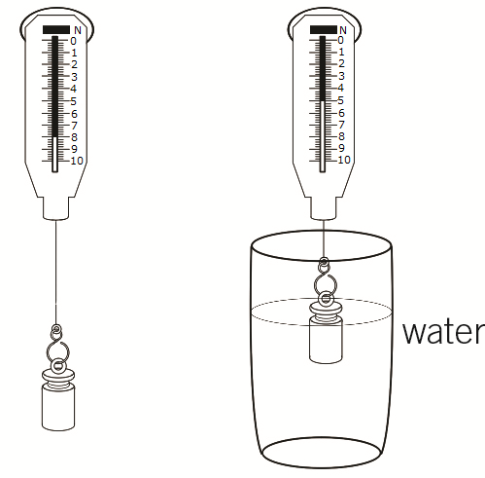
a State the weight of the object in the air.

(1 mark)
b Calculate the upthrust acting on the weight when it is in the water.

(2 marks)

- A student investigated how the area of a parachute affected how fast it fell. Their results are shown in the table.

Area of parachute (cm²) | Time to fall (s)
100 | 1.3
200 | 1.5
400 | 1.8
600 | 2.1
a State the independent variable.

(1 mark)
b State the dependent variable.

(1 mark)

c Plot a graph of the results.
(3 marks)
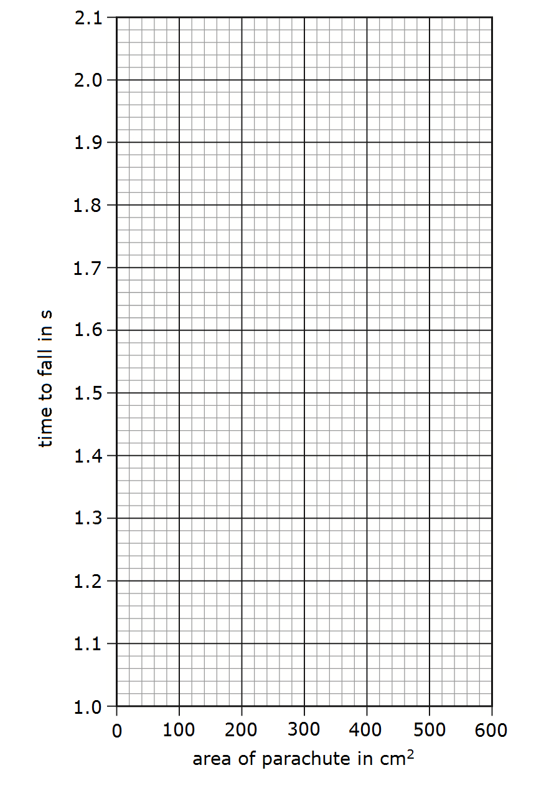
- A snowboarder and her snowboard have a weight of 600 N. The snowboard is 140 cm long and 20 cm wide.

a Calculate the area of the snowboard

= cm²
(1 mark)
b Calculate the stress on the snow when the snowboarder stands on the board.

(2 marks)

- The picture shows a duck in a bath.
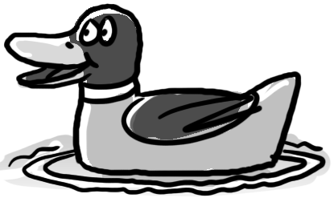
A student says there is no force acting on the duck because it is not moving. Is the student correct? Explain your answer.

- marks)

- The diagram shows the hydraulic braking system in a car.

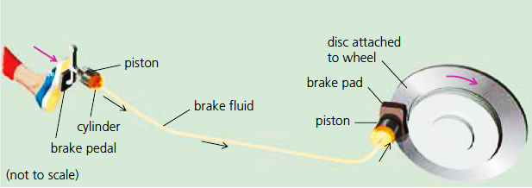
Explain how the hydraulic braking system in a car acts as a force multiplier and why if the system leaked fluid it would not work.
Start by considering the pressure on the liquid caused by the car driver pressing their foot on the brake pedal. You should include calculations in your answer.

Brake pedal piston | Brake pad piston
Force on pedal = 20 N | Area = 500 cm²
Area = 10 cm²

(6 marks)
- A gardener is trying to remove a tree stump.
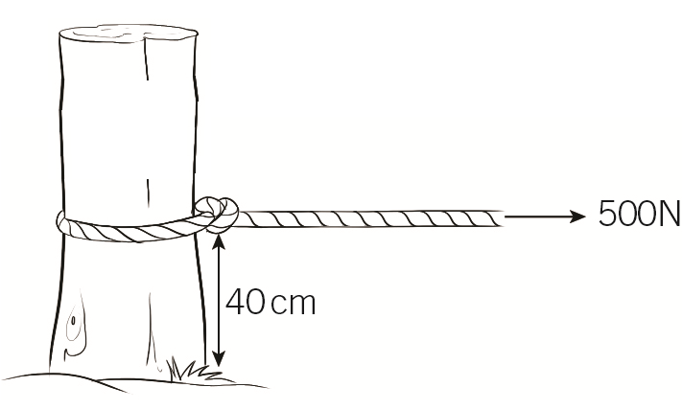
The gardener ties a rope around the tree stump 40 cm above the ground and pulls with a force of 500 N.

a Calculate the moment in Nm.

(2 marks)
The tree is just starting to move but the gardener is struggling to keep pulling with this force. She moves the rope to 80 cm above the ground and keeps the same moment.

b Calculate the new pulling force.

(2 marks)

7. An electromagnet consists of a solenoid and an iron core.
a Draw the magnetic field around a solenoid when a current flows through it.

(1 mark)
b Label the diagram to show where the field is strongest.
(1 mark)
c Describe and explain how the force on a magnetic material changes with distance from the solenoid.
……………………………………………………………………………………………………………………………………
……………………………………………………………………………………………………………………………………
(2 marks)

8. The diagram shows the design of a doorbell.
The homeowner feels the doorbell is too quiet.

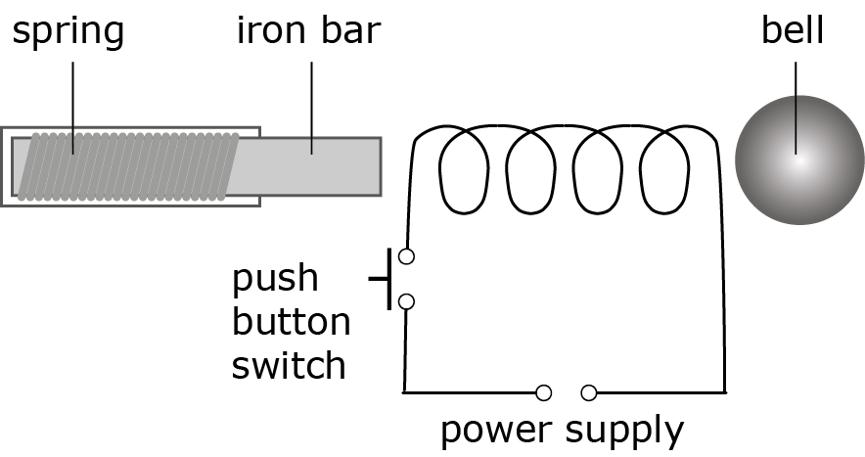

a Describe how the bell works.
……………………………………………………………………………………………………………………………………
……………………………………………………………………………………………………………………………………
……………………………………………………………………………………………………………………………………
……………………………………………………………………………………………………………………………………
(4 marks)
b Describe two changes that could be made to make the doorbell louder.
……………………………………………………………………………………………………………………………………
…………………………………………………………………………………………………………………………………… (2 marks)
9. Describe how you would investigate how the number of coils affects the strength of an electromagnet, using this equipment:
iron core; wire; power supply; paper clips (small, medium, or large)
Your answer should include:
- a method
- how you control the variables
- whether you should repeat
- whether you should use small, medium, or large paper clips
- safety advice.
………………………………………………………………………………………………………………………………………
………………………………………………………………………………………………………………………………………
………………………………………………………………………………………………………………………………………
………………………………………………………………………………………………………………………………………
………………………………………………………………………………………………………………………………………
………………………………………………………………………………………………………………………………………
………………………………………………………………………………………………………………………………………
………………………………………………………………………………………………………………………………………
………………………………………………………………………………………………………………………………………
………………………………………………………………………………………………………………………………………
(6 marks)

10 The diagram shows a toy called floating magnets. Magnet B is pushed down and then released.

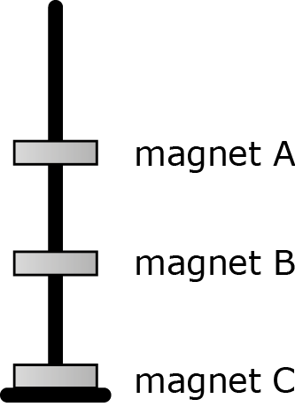

a Describe the motion of magnet B after it is released.
………………………………………………………………………………………………………………………………
………………………………………………………………………………………………………………………………
(2 marks)
b Describe the motion of magnet A when:
i magnet B is pressed down
…………………………………………………………………………………………………………………………
(1 mark)
ii magnet B is released.
…………………………………………………………………………………………………………………………
…………………………………………………………………………………………………………………………
(2 marks)
c Suggest what would happen if a fourth repelling magnet was added on top.
………………………………………………………………………………………………………………………………
………………………………………………………………………………………………………………………………
(1 mark)

 | Chemistry  Department
YEAR 8 CHEMISTRY
5.3 and 5.4
(Big Idea: Matter)
(45 minutes)
Name:
Teacher:
Score: | / 40

Grade | 4- | 4 | 4+ | 5- | 5 | 5+ | 6- | 6 | 6+ | 7- | 7 | 7+
Marks | 14 | 16 | 18 | 20 | 22 | 24 | 26 | 28 | 30 | 32 | 34 | 36

Teacher evaluation | Student evaluation
www: | www:
ebi: | ebi:

1a Plot the data from the table on the graph below.
Remember to add labels for the axes and choose a sensible scale. (4 marks)

Element | Melting point (°C)
Lithium | 180
Sodium | 98
Potassium
Rubidium | 39
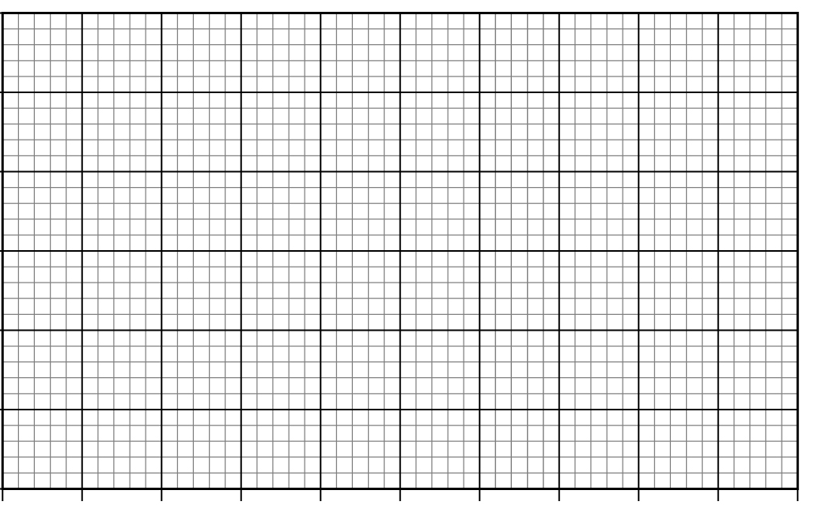
b Describe the trend shown by the graph by completing the sentence below.
As you move down Group 1 the melting point .
(1 mark)
c Use the graph to estimate the melting point of potassium.
(1 mark)

2 Complete the names and proportions of each of the elements in the table.
Chemical formula | Elements and their relative proportions
ZnCO₃
MgO
CO₂
Al(NO₃)₃
(4 marks)
3 a Describe the chemical reactions of Group 1 and Group 7 elements.
Your answer should include:
- examples of word equations for a specific Group 1 element
- the reaction between a Group 7 element and iron
- word equations for any reactions you describe. (6 marks)
In this question you get marks for how well your answer is written.
You will get marks for:
- spelling
- grammar
- organising your ideas and information clearly
- using key scientific words.

b Compare the trends in reactivity between Group 1 and Group 7.

(2 marks)

c i State what is meant by the term “displacement reaction”.

(2 marks)

ii Select the reactions where a displacement reaction will take place.
fluorine + potassium chloride
bromine + sodium iodide
chlorine + sodium fluoride
iodine + potassium chloride
(2 marks)
4a Determine the name for each chemical formula and then draw a particle diagram to represent it. The first one has been completed for you.

Chemical formula | Name | Particle diagram
O₂ | Oxygen | 
NO₂
SO₃
CO
H₂O
(8 marks)
b Identify which of the substances from the table is an element.

(1 mark)
c Explain why a poly(ethene) has a much higher melting point than any of the substances in the table.

(1 mark)

5 Use the diagram below to answer the questions that follow. The letters may be used one, more than once or not at all.

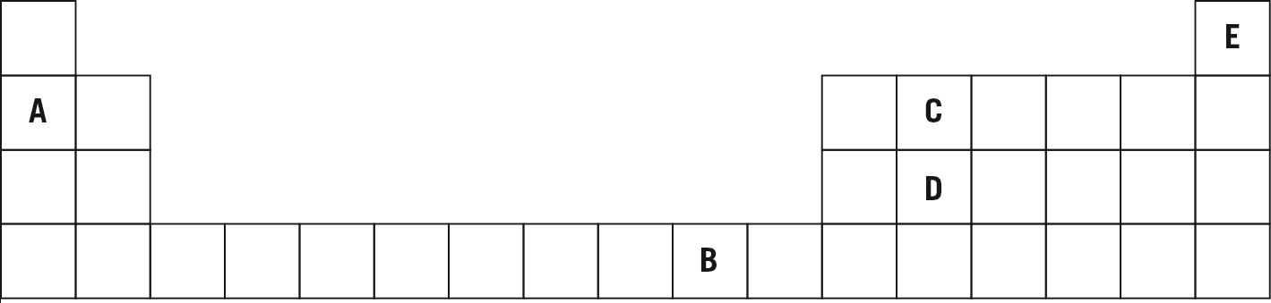

a Element C has a very high melting point and is a solid at room temperature.
Give the letters of the other element(s) that are likely to have these properties and explain your answer.

(2 marks)
b Give the letter of the element you would you use if you needed an electrical conductor to use in wiring.

(1 mark)
c Give the letter of the element you would use to fill a hot air balloon.

(1 mark)
6 This table shows the boiling points of the Group 0 elements.

Element | Boiling point (°C)
helium | –269
neon | –246
argon
krypton | –152
xenon | –108

a Predict the position of an unreactive element with a boiling point of –109°C.

(2 marks)
b Estimate the boiling point for argon

(2 marks)

Biology
Department
GCSE BIOLOGY
B13: Reproduction
(Big Idea: Organisms)
(50 minutes)
Name: | ……………………………………………………………………………………...
Teacher: | ……………………………………………………………………………………...
Score: | ………… / 43

Grade | 9 | 8 | 7 | 6 | 5 | 4 | U
Marks | 33 | 31 | 26 | 22 | 20 | 16 | <15

Teacher evaluation | Student evaluation
www | www
ebi | ebi

Q1.In sexual reproduction, an egg fuses with a sperm.
(a) (i) Draw a ring around the correct answer to complete the sentence.

 | An egg and a sperm fuse together in the process of | cloning.  fertilisation.  mitosis.

(1)

(ii) Egg cells and sperm cells each contain the structures given in the box.

 | chromosome | gene | nucleus

List these three structures in size order, starting with the smallest.
1 .......................................................... (smallest)
2 ..........................................................
3 .......................................................... (largest)
(2)

(iii) The egg and the sperm contain genetic material.
Draw a ring around the correct answer to complete the sentence.

 | The genetic material is made of | carbohydrate.  DNA.  protein.

(1)

(b) The diagram below shows the inheritance of X and Y chromosomes.
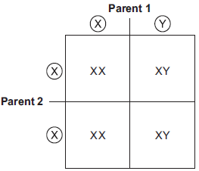

(i) Draw a tick () on the part of the diagram that shows a sperm cell.
(1)

(ii) What is the chance of having a female child?
Give the reason for your answer.
...............................................................................................................
...............................................................................................................
...............................................................................................................
...............................................................................................................
(2)
(Total 7 marks)

Q2.The diagram shows some of the cell divisions that occur during human reproduction.
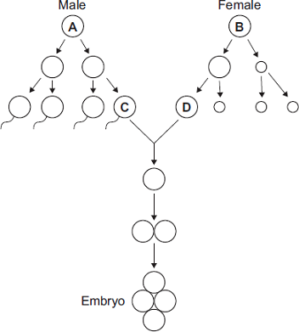
(a) (i) Name the type of cell division that produces cell D from cell B.
...............................................................................................................
(1)

(ii) Which organ in the male body produces cell C from cell A?
...............................................................................................................
(1)

(b) (i) Cells A and B each contain 46 chromosomes.
How many chromosomes would there be in the nucleus of cell C? 
(1)

(ii) Why is it important that cell C has this number of chromosomes?
...............................................................................................................
...............................................................................................................
...............................................................................................................
...............................................................................................................
(2)
(Total 5 marks)

Q3. A child saved apple seeds from an apple she ate. She planted the seeds in the garden. A few years later the apple trees she had grown produced apples.
(a) The apples from the new trees did not taste like the original apple.
Explain why.
........................................................................................................................
........................................................................................................................
........................................................................................................................
........................................................................................................................
........................................................................................................................
(2)

(b) (i) Apple trees can be reproduced so that the apples from the new trees will taste the same as the apples from the parent trees.
Give one method used to reproduce apple trees in this way.
...............................................................................................................
...............................................................................................................
(1)

(ii) Explain why the method you have suggested in part (b)(i) will produce apples that taste the same as the apples from the parent trees.
...............................................................................................................
...............................................................................................................
...............................................................................................................
...............................................................................................................(2)
(Total 5 marks)

Q4.Figure 1 shows an image of a small section of DNA.
Figure 2 shows the structure of a small section of DNA.
Figure 1 Figure 2
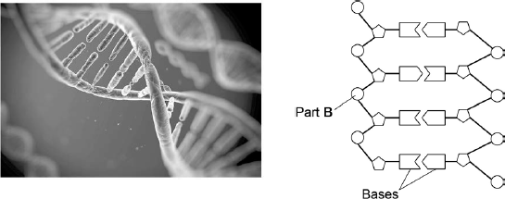
© Svisio/iStock/Thinkstock
(a) What is Part B?
........................................................................................................................
........................................................................................................................
(1)

(b) In Figure 1 the structure of DNA shows four different bases.
There are four different bases and they always pair up in the same pairs.
Which bases pair up together?
........................................................................................................................
(1)

(c) Syndrome H is an inherited condition.
People with syndrome H do not produce the enzyme IDUA.
Figure 3 shows part of the gene coding for the enzyme IDUA.
Figure 3
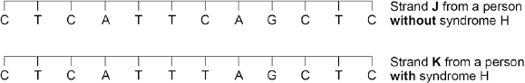
Strand K shows a mutation in the DNA which has caused syndrome H.
The enzyme IDUA helps to break down a carbohydrate in the human body.
The enzyme IDUA produced from Strand K will not work.
Explain how the mutation could cause the enzyme not to work.
........................................................................................................................
........................................................................................................................
........................................................................................................................
........................................................................................................................
........................................................................................................................
........................................................................................................................
........................................................................................................................
........................................................................................................................
........................................................................................................................
........................................................................................................................
(5)

(d) A recessive allele causes syndrome H.
A heterozygous woman and a homozygous recessive man want to have a child.
Draw a Punnett square diagram to determine the probability of the child having syndrome H.
Identify any children with syndrome H.
Use the following symbols:
A = dominant allele
a = recessive allele
Probability = ..................................... %
(5)
(Total 12 marks)

Q5.DNA is the genetic material of human cells.
Figure 1 shows the structure of part of a DNA molecule.
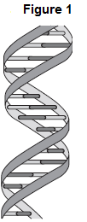
(a) (i) Describe where DNA is found in a human cell.
...............................................................................................................
...............................................................................................................
...............................................................................................................
(2)
(ii) When a cell divides by mitosis the new cells are genetically identical.
What causes the cells to be genetically identical?
...............................................................................................................
...............................................................................................................(1)

(b) Many genes have different forms called alleles.
(i) A person has polydactyly (extra fingers or toes). Polydactyly is caused by a dominant allele.
What is the smallest number of copies of the dominant allele for polydactyly that could be found in a body cell of this person?
............................
(1)
(ii) Another person has cystic fibrosis. Cystic fibrosis (CF) is caused by a recessive allele.
How many copies of the recessive CF allele are there in a body cell of this person?
............................
(1)

(c) A burglar broke into a house. The burglar cut his hand on some broken glass. Scientists extracted DNA from the blood on the broken glass.
The scientists analysed the DNA from the glass and DNA from three suspects, A, B and C. The scientists used a method called DNA fingerprinting.
Figure 2 shows the scientists’ results.
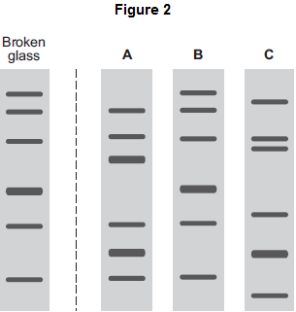
Which suspect, A, B or C, is most likely to have been the burglar?
Tick () one box.

 | A | 
 | B
 | C

(1)
(Total 6 marks)

Q6.Genetic disorder E is a condition caused by a change in the chromosomes.
(a) Figure 1 shows the chromosomes from one cell of a person with genetic disorder E.
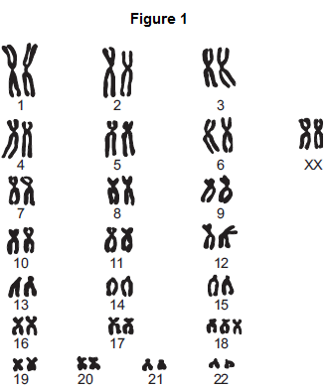
(i) How do you know this person is female?
Use information from Figure 1.
...............................................................................................................
...............................................................................................................
(1)
(ii) Describe how the chromosomes shown in Figure 1 are different from the chromosomes from a person who does not have genetic disorder E.
...............................................................................................................
...............................................................................................................
...............................................................................................................
...............................................................................................................
(2)

(b) As a woman gets older, the chance of her having a baby with genetic disorder E increases.
Figure 2 shows this.
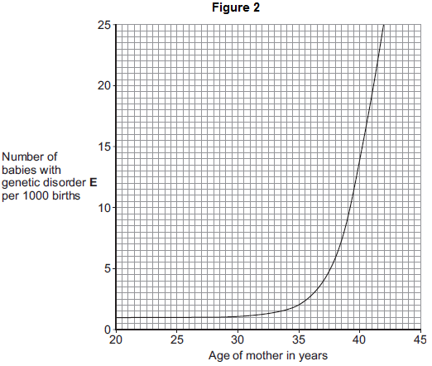
(i) The chance of a 35-year-old woman having a baby with genetic disorder E is 2 per 1000 births.
What is the chance of a 40-year-old woman having a baby with genetic disorder E?
.......................... per 1000 births
(1)
(ii) A 40-year-old woman is more likely than a 35-year-old woman to have a baby with genetic disorder E.
How many times more likely?
.......................................... times
(1)

(c) A 41-year-old woman wants to have a baby. A 41-year-old woman has an increased chance of having a baby with genetic disorder E.
Doctors can screen embryos for genetic disorder E.
The table gives some information about two methods of embryo screening.

 | Method 1 | Method 2
 | 1. The woman is given hormones to  cause the release of a few eggs.  The eggs are taken from her body in  a minor operation.  The eggs are fertilised in a glass  dish. | 1. The woman gets pregnant in the  normal way.
 | 2. One cell is taken from each embryo  when the embryo is 3 days old. | 2. Cells are taken when the embryo is  10 weeks old.
 | 3. Cells are screened for genetic  disorder E. | 3. Cells are screened for genetic  disorder E.
 | 4. An unaffected embryo is placed in  the woman’s uterus.  Embryos that are not used are  destroyed or used in medical  research. | 4. An unaffected fetus is allowed to  develop.  If the fetus has genetic disorder  E, the woman can choose to have  an abortion.
 | 5. This method costs about £6000. | 5. This method costs about £600.

Use information from the table to give two advantages and one disadvantage of Method 1 compared with Method 2 for detecting genetic disorder E.
Advantages of Method 1:
1......................................................................................................................
........................................................................................................................
2......................................................................................................................
........................................................................................................................
Disadvantage of Method 1:
........................................................................................................................
........................................................................................................................
(3)
(Total 8 marks)

