

Curriculum and Progression Overview
Psychology
Plymouth High School for Girls

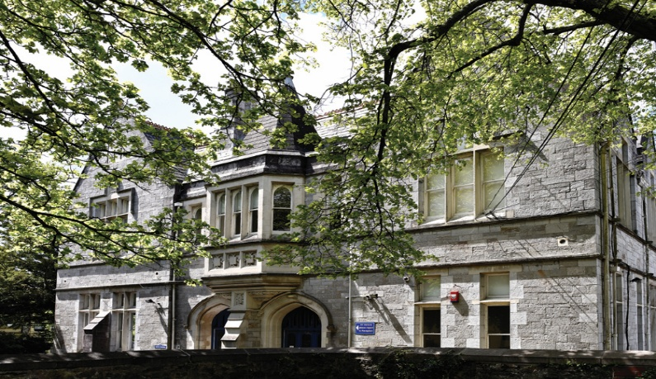

contents
- The Curriculum
  - Intent
  - Implementation
  - Impact
- Curriculum and assessment overview (KS5)
- Feedback and Assessment system

Curriculum

Psychology is fundamentally about the students, their friends and family and the people they will meet in the future. Understanding others is essential in life, and in that respect, we are all natural psychologists as we seek to explain our own and others behaviour in everything we do. Psychology A-level introduces a range of research methods that allow for objective, carefully balanced investigations of the reasons underlying behaviour. It removes many of the myths surrounding the subject and brings scientific rigour to the now complex understandings of human behaviour and emotion.

Intent
Psychology A-level at PHSG is delivered with research methods at its heart. The scientific forms of measurement and investigation of behaviour run concurrently through all of the different topics set out in the AQA A syllabus. Independent research methods lessons are carried out biweekly so that students can continue to apply the huge range of new concepts that they acquire in the first few weeks of teaching. An important assessment objective in the A- level is discussion and evaluation (A03) and unlike many of the other science A-levels all research and theory is critiqued as the students progress through each topic.
Thinking skills are incorporated wherever they fit the syllabus to benefit this critical thinking. For example: bubble maps are used to aid comparison between similar theories explaining the maintenance of relationships in year 2. This critical thinking is not only important within the subject but essential to life after psychology and is central to A-level Psychology right from the outset at PHSG.
At all stages, the use of collaborative learning encourages students to reason logically and creatively through discussion, ideas and concepts. Misconceptions and wrong answers are an opportunity to improve and deepen understanding of concepts, through use of effective questioning and discussion. Psychology A-level aims to:
- To develop a positive attitude to psychology as an interesting and exciting subject in which all students gain success and enjoyment
- To develop psychological understanding through systematic direct teaching of appropriate learning objectives
- To develop an ability in students to express themselves fluently, to talk about the subject with confidence, using correct psychological terminology and vocabulary
- To develop and make connections across topics in Psychology.
- To develop the ability to think clearly and logically with independence of thought and flexibility of mind
- To develop psychological skills and knowledge and a quick recall of basic facts.
- Use Thinking skills and strategies to improve retention and critical thinking within the A-level.

Implementation
The AQA scheme of work is followed through five topics in year 1 so that the linear AS can be taken by students if need be. The course begins with the Memory module looking at memory experiments in detail with a specific application of research methods to these classic studies.
Content is delivered via a range of methods including presentation, group work and practical research methods experiments. Special early focus is made on the written skills needed within the AS assessment looking at fully elaborated A03 writing, less is more and big picture answers using living graphs and exemplar material. Retrieval and salient slides are used to test student’s knowledge from previous lessons and condense down information from that lesson to reduce cognitive load.
The social psychology section follows on in this vein, focusing on the classic studies of conformity, obedience and social change. Heavy criticism is made of the research methods within them that undermine their perhaps overly renowned status. Attachment is the third topic covered including a sensitive look at attachment types and the consequences for future relationships from poor early experience. Topics in this area are obviously difficult to research practically but the topic is reinforced by a visit to the baby lab at the Plymouth University open day each year to look at contemporary methods of research on children (COVID permitting). Psychopathology and the approaches in psychology are taught concurrently because of the similarity in content. Careful planning for the sensitive nature of the mental health topics are made because of students with specific needs. Thinking skills are utilised throughout AS where they fit the content being studied for example, flow maps help students sequentially understand the progression of the stages of attachment from 0-18months in Schaffer and Emerson’s famous research.
At A2 the content heavy topics of issues and debates, relationships, forensic psychology, biopsychology and schizophrenia all follow on in the same vain, with applied research and intriguing material at the heart of delivery. Students build on their written skills working on longer 16 mark answers with a focus on A03 and continue to hone their exam skills in preparation for the mock exams in April.

Inclusion
The Psychology curriculum is designed to be inclusive, ensuring that all students, regardless of background, need or starting point, can access, engage with and succeed in the subject. We sequence learning to build confidence and competence through practica research methods from the first lesson, then biweekly alongside theoretical content.
We support inclusion by:
- Providing scaffolded tasks and modelled examples to support all learners
- Using adaptive teaching strategies to meet a range of needs, including SEND and disadvantaged students
- Offering structured practical experiences that allow all students to develop skills at an appropriate pace
- Incorporating visual aids, demonstrations and step-by-step guidance to reduce cognitive load
- Creating opportunities for collaborative work, enabling peer support and shared problem-solving
- Ensuring all students experience success through clear success criteria and regular feedback
Our aim is to develop confident, independent learners who can use their skills in a supportive environment.
Universal Offer

Our universal offer in A-level Psychology ensures that every student benefits from a high-quality, ambitious curriculum that develops academic success, problem-solving and research methods skills.
All students experience:
- A broad and balanced curriculum across the core topics in Psychology.
- Explicit teaching of research methods skills that underpin all psychological research (bar Freud!) and subject-specific vocabulary
- Access to high-quality resources, and contemporary ways of measuring brain and behaviour.
- A focus on real-world applications, linking learning to everything about them and the people they will meet over their lifetimes.
- Development of key skills including critical thinking that is central to the A03 content of the course.
Through this universal provision, students are equipped with the knowledge and skills to progress to further study and future careers
In Psychology.
Impact
In Psychology, as in other curricular areas, assessment forms an integral part of learning and teaching. It is the gathering of evidence of both attainment and progression for the purpose of informing future planning, teaching and reporting. Student voice information is collected from student surveys and Psychology Captains who act as a conduit for feedback to inform teaching and learning. End of topic assessments reinforce and assess skills to allow all to understand how to improve in their learning. Planning is reflexive to allow for the needs of students and benefitted by the following strategies:

- To share learning objectives and success criteria clearly with students
- To assess understanding through skilful questioning within lessons
- To give students clear and regular feedback in both verbal and written form
- To assist learners and teachers to identify the next steps in the learning process which will ensure progression
- To engage in the process of self and peer assessment

At the end of each year we discuss what went well with the SOL and what needs to be improved and act upon them.

Feedback and assessment systems: Psychology Feedback Sheet
Mark: /
Target:
Name:__________________________________________________
Assessment:_____________________________________________________________________________________________________
Skill | AO1: Knowledge | AO2: Application | AO3: Evaluation | Structure
Level 4 | Knowledge is accurate and generally well detailed | Appropriate application and links made between research and question stem | Evaluations are effective. | Clear, coherent and focussed on the question. Effective use of specialist terminology
Level 3 | Knowledge is evident. There may be occasional inaccuracies | Appropriate application but links to stem not always explained | Evaluation is mostly effective | Answer is mostly clear and organised but lacks focus in places. Specialist terminology mostly used.
Level 2 | Knowledge is vague and/or inaccurate. Or partial answer to question*  Answer is mainly description focused | Only partial application to the stem is seen. | Evaluations present are apparent but have limited effectiveness | Answer lacks clarity , accuracy and organisation in places. Specialist terminology used on occasion
Level 1 | Knowledge is limited and/or partial answer to the question. | Application is limited or absent | Evaluation is very limited, poorly focussed or absent | Whole answer lacks clarity, accuracy and organisation.  Specialist terminology used inappropriately or is absent from the answer.

*e.g where questions states ‘discuss 2 ways’ and only answers one
WWW:

EBI:


CURRICULUM & ASSESSMENT OVERVIEW: KS 5 PSYCHOLOGY
 | Autumn 1 | Autumn 2 | Spring 1 | Spring 2 | Summer 1 | Summer 2
KEY STAGE 5- Exam Board AQA A
Year 12 | Topic(s):  Memory  Assessment:  End of topic test: exam conditions: Memory past paper | Topic(s):  Social  Assessment:  End of topic test: exam conditions: Social past paper | Topic(s):  Attachment  Assessment:  End of topic test: exam conditions: Attachment past paper | Topic(s):  Approaches/Psychopathology  Assessment:  End of topic test: exam conditions: Memory past paper | Topic(s):  Biopsychology/Research Methods  Assessment:  End of topic test: exam conditions: Biopsychology/Research Methods | Topic(s):  Forensics  MOCK EXAM (OR Paper 1/2 mock exam
Year 13 | Topic(s):  Schizophrenia  Assessment:  Jan: Paper 1 A level mock exam  November: End of topic test: exam conditions: Issues and debates | Topic(s):  Relationships  Assessment:  End of topic test: exam conditions: Relationships | Topic(s):  Biopsychology  Assessment:  Mock exams | Topic(s):  Issues and debates  Assessment:  End of topic test: exam conditions: Issues and debates | Topic(s):  Issues and debates  Assessment:  End of topic test: exam conditions: Issues and debates  Revision | AL EXAMS

