

Curriculum and Progression Overview
PE
Plymouth High School for Girls

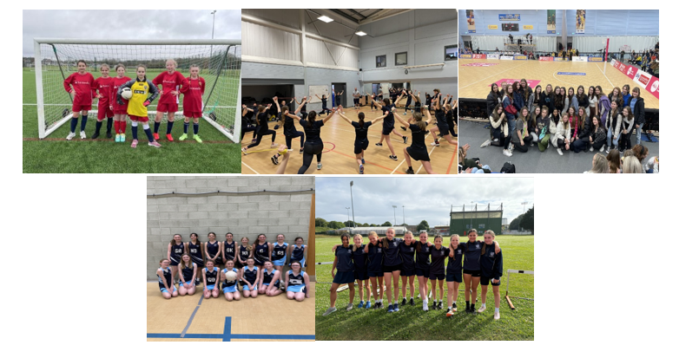
contents
- The Curriculum
  - Universal offer & Inclusion
  - Intent
  - Implementation
  - Impact
- Curriculum and assessment overview (KS3-5)
- KS 3 Progression ladder
- Feedback and Assessment system

Intent
Our physical Education Curriculum at PHSG follows the purpose and aims of:
Inspiring all pupils to succeed and excel in competitive sport and other physically demanding activities. It provides opportunities for pupils to become physically confident in a way which supports their health & fitness and promotes sport for all.
In KS3 students experience a broad range of activities whilst in KS4 they opt into activity streams that suit their interest and hopefully inspire them to develop a lifelong passion for physical activity.
There are opportunities to build character and resilience and help to embed values such as fairness and respect. We also provide opportunities throughout the years to develop leadership, team work and interpersonal skills that students can apply to all aspects of their lives. We aim to encourage our students to not only improve physically but think strategically and tactically in competitive situations.

Implementation
- Pupils develop competence to excel in a broad range of physical activities.
We deliver a broad range of activities from Year 7 to 11, including:
- Invasion games (netball, basketball & football)
- Net/wall games (volleyball, badminton)
- Striking and fielding games (rounders & cricket)
- Athletic activities (athletics, HRF)
- Creative Activities (gymnastics, dance, trampolining)
- Outdoor and adventurous activities (orienteering, climbing)
- Reflective skills using maps and hats to improve

- Pupils are physically active for sustained periods of time.
All students from Year 7 to 9 take part in 2 hours of high quality physical activity per week through timetabled lessons. Year 10 & 11 take part in 3 hours over 2 weeks. On average, 50% of our students take part in our extra-curricular programme on top of their timetabled lessons.

- Pupils have the opportunity to gain academic qualification in order to enhance future careers.
We offer GCSE PE and A Level PE to all students. The activities covered in KS3 allow for progression at GCSE PE as they are then assessed in Netball, Trampolining, Climbing, Athletics and Badminton for their GCSE practical. Theory elements of the GCSE course are introduced in KS3 practical lesson to enhance learning through retrieval and therefore improve memory retention at KS4.

- Pupils engage in competitive sports and activities
In year 7, 8 and 9 all students take part in activities that are competitive. In years 10 to 11, depending on the option blocks they choose, they will experience an opportunity to take part in team sports or OAA
All students including 6th form take part in Sports Day and the indoor Rowing competition which is competing to earn points for their House. Most students take part in other sporting house events which include netball, rounders, dodgeball, swimming, gym and dance.
We have several sports teams which compete against other schools, either locally, regionally and sometimes nationally; providing opportunities to experience organised competitions and events.

We have a Netball coach from Musketeers who comes in to run our netball clubs.

- Pupils lead healthy, active lifestyles
This is at the heart of everything we teach and it drives our KS4 curriculum. We offer activities that students enjoy, and can see themselves continuing in the future so that they are more likely to lead active, healthy lifestyles.
All students are encouraged to take part in sport and physical activity beyond the curricular and extra-curricular programme by giving them the skills and confidence within lesson and by promoting our links to local clubs.

- Student Sports Council

Each year students can apply to be a part of the sports council. The sports council meet every 2 weeks to discuss any up-and-coming events including the running of all inter-house competitions for year 7 to year 13. They are also in charge of checking equipment, updating notice boards, helping with festivals, doing sports write ups for the school website and representing the student voice across the school.

The National Curriculum is taught in Year 7,8 and 9, however if there are overlaps or opportunities to stretch and challenge students by introducing elements from the GCSE specifications, these may be taken. GCSE Option subjects are chosen during Year 9.

Universal offer and Inclusion in ….
KS 3&4 Core PE
All students access a broad, inclusive PE curriculum that develops physical literacy, confidence and lifelong participation.
Teaching & Learning
- Clear modelling of skills and techniques with step-by-step breakdown
- Use of demonstrations and peer modelling
- Opportunities for practice, repetition and refinement
- Explicit teaching of rules, tactics and strategies
- Emphasis on participation, enjoyment and personal progress
Inclusion in Lessons
- Differentiated tasks through adapted rules, equipment and role
- Choice within activities to support engagement and confidence
- Focus on personal best rather than comparison with others
Assessment & Feedback
- Ongoing formative feedback during practical lessons
- Use of self and peer assessment
- Recognition of effort, teamwork and improvement
- End term knowledge quizzes
- End of year knowledge exams
Adaptive Teaching
- Modified equipment (e.g. larger balls, lowered nets)
- Adjusted space and intensity
- Scaffolded skill development
- Flexible grouping to build confidence
Support for Specific Needs
- SEND:
  - Clear routines and instructions
  - Reduced complexity of tasks
  - Additional adult or peer support
- EAL:
  - Demonstration-led learning
  - Visual cues and simplified language
- Disadvantaged:
  - Full access to kit support where needed
  - Encouragement of extracurricular participation
Targeted Intervention
- Small group support for key skills
- Confidence-building activities
- Alternative roles (e.g. officiating, coaching) where appropriate
Equality of Access
All students will:
- Participate in a wide range of activities
- Develop physical competence and confidence
- Experience success regardless of ability

GCSE PE
Theory
- Explicit teaching of key terminology (e.g. aerobic/anaerobic, levers, planes and axes)
- Use of dual coding, diagrams and videos for complex concepts
- Retrieval practice and interleaving of topics
- Structured exam practice using AQA command words
Practical
- Development across three assessed activities
- Clear modelling and progressive skill development
- Regular feedback aligned to AQA moderation criteria
Literacy Support
- Key word glossaries
- Structured writing frames (e.g. extended responses)
- Modelling of high-mark answers
- Booklets
Adaptive Teaching
- Chunking of complex theory (e.g. cardiovascular system)
- Scaffolded exam questions
- Visual and practical examples to support understanding
- Flexible practical pathways based on strengths
Support for Specific Needs
- SEND:
  - Reduced cognitive load
  - Scaffolded exam responses
  - Adapted activities for assessment access
- EAL:
  - Vocabulary pre-teaching
  - Sentence starters for written responses
- Disadvantaged:
  - Access to revision materials and guided practice
  - Support with practical participation and kit
Targeted Intervention
- Small group revision (theory gaps)
- Exam technique sessions
- Practical skill clinics
- Moderation-focused feedback
Stretch & Challenge
- Application of theory to sporting scenarios
- Analysis and evaluation questions (6–9 markers)
- Exposure to complex physiological and biomechanical concepts

A – Level PE
Teaching & Learning
- Explicit teaching of complex content (e.g. energy systems, biomechanics, sport psychology, socio-cultural factors)
- Use of models, diagrams, and applied examples
- Retrieval and synoptic linking across topics
- Regular essay practice (extended 15-mark responses)
Literacy & Academic Skills
- Structured essay frameworks
- Command word focus (analyse, evaluate, discuss)
- Modelling of high-level responses
Adaptive Teaching
- Chunking of complex theory (e.g. cardiac cycle, memory models)
- Scaffolded essay planning
- Use of case studies and real sporting contexts
- Targeted questioning to deepen understanding
Support for Specific Needs
- SEND:
  - Structured notes and guided essays
  - Booklets
  - Additional processing time
  - Scaffolded tasks
- EAL:
  - Academic vocabulary support
  - Booklets
  - Writing frames for essays
- Disadvantaged:
  - Access to revision resources and structured support
  - Booklets
  - Guided independent study
Targeted Intervention
- 1:1 or small group academic support
- Essay writing workshops
- Exam technique and timing practice
- Retrieval-based revision sessions
Stretch & Challenge
- Engagement with current issues in sport
- Critical evaluation of theories
- Independent research tasks
- Development of synoptic answers across paper areas
Equality of Access
All students will:
- Access a rigorous and ambitious curriculum
- Develop analytical and evaluative skills
- Be supported to succeed in both theoretical and practical components

Impact
To ensure or curriculum is fit for purpose, a quality assurance programme is implemented through the year and the HOD uses a number of indicators such as:
- Students being able to verbalise and explain areas of improvement.
- Student involvement and enthusiasm in PE lessons.
- Student feedback (gathered verbally and through year group questionnaires)
- Happiness and well-being of students.
- Student involvement in extra-curricular activities.
- Lesson observations to assess the quality of teaching and learning.
- Uptake of GCSE and A Level PE (both of which has increased over the last 4 years) and exam outcomes.
- Work scrutiny to assess progress and quality of student reflection and feedback from staff.
- Fitness testing results which are gathered termly for each group to monitor fitness levels.

Use of AI
As part of our ongoing commitment to innovation and improving learning outcomes, Plymouth High school for girls is exploring the use of Artificial Intelligence (AI) tools to support teaching and learning. This includes trialling AI-assisted marking tools, which can help provide timely and consistent feedback to students. Please be assured that all AI tools used are carefully selected to meet data protection standards and any use of student work is handled with care. While AI may assist in the marking process, all final assessments and feedback are reviewed by teachers to ensure accuracy and fairness. We are committed to keeping you informed and welcome any questions you may have about this approach.
Key Stage 3 Curriculum
Unit 1 | Invasion games:  Netball, Football, Handball,
Unit 2 | Net & Wall Games:  Volleyball, Badminton, Table Tennis
Unit 3 | Aestheics  Gymnastics, Dance, Trampolining
Unit 4 | Invasion games & Health related fitness
Unit 5 | Striking and Fielding  Rounders & Cricket
Unit 6 | Athletics  100m, 200m, 300m, 800m, Shot Put, Javelin, Long Jump, High Jump

Key Stage 4 & 5 Curriculum
Double and Single lessons
Invasion games: Lacrosse, Basketball, Netball
Net & Wall: Volleyball, Table Tennis, Badminton
Dance: Zumba
Dodgeball & Benchball
Striking & Fielding
OAA: Climbing

Curriculum and assessment Overview- A Level PE
A Level PE is taught with Year 12 and 13 together. We teach the 2 years on a continuous repeat so every other year, it is taught in reverse. This works well as we can teach the course as separate units.

Year 1 | Autumn 1 | Autumn 2 | Spring 1 | Spring 2 | Summer 1 | Summer 2
Physiology | Skeletal and muscular systems | Cardiovascular system | Cardiovascular and respiratory system | Diet and Nutrition | Consolidation and exam preparation | Preparation and training methods
Psychology | Skills and practice | Learning stages theories | Guidance and feedback | Individual differences | Consolidation and exam preparation | Team dynamics and goal setting
Biomechanics | Newtons laws of motion Types of force and factors affecting force | Free Body Diagrams and vertical/horizontal forces | COM, stability and lever systems | Limb kinematics, force plates and wind tunnels | Consolidation and exam preparation | Oral Preparation
Socio-Cultural | Emergence and evolution of modern sport - Pre Industrial Revolution | Post Industrial Revolution  Sport | 20th and 21st Century Sport | Global sporting events - the modern Olympic Games | Consolidation and exam preparation | Oral Preparation
NEA and internal assessments | Year 12 Initial assessment (2nd week) | Progress test of all theory topics | Year 12 start coursework. Year 13 mock exam | Progress Test of all theory topics | Year 12 mock exam  Year 13 Exam | Oral Preparation

Year 2 | Autumn 1 | Autumn 2 | Spring 1 | Spring 2 | Summer 1 | Summer 2
Physiology | Energy for Exercise | Environmental effects | Injury prevention | Injury rehabilitation | Consolidation and exam preparation | Oral Preparation
Psychology | Memory models and attribution | Self-efficacy and confidence | Leadership in sport | Stress management | Consolidation and exam preparation | Team dynamics and goal setting
Biomechanics | Linear motion  Speed/time and velocity/time graphs | Angular motion  Axes of rotation and moment of inertia | Angular momentum Fluid mechanics, air resistance and drag | Lift and the Bernoulli principle Spin and the magnus force  Revision | Consolidation and exam preparation | Oral Preparation
Socio-Cultural | Ethics and deviance - legal/ illegal drugs and doping, violence... | Commercialisation and media in sport | Routes to sporting excellence in the UK - Talent id to elite | Modern technology in sport | Consolidation and exam preparation | Oral Preparation
NEA and internal assessments | Year 12 Initial assessment (2nd week) | Progress test of all theory topics | Year 13 mock exam and oral exam | Progress Test of all theory topics | Year 12 mock exam  Year 13 Exam | Oral Preparation

Practical NEA evidence is completed and gathered by students throughout the year. It is submitted before the Christmas break of Year 2 and internally assessed. Practical moderation occurs in May of Year 2.

Year Group | Students will know | Students will be able to do
Year 7 | - Netball: The basic rules and positions.  - Gymnastics: The importance of tension and extension, the difference between counterbalance and tension, and how to create effective sequences.  - Dance: actions, dynamics and pathways.  - Athletics: The safety principles, rules, and basic techniques of running, jumping and throwing events.  - Tennis: The teaching points of forehand, backhand, volleys and serves in tennis.  - Rounders: Techniques of throwing, collecting, catching, bowling and hitting in rounders.  - OAA: the activities classes as OAA, compass directions and symbols on an orienteering map. Successfully teamwork strategies.  - Football: basic rules, positions and passing  - Badminton: Know the rules of serving and how to score a game. Know the teaching points of the serve, overhead clear, and net shot. How to identify different shots. | - Netball: Demonstrate passing, attacking, defending and shooting skills.  - Gymnastics: Perform prep skills, rolls and inverted skills and jumps on the floor and on low apparatus.  - Dance: Create and perform sequences with different uses of space and relationships (contacts). Evaluate performance of a peer and provide feedback.  - Athletics: Demonstrate running, jumping and throwing techniques in events.  - Tennis: Use a range of shots in a rally and score a game.  - Rounders: Apply the rules and basic skill needed to play a game.  - OAA: Use the school map to accurately and locate orienteering markers. Co-operate with a team to overcome challenges and develop some leadership skills.  - Football: Demonstrating attacking, defending and shooting.  Badminton: To be able to rally with a partner cooperatively and competitively using a range of shots. Play half court singles games and begin to think strategically to gain points.
Year 8 | Netball: team attacking and defending techniques in order to outwit an opponent. How to evaluate performances.  Badminton: Know the rules of serving and how to score a game. Know the teaching points of the serve, net kill, overhead clear, and net shot. How to identify different shots.  Basketball: Know the basic rule and how to do core skills; dribbling, passing and receiving, defending and shooting.  Trampolining: The safety principles of trampolining. The teaching points for all basic jumps, seat landings, twists and front landings. How to create short routines.  HRF: Know the fitness components and how to test them. The short term effects and recovery process of exercise and why pulse rate changes. How to train different fitness components with methods of training. How energy balance is affected by exercise.  Athletics:  More advanced techniques of running, jumping and throwing. How to measure and officiate events accurately. | Netball: Can replicate skills and demonstrate a sound level of tactical awareness and can respond to changing situations by changing and refining their skills and techniques. Can play a variety of positions.  Badminton: To be able to rally with a partner cooperatively and competitively using a range of shots. Play half court singles games and begin to think strategically to gain points.  Basketball: Apply core basketball skills using them tactically with the intention of outwitting their opponents. Can make decisions of when to pass, dribble or shoot.  Trampolining: Spot effectively. Perform all jumps with consistency, showing height, control and tension. Combine twists with these skills to create more complex skills.  HRF: Monitor pulse rates and recovery. Demonstrate correct technique in the different methods of training fitness. Identify what component of fitness is being enhanced through various and be able to plan training and evaluate their fitness.  Athletics:  Demonstrate these technique and evaluate their abilities in athletics events.
Year 9 | - Netball and Football: Increase their knowledge and understanding of tactics and strategies.  - Gymnastics: How to set up and use larger pieces of apparatus safely. How to perform group shapes and balances safely. Correct technique for a range of vaults.  - Badminton: How to perform the high and low serve, a drop shot, the smash, how to play a doubles game - court markings, scoring and umpiring a game.  - HRF: Yoga & Pilates activities  - Trampolining: Know the teaching points for, and how, to perform more complex trampolining moves e.g. back landing and linking moves together to make complex ones e.g. cradle, turntable.  - Basketball and Volleyball: Know how to perform a volley, serve and dig. How to perform a lay up in basketball.  - Rounders: how to bowl with variety e.g. with spin, donkey drop bowl, speed bowl. Know how to vary where they position the ball when batting and what affects their decision making and how to perform a backhand hit.  - OAA: To know how to use and read a map correctly. Know how to pace themselves. Know how to complete a full orienteering course of varying difficulty and length. | - Netball and Football: Be able to apply these effectively in their game situations and when under pressure. To take on different roles within the group e.g. umpire, coach, team captain and all positions.  - Gymnastics: Be able to create larger group sequences using apparatus and be able to perform group shapes and balances with good body tension and control.  - Badminton: Be able to perform the new shots in isolation and in a game situation. Be able to play a full doubles game, including scoring and umpiring a game without ipad assistance.  - HRF: Understand what health related activities you can take part in. Putting together routines.  - Trampolining: Be able to perform the more complex moves and link moves together into a 10 bounce routine with good body tension, extension and control on the bed and consistent height. Be able to help coach each other using the teaching points learnt.  - Basketball and Volleyball: the basketball and volleyball skills effectively in isolation but also in a game situation under pressure. Be able to help coach their peers.  - Rounders: To be able to apply their different bowling techniques. Play a variety of fielding positions and apply tactics and strategies when playing.  - OAA: Be able to complete a full orienteering course and find markers. Be able to orientate a map to know where they are at all times.
Year 10&11 core PE | Individual competitor  - How to tie in safely to a climbing rope  - Different routes for climbing on indoor walls  - The basics of a rowing stroke  - The different methods of serving and the importance of shot placement in badminton.  - The importance of mental resilience when tackling physical challenges.  Health and fitness  - The different methods of serving and the importance of shot placement in badminton.  - The rules of doubles badminton and how to score a game.  - The importance of leading a healthy active lifestyle  - The difference between cardio based equipment and resistance machines.  - The benefits of yoga and pilates  - What meditation is and how to relax.  Team games  - Tactics and strategy within team games  - The basic skills in newly introduced team games  - The more advanced skills in team games being revisited.  - The different methods for shooting  - Defensive techniques and strategies  - The rules of a variety of team games and how to umpire effectively  - The importance of communicating with others in team games  - The rules of rounders and how to officiate. | Individual competitor  - Demonstrate safe belaying and tying a figure of 8 and stopper knot.  - Choose an appropriate route to challenge their ability.  - Demonstrate a catch, drive and recovery stroke.  - Use low and high serves and demonstrate overhead clears, drop shots and net shots.  - Show willingness to give activities a try and resilience to persevere.  Health and fitness  - Apply rules and correct scoring system when playing a game of badminton.  - Use low and high serves and demonstrate overhead clears, drop shots and net shots.  - Demonstrate basic zumba moves.  - Use fitness suite equipment safely and effectively for cardio and weights.  - Complete yoga and pilates exercises safely.  Team games  - Contribute effectively to a team, applying the principles of attack and defence.  - Demonstrate a dig and volley  - Demonstrate a lay up in basketball  - Outwit an opponent using intercepting/marking skills  - Use an appropriate shooting style for the game.  - Explain the triple threat in basketball  - Explain and apply the rules of the game  - Demonstrate listening and communication skills when working with others  - Play or officiate a game of rounders using standard rules
GCSE PE  AQA | Theory  1. knowledge and understanding of the key body systems and how they impact on health, fitness and performance in physical activity and sport.  2. knowledge and understanding of the basic principles of movement and their effect on performance in physical activity and sport.  3. Knowledge and understanding of the principles of training and different training methods in order to plan, carry out, monitor and evaluate personal exercise and training programmes:  4. Knowledge and understanding of data analysis in relation to key areas of physical activity and sport.  5. Knowledge and understanding of the psychological factors that can affect performers in physical activity and sport.  6. Knowledge and understanding of the socio-cultural factors that impact on physical activity and sport, and the impact of sport on society.  7. Knowledge and understanding of the benefits of participating in physical activity and sport to health, fitness and wellbeing.  Practical:  knowledge, understanding, skills and values to develop and maintain their performance in physical activities and understand the benefits to health, fitness and wellbeing. | AO1: Demonstrate knowledge and understanding of the factors that underpin performance  and involvement in physical activity and sport.  AO2: Apply knowledge and understanding of the factors that underpin performance and  involvement in physical activity and sport.  AO3: Analyse and evaluate the factors that underpin performance and involvement in  physical activity and sport.  AO4:  - Perform effectively in different physical activities by developing skills and techniques and selecting and using tactics, strategies and/or compositional ideas in: badminton, athletics, netball, climbing and trampolining.  - Demonstrate skills in these activities in progressive practices and apply these skills into the full context.  - Analysis of their skills and fitness and evaluation of performance to bring about improvement in one activity.
A Level  AQA | Paper 1: Factors affecting participation in physical activity and sport:  What's assessed  Section A: Applied anatomy and physiology  Section B: Skill acquisition  Section C: Sport and society  Paper 2: Factors affecting optimal performance in physical activity and sport  What's assessed  Section A: Exercise physiology and biomechanics  Section B: Sport psychology  Section C: Sport and society and technology in sport | - Apply acquired knowledge and understanding to two exam papers.  - Submit evidence towards their practical grade demonstrating their ability in their chosen sport.  - Complete coursework on a chosen activity in depeth comparing to a role model/professional athlete.  Please use the link below to see specific details on each section of the course.  A-level Physical Education Specification Specification for first teaching in 2016

KS3 Progression Ladders Year 7, 8 and 9 are assessed at the end of each unit (once a half term) in line with the school assessment policy. This is using GCSE grades. We have a progress ladders for each activity covered. This is an example: 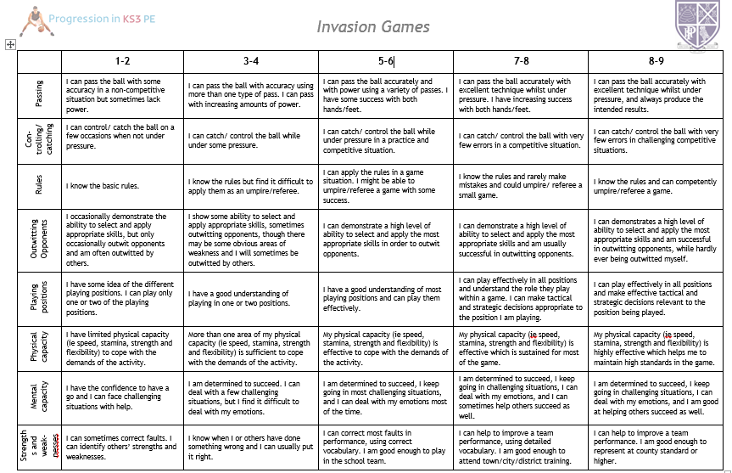
Feedback and Assessment system
Students are given feedback in the form of verbal or written feedback. We assess them in the following categories:
Skill – how the perform practically
Knowledge – understanding of knowledge of the activities, strategy, tactics and decision making
Character – how much effort students demonstrate, the support students show
Students regularly self and peer assess during lessons as well as a self-assessment which is completed in the form of an online quiz and the end of each term.
Students are encouraged to use thinking hats to help them think more deeply through retrieval and salient activities in all lessons.
Thinking strategies are used to teach GCSE & A Level to embed knowledge into long term memory.
Use of modern technology enhances the assessment opportunities. Use of an iPad to support learning.

