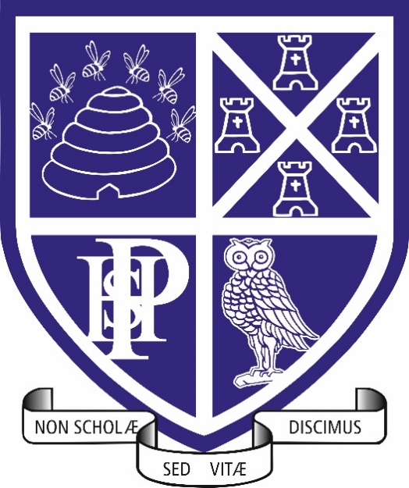
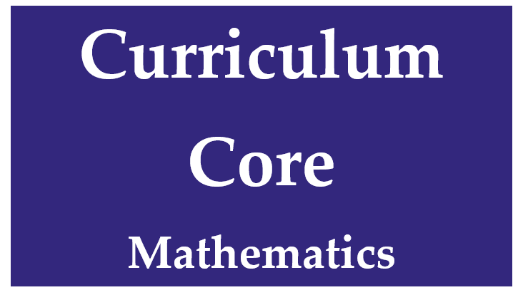
AQA Level 3 Core Mathematics
Curriculum & Assessment Overview
2026-27

Option 2A: Statistical Techniques

contents
Curriculum
Intent
Implementation
Impact
Impact
Student Voice
Feedback
Assessment Preparation
Learning Journey

Curriculum
Plymouth High School for Girls aims to be an outstanding Grammar School for the 21st century remaining true to the philosophy of the school’s motto ‘For Life Not School We Learn’.
A school which:
- Promotes a culture of high aspiration enabling personal and academic success
- Prepares students to think confidently and independently
- Provides an outstanding education for all, the key to this being high quality teaching
- Provides enjoyment, excitement and challenge for all, stimulating an enthusiasm for lifelong learning
Prepares students to become active citizens, equipped to succeed in a world of rapid change
INTENT
At Plymouth High School for Girls, Core Mathematics is designed to equip students with the confidence and competence to apply mathematical thinking in authentic real-world contexts. The AQA Level 3 Mathematical Studies qualification (Option 2A: Statistical Techniques) develops the quantitative, analytical and statistical skills required for higher education, employment and informed citizenship.
Core Mathematics develops confidence in applying mathematics to real life contexts, decision making, finance, interpretation of data and statistical reasoning.
Our Core Mathematics curriculum enables students to:
- Develop confidence in using mathematics beyond GCSE.
- Apply statistical techniques to analyse, interpret and evaluate real-life data.
- Make informed decisions using evidence, probability and risk.
- Understand personal finance including taxation, loans, mortgages and budgeting.
- Critically evaluate numerical information presented in the media and wider society.
- Use technology appropriately to model situations, analyse data and communicate conclusions.
- Strengthen the numerical and analytical skills required in subjects such as Psychology, Biology, Geography, Business, Economics and the Social Sciences.
Through our curriculum, students develop as independent thinkers who can question data, identify bias, interpret trends and make reasoned judgements based upon evidence.
Core Maths Through Three Strands
Knowledge Students develop secure knowledge of key statistical concepts, financial mathematics and mathematical terminology. They build a strong foundation of facts, formulae and methods that support future study and employment.
Application Students practise applying mathematical techniques within realistic contexts, drawing conclusions from data, interpreting statistical outputs and solving financial problems.
Evaluation Students develop higher-order thinking skills by critiquing information, identifying limitations of models, evaluating risk and communicating evidence-based conclusions.
Implementation
Our Core Mathematics curriculum is delivered through engaging, context-rich learning that demonstrates the relevance of mathematics in the modern world.
Lessons are designed to:
- Begin with retrieval practice to strengthen long-term memory.
- Explicitly connect mathematics to real-life situations.
- Develop fluency with statistical and financial techniques.
- Provide opportunities to analyse authentic datasets.
- Encourage discussion, reasoning and justification.
- Develop confidence with calculators, spreadsheets and digital tools.
- Build problem-solving skills through increasingly complex scenarios.
Students work with:
- Statistical investigations.
- Government and public datasets.
- Business and financial case studies.
- Media reports and numerical claims.
- Probability scenarios.
- Spreadsheet modelling.

Thinking, Teaching and Learning
Core Mathematics lessons incorporate:
Retrieval
Regular review of prior learning to strengthen retention.
Application
Opportunities to apply techniques in unfamiliar contexts.
Analysis
Critical examination of data, evidence and conclusions.
Communication
Students justify methods and explain conclusions using appropriate mathematical language.
Problem Solving
Extended tasks requiring students to select and apply suitable statistical techniques independently.
Independent Study
Students are supported through:
- Microsoft Teams and resources.
- Practice questions and exam-style materials.
- Independent research tasks.
- Revision resources and self-assessment opportunities.
Independent learning develops resilience, curiosity and the ability to use mathematics beyond the classroom.

Impact
The impact of the Core Mathematics curriculum is demonstrated through students who can confidently apply mathematics in meaningful situations and use evidence to support decision-making.
Students successfully:
- Interpret statistical information accurately.
- Evaluate the reliability and validity of data.
- Understand and manage personal financial decisions.
- Communicate mathematical reasoning effectively.
- Solve unfamiliar real-world problems.
- Use technology to analyse and model data.
- Demonstrate increased confidence with mathematics beyond GCSE.

Assessment
Students complete a range of assessments including:
- Retrieval and low-stakes quizzes.
- Financial modelling activities.
- Data analysis tasks.
- Formal mock examinations.
- Examination-style problem-solving assessments.
Assessment provides opportunities to demonstrate knowledge, application and evaluation skills within realistic contexts.
Preparing Students to Go Further
By the end of the course, students are equipped with the mathematical literacy, statistical understanding and critical thinking skills required to:
- Succeed in higher education.
- Access a wide range of degree pathways.
- Interpret information critically in everyday life.
- Make informed financial decisions.
- Thrive in data-rich workplaces.
Core Mathematics ensures that students leave school as confident, analytical and evidence-informed individuals who are prepared for life beyond formal education.
USE OF AI
As part of our ongoing commitment to innovation and improving learning outcomes, Plymouth High school for girls is exploring the use of Artificial Intelligence (AI) tools to support teaching and learning. This includes trialing AI-assisted marking tools, which can help provide timely and consistent feedback to students. Please be assured that all AI tools used are carefully selected to meet data protection standards and any use of student work is handled with care. While AI may assist in the marking process, all final assessments and feedback are reviewed by teachers to ensure accuracy and fairness. We are committed to keeping you informed and welcome any questions you may have about this approach.
Student Voice
Our curriculum design gives students opportunities for student lead revision ahead of formal and external assessments ensuring that students take an active role in shaping their assessment preparation journey.
Formal and informal assessment for learning strategies in every lesson ensure that all students understanding is assessed as new content is explored and teachers react appropriately so that targeted support and extension is provided for those who have indicated that this is their need.
Formal student voice via Microsoft Teams surveys is collected from all year groups to ensure that both understanding and opinions on our systems and policies for thinking, learning and assessment can be voiced.
Microsoft teams is used professionally and frequently to allow for ad hoc student voice and dialogue from student and groups of students to teachers, contributing to a curriculum which is understood, accessible and where success is achievable for all; even remotely.
Feedback
Feedback opportunities are built into every lesson following whole class checks for understanding and reviewing independent work in books in the lesson time. Students are provided with mini whiteboards, and they are used routinely in lessons for teachers to check understanding and give instant feedback.
Additional feedback is given to students:
- At least three times per year following formal assessment
- At least once per half term after a classwork review
- Instant feedback via online homework self-marking platforms

Assessment Preparation
With long term memory building a key part of the Mathematics curriculum as an integrated part of learning from year 7 upwards, our students build on their knowledge with protected time periods of revision and exam strategy focus in both year 12 and 13. Our students benefit greatly from the timings of our teaching which offers months of external examination preparation time and opportunities to consolidate through spaced learning and revision which includes opportunity for student voice requests.
Learners are always guided to specific recommendations for their assessment revision which includes (but is not limited to):
- Share point websites
- Predicted papers
- Practice papers,
- Revision lists linking to online learning and self-marking practice work, access to exam board specific resources and structured revision lessons before any assessment.

LEARNING JOURNEY Year 12
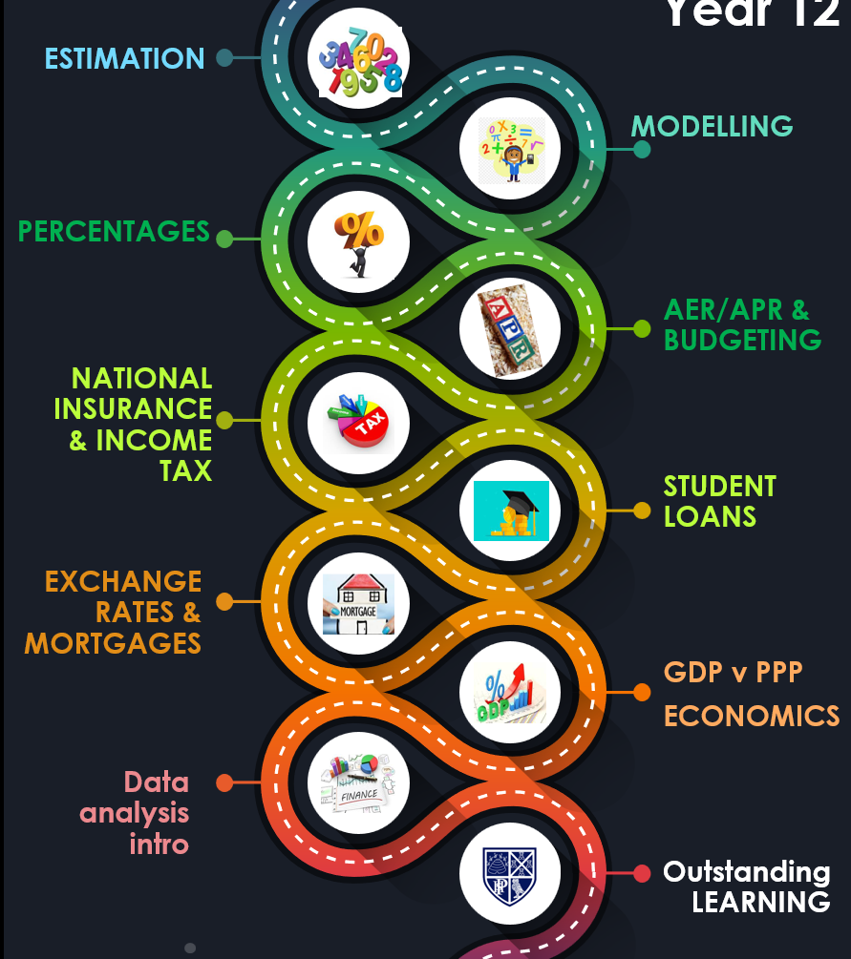

LEARNING JOURNEY Year 13


