

Curriculum
Mathematics

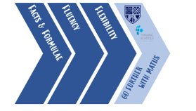

contents
Curriculum Intent for Mathematics:
  - Intent: What is our Go Further Curriculum?
  - Implementation: Thinking, Teaching and Learning in Lessons
  - Impact: Go Further Assessments
  - Impact: Independent Study
  - Student Voice
  - Feedback
  - Opportunities to Go Further
  - Assessment Preparation

Mathematics progression and content map
- What is our Go Further curriculum?
At PHSG we cover the relevant specifications for a breadth of challenging pathways. Our Go Further Curriculum ensures that our students have not only the pathways and qualifications that they will need to Go Further in their later lives but are each the very best Mathematician that they can be.

Our students acquire the aptitudes of outstanding Mathematicians by thinking and learning about Mathematics in three explicitly linked strands:

Facts and Formulae: Students will acquire knowledge and embed key Mathematical facts and formulae into long term memory. Students will have freedom of thought in their working memory, a developed vocabulary for reasoning and lower assessment anxieties because of accumulating expertise over time.

Fluency: Students will be secure with the application of learned skills and execute learnt methods with precision, accuracy, and efficiency. Thinking maps are used to organise and compare processes and new techniques are learned.

Flexibility: Students will use both their acquired knowledge and skills to adapt to new problems, thinking about strategy, creative solutions and critically evaluating their conclusions. Thinking hats are used to consciously select, use and evaluate Mathematical skills to confidently approach new and blended problems.

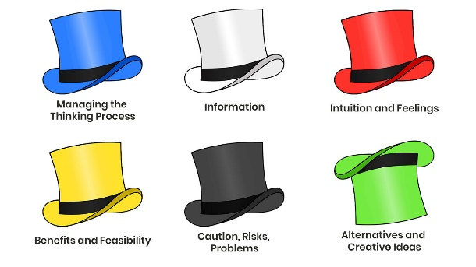

Our curriculum content ensures that all students are able to achieve on a higher tier GCSE pathway by the end of year 11.
We study the 5 key areas of Number, Geometry, Algebra, Data & Statistics and Ratio and Proportion with an interleaved and spiralled curriculum design from years 7-11.
Students in year 11 focus on consolidation, revision for long term memory and problem-solving technique as the content of the GCSE course is covered early in their academic year. All students cover the higher tier Edexcel GCSE content.

Mathematics is based on 6 big ideas.

Number | Ratio and Proportion | Algebra
Geometry | Data Analysis | Probability

Our curriculum is an ambitious seven-year programme, gradually leading to the mastery of these 6 big ideas.

At Key Stage 5 all students can choose a pathway that suits their needs to Go Further with their Mathematical Studies in Further Education or the workplace. Students can choose from
- Core Mathematical studies; blending Pure Mathematics with Statistics and Modern Finance All students cover the level 3 AQA content.
- A level Mathematics; A Pure Mathematics rich course combining Mechanics, Statistics and Mathematical Comprehension Skills. All students cover the 2 YEAR A level content in addition to following a journalled enrichment, careers ICT and reading unit.
- A level Further Mathematics; adding both breadth and depth to A level Mathematics with greater depth on Statistics (major) and Modelling with Algorithms (minor). All students cover the OCR MEI B content.

How does this fit in with the PHSG curriculum?
Plymouth High School for Girls aims to be an outstanding Grammar School for the 21st century remaining true to the philosophy of the school’s motto ‘For Life Not School We Learn’.

A school which:
- Promotes a culture of high aspiration enabling personal and academic success
- Prepares students to think confidently and independently
- Provides an outstanding education for all, the key to this being high quality teaching
- Provides enjoyment, excitement and challenge for all, stimulating an enthusiasm for lifelong learning
- Prepares students to become active citizens, equipped to succeed in a world of rapid change

Inclusion in Mathematics
Our curriculum and lessons from year 7-13 are designed with inclusion at its heart and we consistently construct learning opportunities that give every student the opportunity to succeed with confidence.
We understand that both confidence with numeracy and outcomes in public examinations are key to ensuring that all students have every opportunity to be successful both in education and Going Further in later life.
We use research driven strategies relating to supporting pupil premium groups to ensure that all students benefit from feedback and support for independent study (use of online platforms and specific support clubs), increased repetition of key skills at Key Stage 4 and equally high expectations and aspirations for all learners.
We employ universal strategies which support all types of learners and adapt our curriculum, resources and delivery with additional interventions including (but not limited to):
- Use of teacher guidance sheets to understand individuals where adaptations to teaching will improve their opportunities and success in learning. (This includes but is not limited to all students with EAL and SEND associated needs).
- Adaptations for classes or year groups where there are specific learning needs or identified deficits in prior learning.
- Consistent and frequent use of the school behaviour systems to enhance students’ experiences in belonging, reward and success as well as ensuring disruption free learning for all.
- Structured lessons and clear routines in all lessons from year 7-13 to ensure that all learners feel safe, ready and comfortable in their learning.
- Numeracy interventions at targeted times over KS3 and KS4 in tutor led sessions, Mathematics lessons and integrated into independent learning and homework.
- Support for our pupil premium students including adaptations as required, close monitoring and intervention both in lessons and over cycles of learning and support where appropriate. This ranges from organisation and equipment support (which could be financial), additional learning feedback, strong links and regular communication with parents and carers and carefully considered seating arrangements in lessons.
- Regular quality assurance systems, training and collaboration within the Mathematics teaching team to ensure that the needs of all students are met and that teachers are acutely aware of those students for which inclusion and belonging is a priority.

Thinking, Teaching and Learning in Lessons
All Mathematics lessons incorporate the three strands of the curriculum of facts and formulae, fluency and flexibility in proportions which are relevant to the learned content.
Every lesson has both a low stakes retrieval quiz and salient slide summary to create long term memories. Facts and formulae are directly linked to the Knowledge Bank linked to the learning for the current learning cycle and low stakes long term memory assessments (extended quiz) take place 3 times a year to measure the impact of the memory techniques that are employed.
Students are actively involved in every part of the lesson through whole class questioning, think pair share discussion times, use of thinking maps to organise thoughts, thinking hats to approach and solve new problems and connect different areas of Mathematics. Students are given explicit instructions about the purpose and criteria for each small task and are aware when a task should be completed independently.
Lessons are thoughtfully planned to incorporate all the crucial elements above which are encapsulated through our RESPECT lesson ingredients; we have high expectations for our learners in each moment and for their overall outcomes.

R Retrieval
E Expectations (learning)
S Salient
P Pace
E Expectations (behaviour)
C Challenge
T Thinking Strategies

Teachers use targeted question, regular checks for understanding and instant ‘live’ feedback to monitor and ensure the progress of all learners in the classroom during every lesson.
The Go Further Curriculum takes into account the unique start point of our very able year 7’s and separates learning objectives into Building Blocks, Expected and Go Further Outcomes.
Building blocks are assumed prior learning and are signposted and resourced all the way through our curriculum; empowering students to bridge any identified gaps for themselves and making them explicit aware of the cumulative nature of the subject.
Go Further outcomes are linked to each expected learning outcome and all students are exposed to and expected to use thinking tools to collaboratively and later independently work through higher level problems associated with the Mathematical concepts they have mastered. Students regularly use reverse processes, proof and reasoning and multi-step processes to show their thinking and strategies and meet these challenging objectives.
What is ‘Going Further’ in Mathematics?
We work with students over their entire Maths journey at Plymouth High School for Girls to develop the aptitudes of truly outstanding Mathematicians; rather than simply being able to follow steps and replicate methods. Here are the aptitudes that we develop by following our unique curriculum and approach to learning and expect of our students when they are thinking and working with FLEXIBILITY:

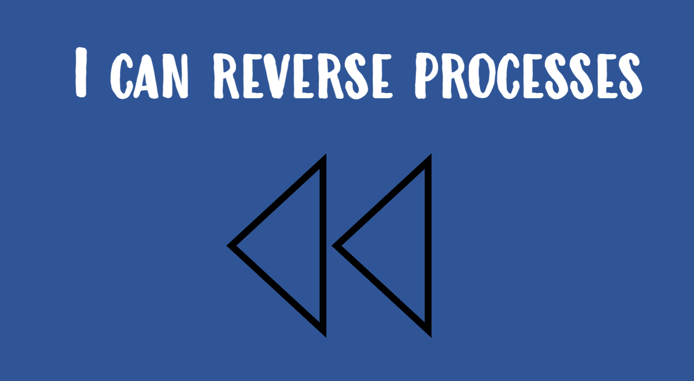 | 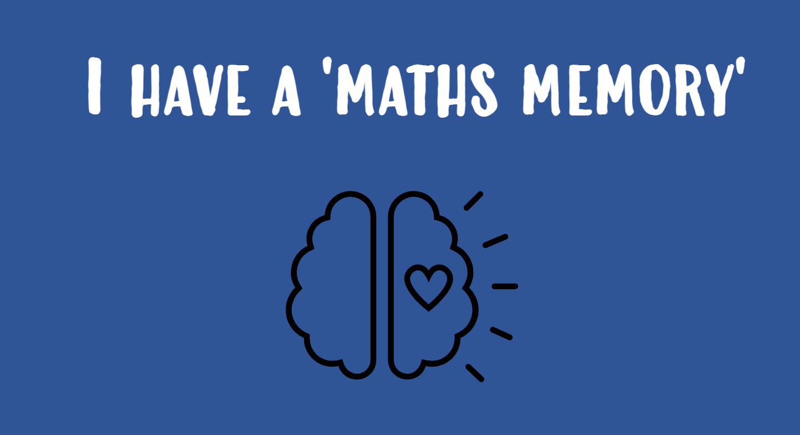 | 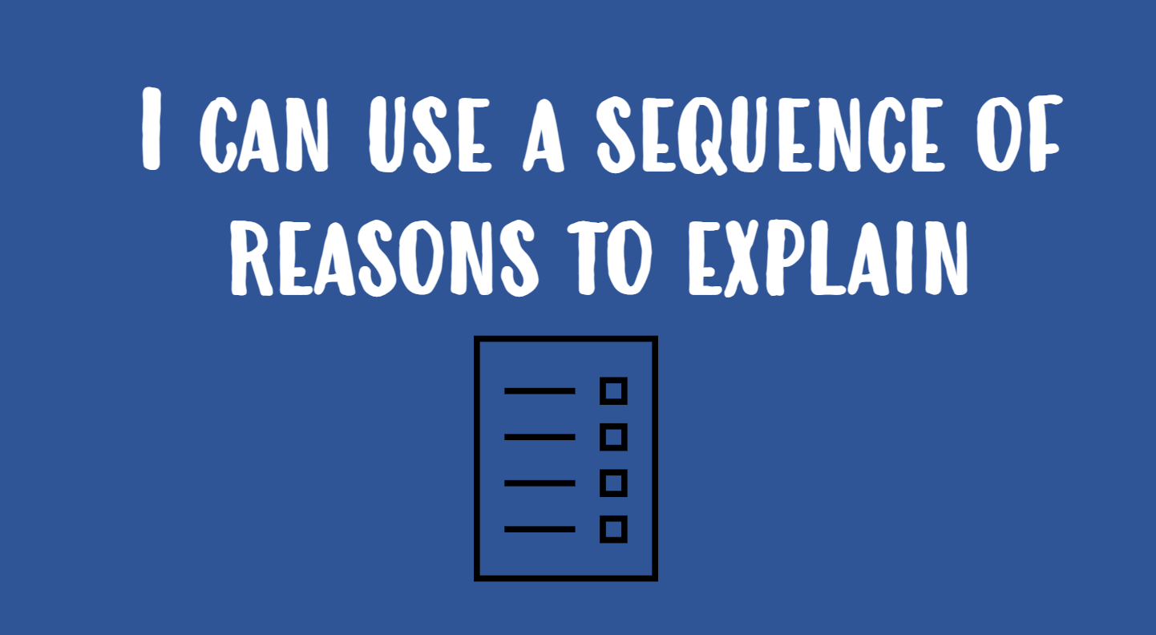 | 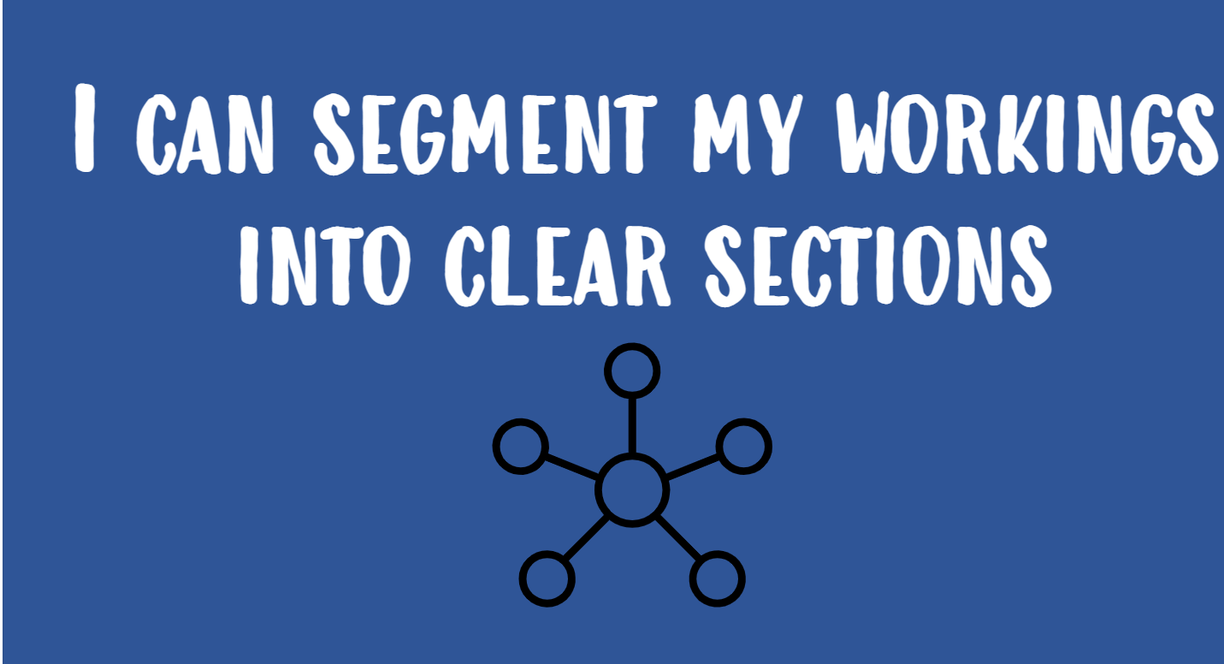
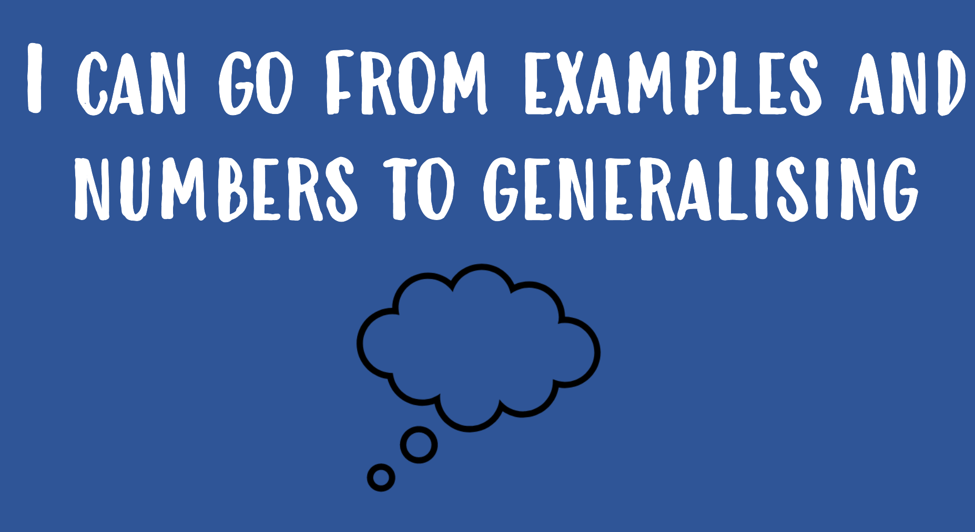 | 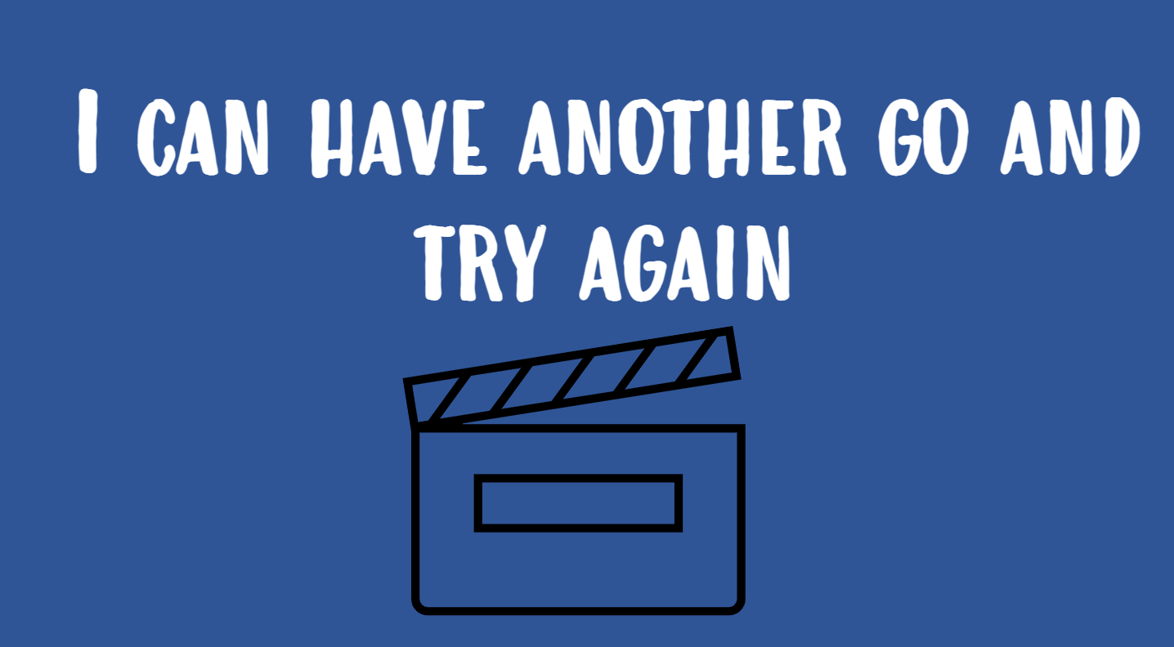 | 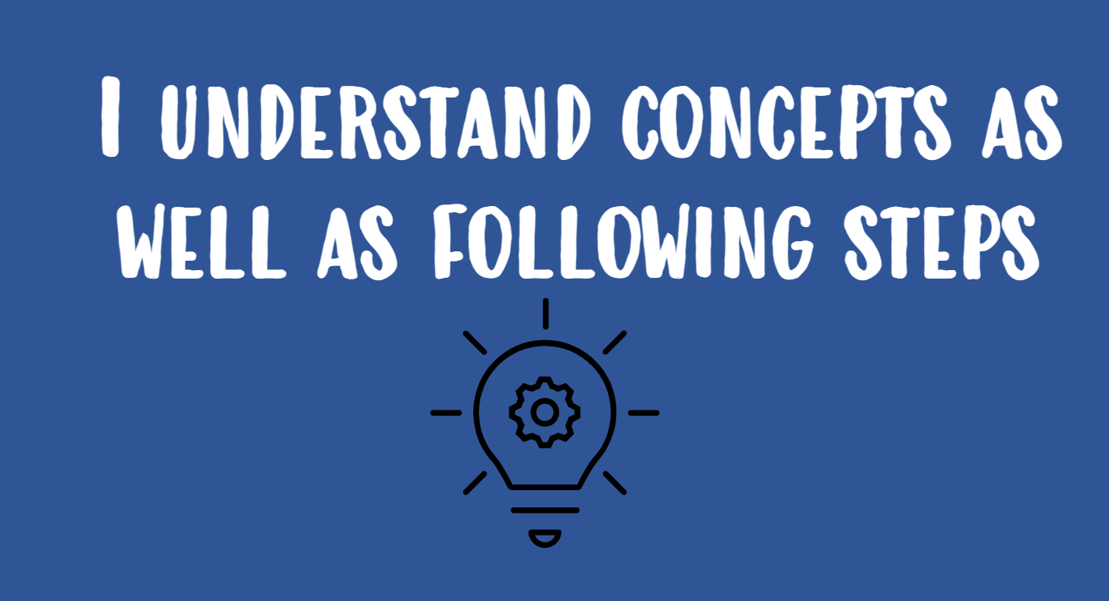 | 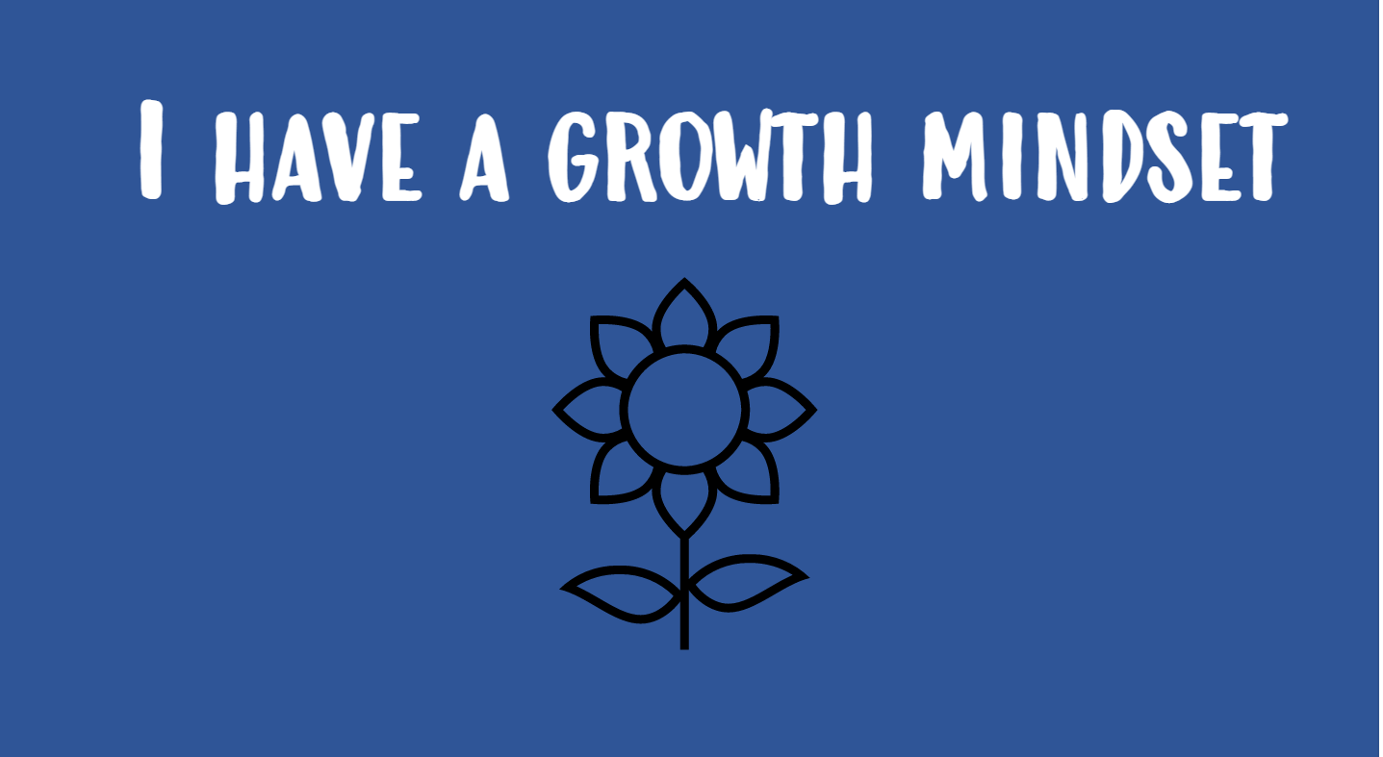
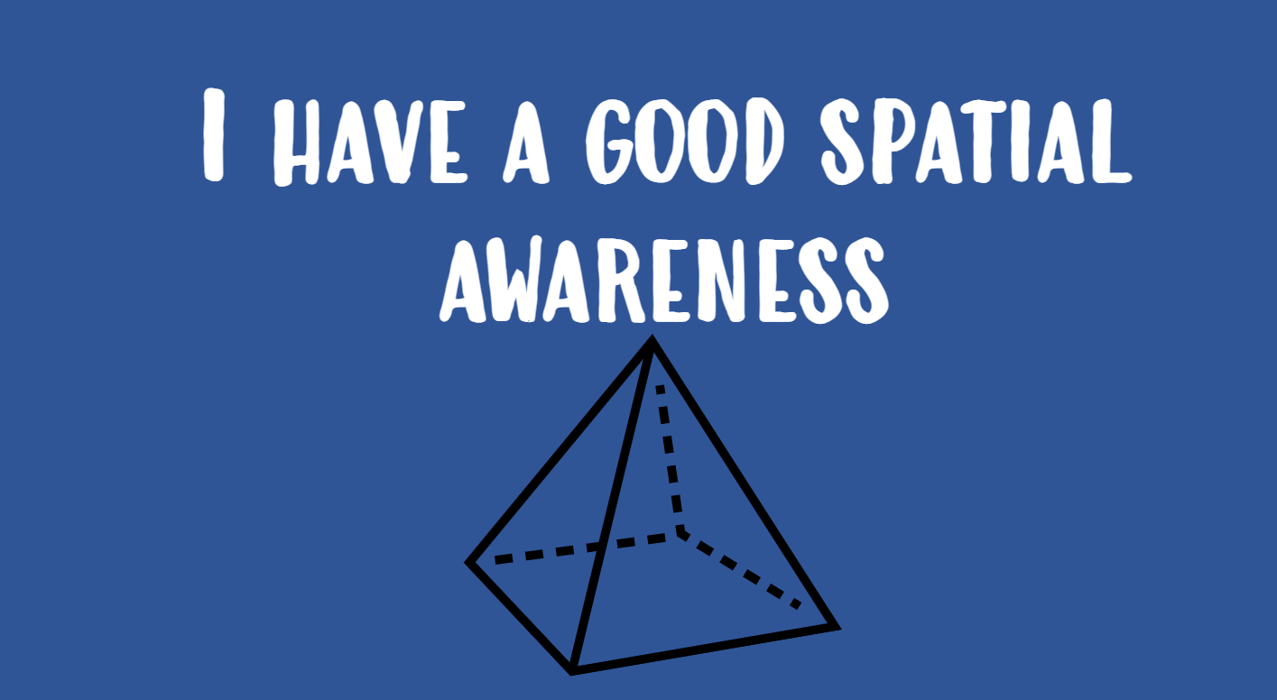 | 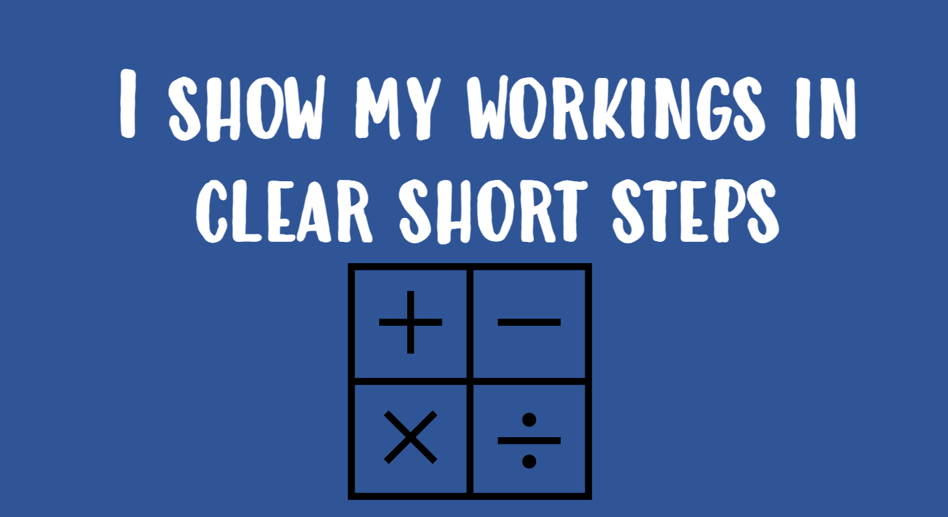 | 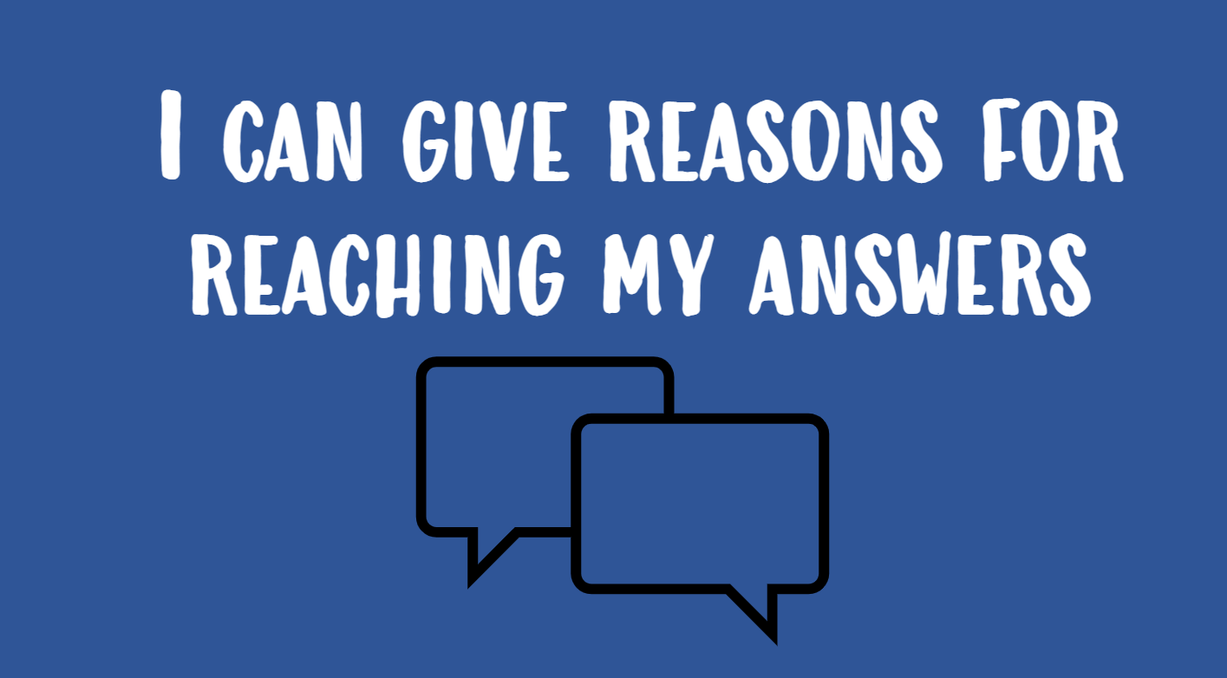 | 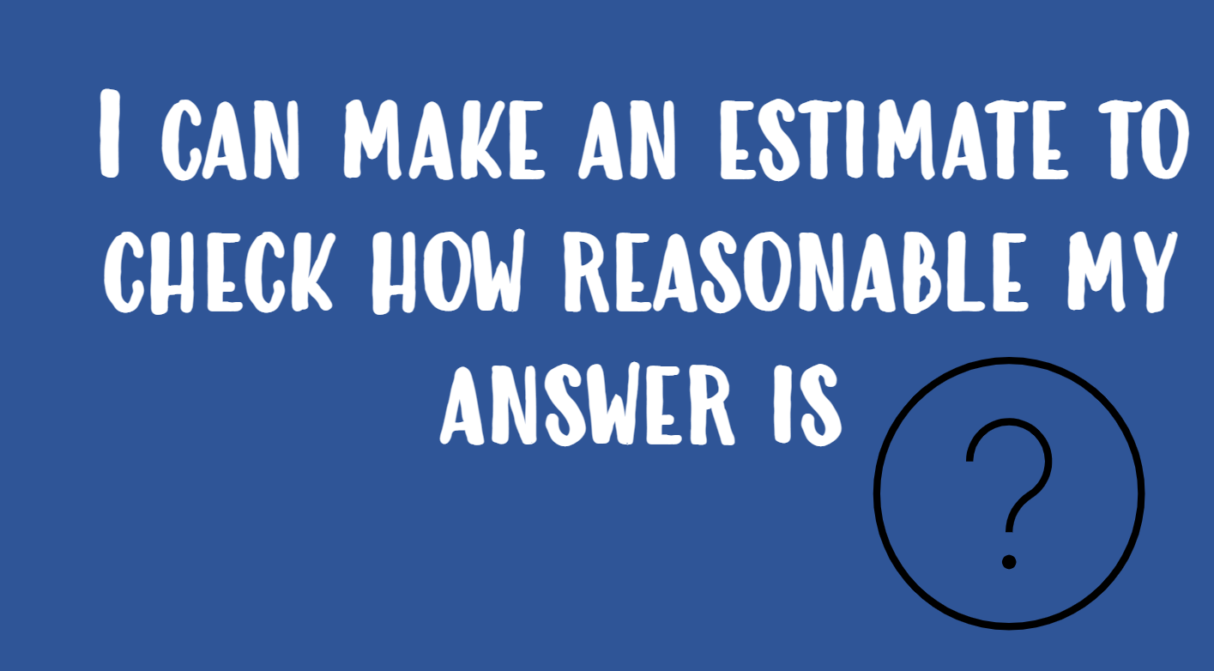
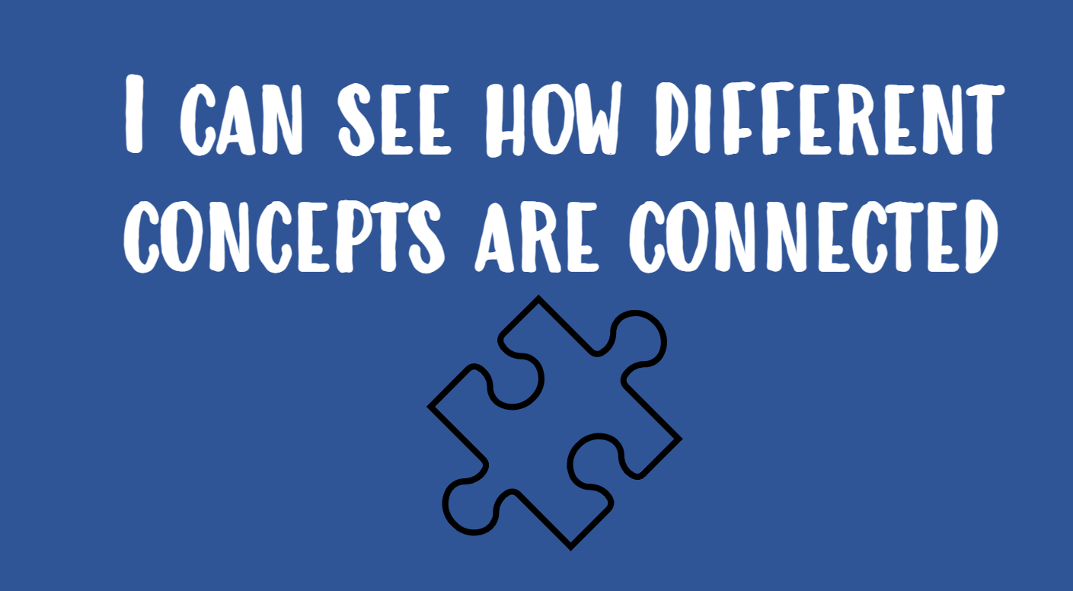 | 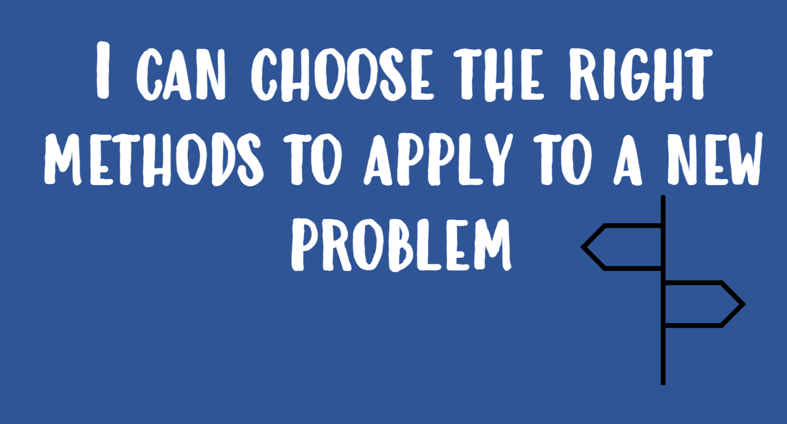 | 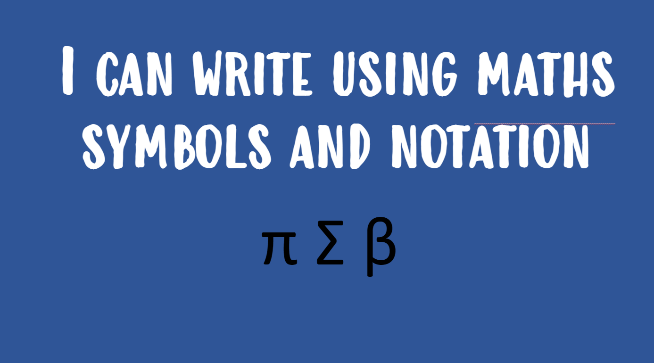 | 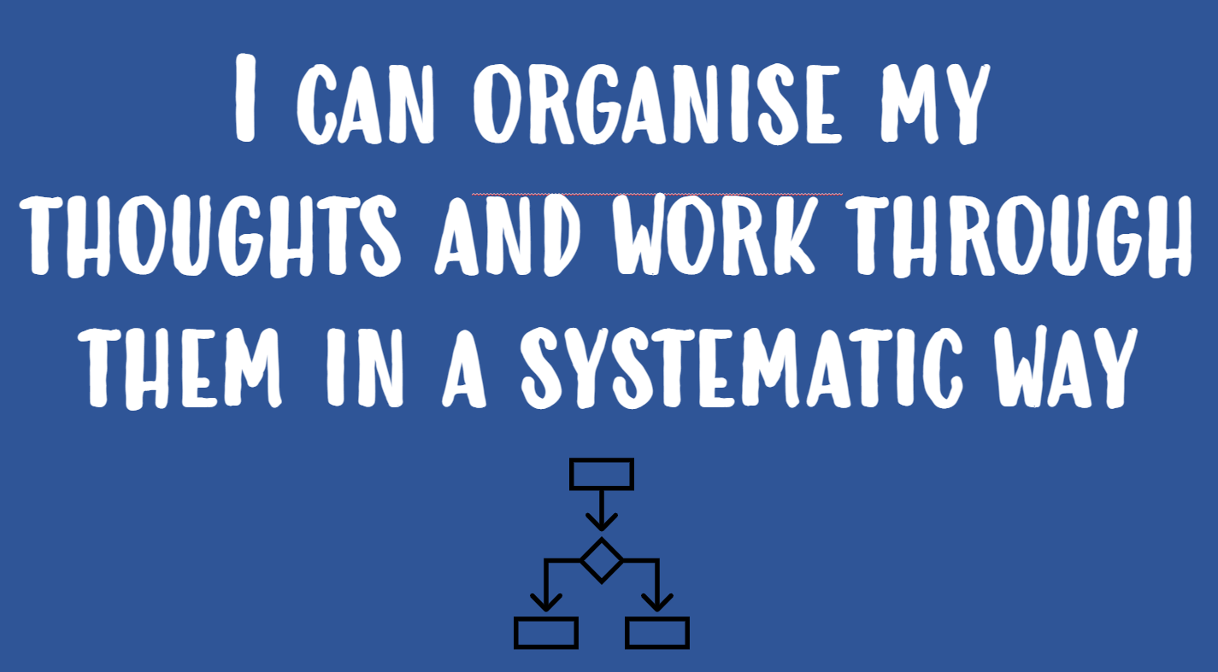

Going Further than GCSE in year 11
Some students in year 11 can go beyond the GCSE curriculum and stretch their depth of understanding of the subject by learning some or all the level 2 AQA Further Maths content interleaved with the GCSE revision unit to extend their understand and fortify their grade 9 problem solving skills. Some students each year will choose to certify in this course with 2 additional examinations at the end of their year 11. (Students working at a grade 8+/9 level will be selected for this pathway rather than opting in).
Go Further Assessments
Thinking and learning is clearly sectioned into 6 half termly cycles. Students are aware of the content that is to be covered each cycle; as it begins. Each student will sit 3 assessments per year but each of the 6 cycles routinely end with consolidation and revision. The KS3 National Curriculum and GCSE Higher Tier Edexcel specification is interleaved between years 7-11 to ensure challenge and connected ideas are revisited; each time in greater depth and drawing on previous concepts.
Each assessment incorporates and requires the three strands of the Go Further Curriculum as such
- Knowledge recall of facts, flow maps and formulae as a measure of long term memory
- Basic and uncomplicated application of skills learned in this cycle as a measure of fluency
- Flexible thinking to solve problems which are new and / or required a blend of skills.
We expect all students to strive for the 70% ‘good pass mark’ or higher in our assessment as an indication that they are keeping up with the challenges of our curriculum, working towards a grade 7+ at GCSE level, and securing long term memory.
A level and Further Mathematics A level students complete both topic-based assessments and blended ‘midterm’ assessments throughout the year as well as longer examinations (internal in year 12 and mocks and real examinations in year 13). In this way students develop an awareness of which individual parts of the course are secure or need revising as well as having the opportunity to test long term memory, problem solving skills and simulate exam experience and time pressures through our mixed midterms.
Core Mathematical studies assessments combine investigative projects with real life case study of financial matters as well as more traditional practice of Mathematical techniques. Assessments not only reflect the expectations of the external exams but also include real life analytical approaches to scenarios involving money or large data sets; sometimes incorporating software that is used in industry.

Independent Study
We believe in supporting our students to Go Further with education and their careers by simultaneously developing effective independent learning habits as a crucial aspect of the mathematics curriculum. A core responsibility of a PHSG Mathematician is that of using mark schemes and correct answers to edit and amend workings and ideas. Access to answers; solutions and mark schemes are a critical resource in our curriculum as our students develop the habits to self-check and self-correct. We use ONE NOTE to share resources and lesson notes and examples with all students. Students in year 11 and year 13 also have access to share point websites to make finding and using revision resources as simple and accessible as possible and to cater for the range of revision needs within these year groups.
Students are fully equipped with not only the information but bespoke and perfectly matched resources to empower them to become motivated independent learners.
Students in years 7-11 and on A level pathways all have a unique student account to an online independent learning platform (Sparx or Dr Frost or Integral depending on their year group and course) which can be accessed from home or school. The online learning platforms feature linked videos, show students assignments that are set by their teachers and offer a range of matching questions at varying difficulty levels. We endorse independence and believe that all students have the tools to achieve 100% completion in their set tasks each week, this is an expectation.
Our curriculum is consciously interleaved through set online tasks. Students use a range of interfaces to commits facts and formulae to memory, to rehearse fluency and to flexibly apply their skills to strategically linked problems.
Online learning gives students the opportunity to instantly receive their score, re-attempt any outstanding problem areas, find directly matched help with each type of question and communicate directly with their own class teacher.
Our curriculum content and expectations are mirrored in the way that we structure the tasks for our students so that in their own time they will revisit topics for memory building as well as being able to find help when they are finding new topics challenging. We believe that training students to work through the curriculum with both repetition and easy to access help resources makes the curriculum accessible and achievable for all and embeds learning habits for life as they repeat this model each week.

Student Voice
Our curriculum design gives students opportunities for student lead revision ahead of formal and external assessments ensuring that students take an active role in shaping their assessment preparation journey.
Formal and informal assessment for learning strategies in every lesson ensure that all students understanding is assessed as new content is explored and teachers react appropriately so that targeted support and extension is provided for those who have indicated that this is their need.
Formal student voice via Microsoft Teams surveys is collected from all year groups to ensure that both understanding and opinions on our systems and policies for thinking, learning and assessment can be voiced.
Microsoft teams is used professionally and frequently to allow for ad hoc student voice and dialogue from student and groups of students to teachers, contributing to a curriculum which is understood, accessible and where success is achievable for all; even remotely.

Feedback
Feedback opportunities are built into every lesson following whole class checks for understanding and reviewing independent work in books in the lesson time. Students are provided with mini whiteboards, and they are used routinely in lessons for teachers to check understanding and give instant feedback.
Additional feedback is given to students:
- At least three times per year following formal assessment
- At least once per half term after a classwork review (we incorporate habits of mind and set a First Important Priority)
- Instant feedback via online homework self-marking platforms – for year 7-11 any misconceptions then lead to a shadow model example to support them
- In lessons or for other set revision task in addition to the above

As part of our ongoing commitment to innovation and improving learning outcomes, Plymouth High school for girls is exploring the use of Artificial Intelligence (AI) tools to support teaching and learning. This includes trialling AI-assisted marking tools, which can help provide timely and consistent feedback to students. Please be assured that all AI tools used are carefully selected to meet data protection standards and any use of student work is handled with care. While AI may assist in the marking process, all final assessments and feedback are reviewed by teachers to ensure accuracy and fairness. We are committed to keeping you informed and welcome any questions you may have about this approach.

First Important Priority: (An actionable target highlighted to each student suggesting an improvement to their work).

Opportunities to Go Further
Whilst the central direction of our curriculum lends itself to higher tier GCSE and a range of 3 KS5 courses; it features an explicit range of additional and strengthening strands.
Our most able students add depth of understanding and develop acute problem-solving skills through accessing our ‘UKMT Maths Challenge’ society, Axiom Maths circles (invite only) or Level 2 Further Maths in year 11. Participating groups of students follow mini calendared schemes of learning and weekly workshops as well as having access to the curriculum and resources online and lead teachers to support them with their additional studies.
We find and build opportunities for celebration of our subject through global events such as pi day and build links with local professionals such as the University of Plymouth to add breadth to our curriculum with offsite experiences.
Our curriculum offer across all years is strengthened and made truly inclusive through both weekly intervention and support clubs (drop in style and targeted small group tuition). Additional time and support is on hand for students that need further time and consolidation to keep up with the pace of our challenging and deep Mathematical curriculum. Many students enjoy the change of pace and style that support sessions offer as a complement to their lessons and independent learning.

Assessment Preparation
With long term memory building a key part of the Mathematics curriculum as an integrated part of learning from year 7 upwards, our students build on their knowledge with protected time periods of revision and exam strategy focus in both year 11 and 13. Our students benefit greatly from the timings of our teaching which offers months of external examination preparation time and opportunities to consolidate through spaced learning and revision which includes opportunity for student voice requests.
Learners are always guided to specific recommendations for their assessment revision which includes (but is not limited to): Share point websites, predicted papers, practice papers, revision lists linking to online learning and self-marking practice work, access to exam board specific resources and structured revision lessons before any assessment.
External qualifications are listed below showing the examination board that we use to best suit the current and future needs of our students. Wherever possible, students do not deviate from their intended pathways.

GCSE examinations: Higher Tier Edexcel 9-1
Level 2 Further Mathematics: AQA
Level 3 Core Mathematics: AQA with Statistics pathway
A level Mathematics: Edexcel
A level Further Mathematics: MEI OCR with Statistics major and Modelling with algorithms minor pathways.
Use of AI
As part of our ongoing commitment to innovation and improving learning outcomes, Plymouth High school for girls is exploring the use of Artificial Intelligence (AI) tools to support teaching and learning. This includes trialling AI-assisted marking tools, which can help provide timely and consistent feedback to students. Please be assured that all AI tools used are carefully selected to meet data protection standards and any use of student work is handled with care. While AI may assist in the marking process, all final assessments and feedback are reviewed by teachers to ensure accuracy and fairness. We are committed to keeping you informed and welcome any questions you may have about this approach.


Mathematics progression and content map
 | Autumn 1 | Autumn 2 | Spring 1 | Spring 2 | Summer 1 | Summer 2
KEY STAGE 3
Year 7 | Ratio sharing  Best buys  Negative numbers  Laws of indices  Rounding  Standard form | Algebra essentials  Expanding brackets  Factorising expressions  Substitution  Venn diagrams  HCFs and LCMs | Solving equations  Converting units  3D shapes  2D representations of 3D shapes  Speed, distance, time | Area and perimeter  Straight line graphs; recognising and plotting  3D coordinates  Midpoints  Symmetry  Reflection  Rotation  Translation | FDP conversions  Fractions arithmetic  Percentages calculations  Reverse percentages  Currency Conversion  END OF YEAR EXAMS | Averages calculations  Averages from tables  Frequency Polygons  Pie Charts  Scatter Diagrams
Year 8 | Calculations with standard form  Simplifying surds  Bearings  Angles on parallel lines | Solving complex linear equations  Rearranging formulae  Inequalities  Expanding double brackets  Factorising and solving quadratics | Multipliers  Repeated % change  Linear sequences  y=mx+c and gradient  Area and volume unit conversion  Speed from distance time graphs | Area of a circle  Circumference of a circle  Volume of prisms  Pythagoras’ theorem  Distance between 2 points  Graphs of quadratic and functions | Surface area of prisms  Similarity  Experimental probability and expectation  END OF YEAR EXAMS | Time series and moving averages  Averages from grouped data  Sampling  Capture Recapture
Year 9 | Non calc skills review  Decimal and fraction arithmetic  Negative and fractional laws of indices  Direct and inverse proportion problems  Trial and improvement  Iterations | Compound measures  Speed time graphs  Impact of rounding  Simultaneous Equations  Solving equations from graphs | Difference of 2 squares  Factorising complex quadratics  Sketching quadratic functions  Solving quadratics from graphs  The quadratic formula  Solving complex inequalities | Sample Spaces  AND OR rules  Tree diagrams  Conditional probability  IQRS and boxplots  Comparing data sets  Cumulative Frequency | Ruler and compass constructions  Loci  Right angled trigonometry  Reverse percentages (calc techniques)  END OF YEAR EXAMS | Arc Lengths  Sector Areas  Circle Theorems  Angles in Polygons
KEY STAGE 4
Year 10 | Limits of calculations  Surds arithmetic  Rationalising the denominator  Direct and inverse proportion  Combining ratios  Recurring decimals | Expanding 3 brackets  Algebraic fractions  Graphical linear inequalities and region shading  Functions | Sequences; quadratic, Fibonacci and geometric  Equation of a circle  Quadratic simultaneous equations  Coordinate geometry skills  Parallel and Perpendicular lines | Histograms  Dimensional Analysis  Similarity with area and volume  3D Pythagoras  Exact trig values  3D trigonometry | Sine and cosine rules  Area of a non-right triangle  Venn Diagrams with probability  Complex rearranging and SUVAT  Algebraic proof | Vector arithmetic, geometry and proof  END OF YEAR EXAMS
Year 11 | Complex solids  Quadratics in context  Quadratic inequalities  Ratio problem solving  Reciprocal, exponential and cubic functions  Trig function graphs  Solving trig equations  Transforming curves  Completing the square form | Enlargements with negative and fractional scale factors and combined transformations  Geometric proof and tests for congruency  Product rule for counting  MOCK EXAMS | Revision, consolidation, and examination preparation.  Level 2 Further Maths (for some) | Revision, consolidation, and examination preparation  Level 2 Further Maths (for some) | Revision, consolidation, and examination preparation | GCSE EXAMS
A level Mathematics and A level Further Mathematics
Year 12 | Topic(s):  Pure – Indices and surd, trigonometry, quadratics, simultaneous equations and inequalities, polynomials.  Stats – The data cycle, summary statistics, Mechanics-Kinematics and vectors | Topic(s):  Pure – binomial expansion  Stats – The data cycle, representing data, permutations and combinations  Mechanics-Kinematics, vectors and forces and Newton’s Laws | Topic(s):  Pure – calculus: differentiation  Stats – Probability, Binomial Distribution, Hypothesis testing | Topic(s):  Pure – integration, coordinate geometry  Mechanics – Variable acceleration | Topic(s):  Pure –Graph transformations, sequences and series  YEAR 12 EXAMS | Topic(s):  Pure – logarithms, exponentials, further differentiation and integration
Year 12  Further Maths | Topic(s):  Pure –  Statistics -, discrete random variables | Topic(s):  Pure -  Statistics – Poisson Distribution, Uniform and Geometric Distributions | Topic(s):  Pure -  Statistics – Bivariate Data analysis, PMCC, LSR, Rank correlation | Topic(s):  Pure -  Statistics – Chi squared distribution and good ness of fit | Topic(s):  Pure -  Statistics – Conditional Probability, Bayes theorem, Normal Distribution  YEAR 12 EXAMS | Topic(s)  Pure -  Statistics – Continuous random variables
Year 13 | Topic(s):  Pure – partial fractions and further binomial expansion, numerical methods | Topic(s):  Pure –Further differentiation, functions  Stats – probability distributions  Mechanics – kinematics and projectiles | Topic(s):  Pure – Further integration, trigonometry  Stats – hypothesis testing  MOCK EXAMS | Topic(s):  Pure – differential equations, trigonometric functions  Mechanics- forces and motion, friction  Pure – Parametric equations  Mechanics – moments | Revision, consolidation, and examination preparation | A LEVEL EXAMS
Year 13  Further Maths | Topic(s):  Pure –vectors, matrices, series and induction  Statistics - Expectation algebra, confidence intervals, hypothesis testing | Topic(s):  Pure –further calculus, polar coordinates, Maclaurin series  Statistics-  simulation | Topic(s):  Pure –Hyperbolic functions, first order differential equations  Decision- algorithms and modelling with graphs and networks  MOCK EXAMS | Topic(s):  Pure – complex numbers, second order differential equations  Decision-network algorithms, linear programming | Topic(s):  Pure -REVISE  Decision- simplex method  Revision, consolidation, and examination preparation | A LEVEL EXAMS

