

Curriculum and Progression Overview
Geography
Plymouth High School for Girls



contents
- The Curriculum
  - Intent
  - Implementation
  - Impact
- Curriculum and assessment overview (KS3-5)
- KS 3 Progression ladder
- Feedback and Assessment system

- The Curriculum
Plymouth High School for Girls aims to be an outstanding Grammar School for the 21st century remaining true to the philosophy of the school’s motto ‘For Life Not School We Learn’.
A school which:
- Promotes a culture of high aspiration enabling personal and academic success
- Prepares students to think confidently and independently
- Provides an outstanding education for all, the key to this being high quality teaching
- Provides enjoyment, excitement and challenge for all, stimulating an enthusiasm for lifelong learning
- Prepares students to become active citizens, equipped to succeed in a world of rapid change
Intent
The Geography department at Plymouth High enthusiastically provide a high-quality geography education that will inspire in pupils a curiosity and fascination about the world and its people that will remain with them for the rest of their lives.
Our teaching equips pupils with knowledge about diverse places, people, resources and natural and human environments, together with a deep understanding of the Earth’s key physical and human processes. As pupils progress, their growing knowledge about the world should help them to deepen their understanding of the interaction between physical and human processes, and the formation and uses of landscapes and environments.
We aim to ensure that all pupils:
- Develop contextual knowledge of the location of globally significant places – both terrestrial and marine – including their defining physical and human characteristics and how these provide a geographical context for understanding the actions of process.
- Understand the processes that give rise to key physical and human geographical features of the world, how these are interdependent and how they bring about spatial variation and change over time.
- Are competent in the geographical skills needed to collect, analyse, interpret and communicate a wide range of data using a wide range of maps, quantitative and qualitative methods.
- Improve their understanding of the ways in which values, attitudes and circumstances have an impact on the relationships between people, place and environment, and develop the knowledge and ability to engage, as citizens, with the questions and issues arising.
- Develop the ‘Thinking Skills’ approaches to promote independent and resilient learners.
- Actively find opportunities to gain student voice, both informally and formally, to improve and promote Thinking, Teaching and Learning.

Our Commitment to Inclusion and Adaptive Teaching
We are committed to ensuring that every student can access, participate in and succeed within our curriculum. We maintain high expectations for all learners while recognising that students may require different forms of support to achieve the same ambitious curriculum goals.
Inclusive practice is built into our universal classroom offer through clear explanations, carefully sequenced learning, effective modelling, purposeful questioning and regular checks for understanding. Where particular barriers to learning are identified, teachers use pre-planned adaptations informed by students’ needs, prior attainment and available support plans. Teachers also adapt their teaching in the moment, responding to assessment, feedback and classroom observation to provide additional explanation, scaffolding, challenge or alternative approaches as required.
These adaptations are designed to remove barriers without unnecessarily reducing the breadth, depth or ambition of the curriculum, enabling all students to develop their knowledge, confidence and independence.

Implementation
There are certain foundation blocks upon which geography is set upon. Map skills, understanding place and the route to enquiry are at the very core of this. Year 7 sets about laying this foundation firmly against a backdrop of local and international locations. Then throughout the following 6 years of study, the topics change, but the use of maps, locations and enquiry are the tools with which we deliver this content.
As we revisit ideas, the level of challenge increases.

- The skillset changes from a “describe and explain” approach to one of analysis and scrutiny.
- The mathematical demands increase, from simple arithmetic to use of statistical tests.
- The use of IT becomes more expert, from graphs and charts to advanced GIS systems.
- Thinking strategies are developed in their complexity as the challenge of the courses and more independence is needed.
- Memory is developed across the 7 years of the curriculum, with the aim of increasing metacognitive ability and independence by the end of Year 13.
- Students are given informal and formal opportunities to give feedback regarding the structure and learning of the course.

The National Curriculum is taught in Year 7,8 and 9, however if there are overlaps or opportunities to stretch and challenge students by introducing elements from the GCSE specifications, these may be taken. GCSE Option subjects are chosen during Year 9.

Fieldtrips
Field trips and data collection are key to Geography and are undertaken regularly. Links to other opportunities such as the Model United Nations debates, TED talks in Exeter are also used as often as possible.

Impact
Our students are active global citizens with an ethical moral compass, keenly aware of the modern world around them and their sense of place in that world. Students actively find platforms to express their ideas and their learning from the course, promoting causes which are Geographical in content that they feel need addressing. They are hugely capable in communicating, thinking and operating in that world and being the positive change in the future, the creation and continued success of the Earth Alliance is one demonstration of this.
Quality assurance is undertaken to ensure the quality of teaching and learning and to inform evaluation of what we are doing.

USE OF AI
As part of our ongoing commitment to innovation and improving learning outcomes, Plymouth High school for girls is exploring the use of Artificial Intelligence (AI) tools to support teaching and learning. This includes trialling AI-assisted marking tools, which can help provide timely and consistent feedback to students. Please be assured that all AI tools used are carefully selected to meet data protection standards and any use of student work is handled with care. While AI may assist in the marking process, all final assessments and feedback are reviewed by teachers to ensure accuracy and fairness. We are committed to keeping you informed and welcome any questions you may have about this approach.

2. CURRICULUM & ASSESSMENT OVERVIEW: KS 3-5 GEOGRAPHY
 | Autumn 1 | Autumn 2 | Spring 1 | Spring 2 | Summer 1 | Summer 2
KEY STAGE 3
Year 7 | Topic(s): Mapping  Assessment: Dartmoor | Topic(s): Weather  Assessment : Weather | Topic(s): UK  Assessment : UK | Topic(s): Europe  Assessment :Europe | Topic(s): Africa  And Fieldwork  Assessment: End of year assessment | Topic(s): Glaciation
Year 8 | Topic(s): Ecosystems  Assessment:Ecosystems | Topic(s): Russia  Assessment: Russia | Topic(s): Resources  Assessment: Resources | Topic(s): Asia  Assessment: Asia | Topic(s): Development  Assessment: EoT test | Topic(s): Rivers  Assessment: Fieldwork
Year 9 | Topic(s): Tectonics and volcanoes  Assessment: EoT | Topic(s): Tropical storms and Climate change  Assessment: EoT | Topic(s): Population and migration  Assessment: EoT Test | Topic(s): The Middle East  Assessment: EoT test | Topic(s): Plastics and sustainability  Assessment: EoY Exam | Topic(s): Coasts  Assessment: Fieldwork
KEY STAGE 4– Exam Board AQA
Year 10 | Topic(s):Urban issues and challenges  Assessment(s): EoT test | Topic(s): Urban issues and challenges  Assessment(s): EoT test | Topic(s): Changing economic world  Assessment(s): EoT test | Topic(s): Resource management  Assessment(s): EoT test | Topic(s): Physical landscapes of the UK  Assessment: EoY exam | Topic(s): River and Urban Fieldwork
Year 11 | Topic(s): The challenge of natural hazards  Assessment (s): In class | Topic(s): The challenge of natural hazards  Assessment(s): Mock exams | Topic(s): The Living world  Assessment(s): EoT test | Topic(s): Issue evaluation  Assessment(s): EoT test | Topic(s): Revision  Assessment(s):Mocks practice | GCSE EXAMS
KEY STAGE 5 – Exam Board AQA
Year 12 | Topic(s): Coasts +Rebranding  Assessment(s):Essays | Topic(s):Coasts +Rebranding  Assessment(s): EoT test | Topic(s): Globalisation + Tectonics  Assessment(s): Essays | Topic(s): Globalisation + Tectonics  Assessment(s): Essays | Topic(s): NEA  Assessment: EoY exam | Topic(s): NEA  Coursework write up
Year 13 | Topic(s):Water + Carbon  Assessment(s): Essays | Topic(s): Water + Carbon  Assessment(s): EoT test | Topic(s): Superpowers and Health Rights  Assessment(s): Mock 1 | Topic(s): Superpowers and Health Rights  Assessment(s):Mock 2 | Topic(s): Revision  Assessment(s):Mock 3 | AL EXAMS

3. PROGRESSION IN KS3: GEOGRAPHY
 | Knowledge and understanding | Map skills | Interpreting data skills | Fieldwork skills | Geographical IT skills
8 - 9 | Descriptions of features, places and processes are detailed and a range of reasoned explanations are offered. Students start to analyse information.  Responses show a good understanding and misinterpretations are less common.  A wide range of geographical vocabulary is used consistently.  A fairly broad factual knowledge is demonstrated. | Very accurate use of a wide range of skills.  Very accurate presentation.  Uses full range of map skills accurately.  Can produce cross-sections using OS maps.  Interprets maps with confidence to answer independent enquiry questions.  Can navigate by using a map and compass. | Is very secure in recognising, describing and explaining data sets from a very wide range of different graphical representations.  Confident in comparing a variety of different data sets, offering excellent explanations. | Able to identify a wide range of risks associated with collecting data in the field and produce clear understanding on how to reduce the risks and plan accordingly.  Will show the ability to dynamic risk assess when out on fieldwork and will implement plans to keep self and group safe.  Able to evaluate on a range of locations to collect data sets and confidently explain why they have chosen these over other locations.  By able to decide on the type of sampling method they will use correctly and be able to explain why.  Able to collect a wide range of data sets with no error and record these with an excellent level of accuracy. | Often produces a wide range of charts using IT without being shown, with titles and axis labels.  Likely to have created something unique, and combining 2 or more ideas to create something more sophisticated.  Can produce electronic maps with careful considerations for scale and compass direction and titles, and will likely overlay information on these.  Work is word processed to a very high level of accuracy. With clear thought showing review of work and careful design at all times.  Uses multimedia forms to create films and powerpoints showing excellent editing skills of both images and sound that are unique in their appearance.
6 - 7 | Descriptions of features, places and processes are detailed and a range of reasoned explanations are offered. Students start to analyse information.  Responses show a good understanding and misinterpretations are less common.  A wide range of geographical vocabulary is used consistently.  A fairly broad factual knowledge is demonstrated. | Effective/competent use of a range of skills with very few errors.  Good presentation.  Can calculate non-straight-line distances using a scale and produce scaled maps.  Can recognize simple contour features and measure height using contours. | Is secure in recognising, describing and explaining data sets from a wide range of different graphical representations.  Able to clearly compare two or more sets of data and offer good explanations for the similarities and differences. | Able to identify a wide range of risks associated with collecting data in the field and produce clear understanding on how to reduce the risks and plan accordingly.  Will show the ability to dynamic risk assess when out on fieldwork and will implement plans to keep self and group safe.  Able to evaluate on a range of locations to collect data sets and confidently explain why they have chosen these over other locations.  By able to decide on the type of sampling method they will use correctly and be able to explain why.  Able to collect a wide range of data sets with no error and record these with an excellent level of accuracy. | Can produce a range of charts using IT without having to be shown, most with titles and axis labels.  Can produce electronic maps with careful considerations for scale and compass direction and titles.  Work is word processed to a high level of accuracy. With clear thought showing review of work and careful design.  Uses multimedia forms to create films and powerpoints showing excellent editing skills of both images and sound.
4 – 5 | Descriptions of features, places and processes include more detail but explanation, if given, is basic.  Responses show a good understanding but misinterpretations are still common.  A range of appropriate geographical vocabulary is used.  An adequate factual knowledge is demonstrated more consistently. | Satisfactory use of a range of skills.  Can follow a route on an OS map.  Satisfactory presentation.  Uses 4 and 6-figure grid references and can calculate straight line distances using a scale. Gives directions using an 8-point compass. | Can recognise and describe data from a range of straight forward graphical representations.  Will be able to compare two sets of data and offer explanations for the differences | Able to identify a range of risks associated with collecting data in the field and come up with some ideas about how to reduce this risk.  Able to decide on locations to collect data and explain why they chose these locations.  Able to collect 3 or 4 simple data sets and record these with a level of accuracy. | Beginning to produce simple charts using IT, likely to be missing titles and axis labels.  Beginning to produce electronic maps with incorrect or missing scale/compass direction and titles.  Beginning to word process work with a limited range of skill, often focus is on colour rather than on content.  Beginning to use multimedia to create film and powerpoints, but which have many editing issues or not able to complete on time.
1 - 3 | Beginning to describe places, features and processes but not in detail.  Beginning to use appropriate geographical vocabulary.  Demonstrates an adequate factual knowledge at times. | Uses a small range of simple map skills although makes occasional errors.  Can recognize features on a map and draw a simple map. Use simple directions.  Uses 4-figure grid references and can recognise some OS map symbols. | Beginning to show ability to recognise and describe data from simple graphical representation. | Beginning to identify risks associated with collecting data in the field  Able to pick places to collect data and locate these on a map  Able to collect 1 or 2 simple data sets and record these with some errors. | Beginning to produce simple charts using IT, likely to be missing titles and axis labels.  Beginning to produce electronic maps with incorrect or missing scale/compass direction and titles.  Beginning to word process work with a limited range of skill, often focus is on colour rather than on content.  Beginning to use multimedia to create film and powerpoints, but which have many editing issues or not able to complete on time.

4. Feedback and Assessment system
Student feedback is extremely important and we aim to give this in a variety of formats across all year groups. Throughout we focus on a WWW and EBI approach and this notation will be seen and understood in student books.
- Instant and oral – comments by teachers on work in lesson and discussion during class is a vital lifeline of feedback that students get throughout their classes.
- Peer led feedback – we take time to develop and structure our peer assessment and feedback as this is also an incredibly important learning tool for lifelong learning. Often this is done on shorter answers, or before a teacher then marks a piece.
- Template review on classwork and questions – given after an attempted question at GCSE, for quick feedback.
- Short development responses – given when students are working on larger pieces of work and are themselves reviewing work before final piece submitted.
- In-depth class feedback after exam questions or assessment piece – this will normally take the form of “common mistakes”, and a “model answer” followed by students identifying their own weaknesses and setting themselves new targets.
- At 6th form, students work is also marked at length and detailed written feedback is provided on work with clear notes on how to improve.

On the next page is an example of the type of template we use for Key stage 3 and 4.

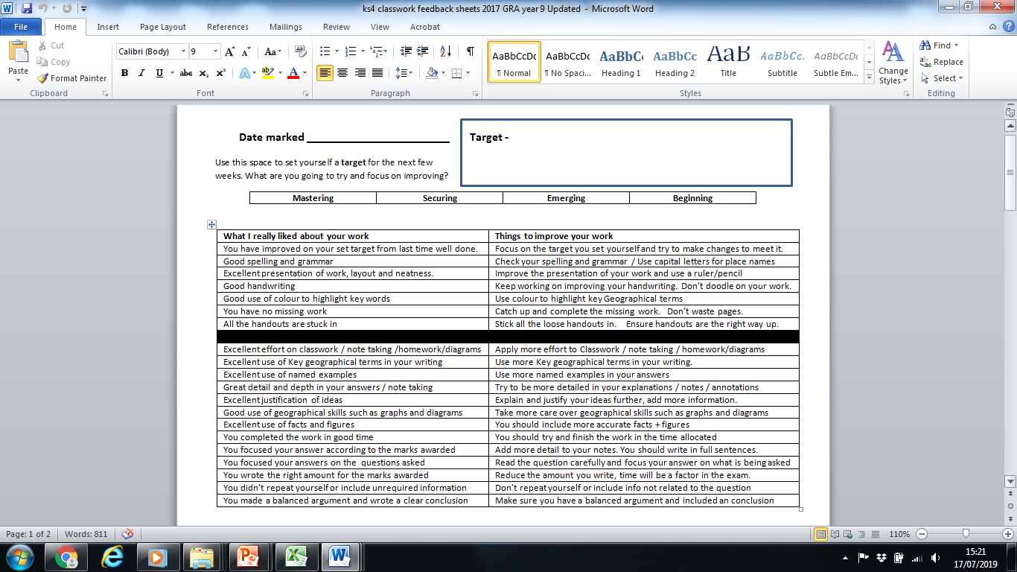
By the end of Year 7 students will know about the region and country they live in, be able to compare this with a contrasting country and will be able to use maps to locate and describe position and physical features in various scales.

By the end of year 8 students will know more about a sense of place by understanding at a larger scale places such as Europe and our part within it, along with a deeper understanding of Developing Nations of China, the Middle East and Russia and will be able to use skills to collect data to test hypothesis about formations of rivers and sediment load.

By the end of year 9 students will know about the physical geography of our planet and the range of natural threats. They will be able to plan collection of geographical data, manipulate that data in a range of charts and graphs with IT.

By the end of year 10 students will know in detail the human geography of development, how we measure it and how we compare to other countries around the globe. They will be able to plan and write detailed extended written answers using their case studies of place around the world. They will also understand more the issues around resources in the world, in particular energy and the conflict this can cause. Fieldwork also plays a large part of this year and so students will have developed the ability to safely collect meaningful data from a range of strategies to test a hypothesis and to analyse this data and draw clear conclusions.

By the end of year 11 students will know in more detail about the future challenges for our society, in particular the natural hazards that countries may face and how climate change threatens all parts of the globe in different ways. They will be able to assess information and analyse data to draw conclusions to current issues and make persuasive arguments to advocate their point of view.

By the end of year 12 students will know in more detail the issues surrounding Coasts, globalisation, regeneration and tectonics and how human and physical geography is very much cemented together. They will be able to devise and plan their own fieldwork question from scratch and complete the independent research and assessment write up.

By the end of year 13 students will know in detail about the main fundamental issues facing the future of our planet, in particular the water and carbon cycles and how that relates to everyone on the globe, but also the political outlook of Superpowers and the violation of human rights. They will be able to write detailed articulate extended answers over a wide range of issues and also be able to advocate clear and reasoned points of view, balanced upon the evidence provided.

