

Curriculum and Progression Overview
Computing
Plymouth High School for Girls

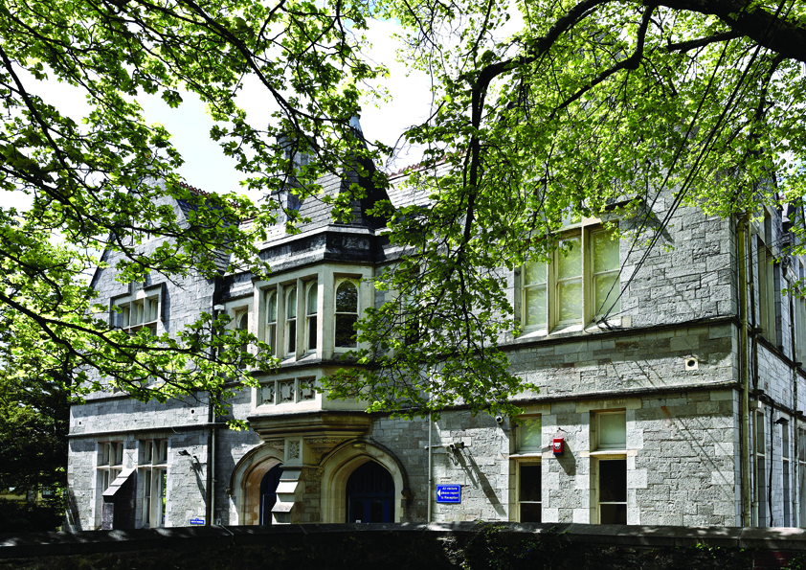

contents
- The Curriculum
  - Intent
  - Implementation
  - Impact
- Curriculum and assessment overview (KS3-4)
- KS 3 Progression ladder
- Feedback and Assessment system

- Curriculum

Computers are now part of everyday life and, for most of us, technology is essential to our lives, at home and at work. ‘Computational thinking’ is a skill that all pupils must learn if they are to be ready for modern the workplace and able to participate and develop effectively in the digital world.
Computer Science is an engaging and practical subject, encouraging creativity and problem solving. It encourages students to develop their thinking skills, understanding and application of the core concepts in computer science. Students also analyse problems in computational terms and devise creative solutions by designing, writing, testing and evaluating programs.
Rationale
Through IT and Computing in KS3 and KS4, students will learn how computers and computer systems work, they will design and build programs, they will develop their ideas using technology, create a range of digital content and solve problems.
The three main strands of computing are:
- Computer Science
- Digital Literacy
- Information Technology.

Computer science is the scientific and practical study of computation: what can be computed, how to compute it, and how computation may be applied to the solution of problems.
Digital literacy is the ability to effectively, responsibly, safely and critically navigate, evaluate and create digital artefacts using a range of digital technologies. The creation of digital artefacts will be integral to much of the learning of computing. Digital artefacts can take many forms, including digital images, computer programs, spread sheets and 3D animations.
Information technology is concerned with how computers and telecommunications equipment work, and how they may be applied to the storage, retrieval, transmission and manipulation of data.

Ambition
We want our students to experience success in computer science and develop the confidence to take risks to solve problems, ask questions and explore alternative solutions without fear. They will therefore, enjoy exploring and applying concepts to understand and solve problems, explaining their thinking and presenting their solutions to others in a variety of ways.
At all stages, the use of collaborative learning and thinking skills encourage students to reason logically and creatively through discussion, and the sharing of ideas and concepts. Misconceptions and wrong answers are an opportunity to improve and deepen understanding of computational concepts, through use of effective questioning and discussion.
We want students to :
- To develop a positive attitude and thinking approach to computing as an interesting and exciting subject in which all students gain success and enjoyment
- To develop computational understanding through systematic direct teaching of appropriate learning objectives
- To encourage the effective use of computing as a tool in a wide range of activities within school and, subsequently, adult life
- To develop an ability in students to express themselves fluently, to talk about the subject with confidence, using correct computational language and vocabulary
- To develop and make connections within computing
- To develop the ability to think clearly and logically with independence of thought and flexibility of mind
- To develop computational skills and knowledge and a quick recall of basic facts

Implementation
The National Curriculum is taught in Year 7,8 and 9, however if there are overlaps or opportunities to stretch and challenge students by introducing elements from the GCSE specifications, these may be taken. GCSE option subjects are chosen during Year 9.
The aims of computing as a whole also reflect the distinction between the three strands.
- Students can understand and apply the fundamental principles and concepts of computer science, including abstraction, logic, algorithms and data representation (CS)
- Students can analyse problems in computational terms, and have repeated practical experience of writing computer programs in order to solve such problems (CS)
- Students can evaluate and apply information technology, including new or unfamiliar technologies, analytically to solve problems (IT)
- Students are responsible, competent, confident and creative users of information and communication technology. (DL)
The strands above are implemented through:
- Planned active learning with opportunities to observe, think, explore, investigate, experiment and play
- Development of problem-solving capabilities, with an increased opportunity for discussion, communication and explanation of thinking (think, pair, share)
- Plan for both depth and breadth with topics as well as across the curriculum as a whole.
- Use of relevant contexts, familiar to young people’s experiences
- Collaborative and independent learning using thinking tools
- Making links across the curriculum where appropriate
- Sharing of resources across the department to encourage equitable delivery and team planning to take place wherever possible

Inclusion and Universal Offer – IT and Computer Science
In IT and Computer Science, we are committed to ensuring that all students can access, engage with, and succeed in the curriculum regardless of their starting point, needs, or background. Our teaching is underpinned by adaptive practice, high expectations, and inclusive design.

Universal Offer
All students benefit from:
- Carefully sequenced curriculum content that builds knowledge incrementally, using clear modelling and worked examples.
- Explicit teaching of key vocabulary, with dual coding (visuals and text) to support understanding of technical concepts.
- Scaffolded programming and problem-solving tasks, including structured code templates and step-by-step guidance.
- Use of retrieval practice and regular low-stakes assessment to reinforce core knowledge and build confidence.
- Opportunities for practical, hands-on learning, enabling students to apply theoretical knowledge in meaningful contexts.
- Flexible use of technology, including screen readers, accessibility settings, and differentiated digital resources.
- Clear routines and modelling within practical lessons, ensuring all students can safely and effectively participate.
- Collaborative learning opportunities, allowing peer support and discussion to deepen understanding.
Inclusion (Adaptive Teaching and Support)
To meet the needs of all learners, including those with SEND, EAL, or lower prior attainment:
- Task adaptation is used in place of differentiation by outcome, ensuring all students access the same ambitious curriculum with appropriate support.
- Chunking of complex processes, particularly in programming and systems understanding.
- Reduced cognitive load through simplified instructions and structured workflows, especially for debugging and computational thinking tasks.
- Targeted questioning and live feedback to address misconceptions in real time.
- Alternative ways to demonstrate understanding, such as annotated code, verbal explanation, or visual diagrams.
- Pre-teaching and overlearning of key concepts and terminology where needed.
- Teacher and TA support strategically deployed to guide students through practical and conceptual challenges.
- Extension through open-ended problem solving for students ready to deepen their understanding.
Equity of Access
We ensure all students can:
- Access necessary hardware and software, both in school and, where possible, beyond.
- Develop digital literacy skills that enable independence and participation in a digital world.
See the relevance of computing through real-world contexts and diverse role models, supporting aspiration and engagement.

Impact
In computing, as in other curricular areas, assessment forms an integral and on going part for and of learning and teaching. It is the gathering of evidence of both attainment and progression for the purpose of informing future planning and interventions of teaching. In working with students, our teachers continuously evaluate and make use of this assessment in planning future activities.
- To share learning objectives and success criteria clearly with students
- To assess understanding through skilful questioning within lessons
- To give students clear and regular feedback in both verbal and written form
- To assist with the identifying of the next steps in the learning process which will ensure progression
- To engage in the process of self/peer assessment including retrieval
- To encourage students to use thinking skills in their approach to problem solving
At the end of each unit feedback is sought from the students on WWW and EBI and teachers where appropriate act on the suggestions/comments. Staff also review the SOL, the objectives, the tasks and the outcomes of students to help further develop an inclusive yet challenging curriculum.
Please see the following link for further enrichment material:
https://csunplugged.org/en/ https://code.org/

Use of AI
As part of our ongoing commitment to innovation and improving learning outcomes, Plymouth High school for girls is exploring the use of Artificial Intelligence (AI) tools to support teaching and learning. This includes trialling AI-assisted marking tools, which can help provide timely and consistent feedback to students. Please be assured that all AI tools used are carefully selected to meet data protection standards and any use of student work is handled with care.
While AI may assist in the marking process, all final assessments and feedback are reviewed by teachers to ensure accuracy and fairness. We are committed to keeping you informed and welcome any questions you may have about this approach.

- CURRICULUM & ASSESSMENT OVERVIEW: KS 3 Computer Science
 | Autumn 1 |  | Autumn 2 |  | Spring 1 |  | Spring 2 |  | Summer 1 |  | Summer 2
KEY STAGE 3
Year 7 | Topic(s): Visual programming (KODU)  Assessment:  Finished game with skills applied and assessment |  | Topic(s): Touch Typing/ Computing Key Skills  Assessment: Progression test with timed assessment |  | Topic(s): Webpage creation using HTML code  Assessment:  Finished website with skills applied and assessment |  | Topic(s): How computers work  Assessment:  Finished topics with skills applied and assessment |  | Topic(s): Microsoft office higher level Word and PowerPoint skills  Assessment:  Finished topics with skills applied and assessment |  | Topic(s): Microsoft office higher level Excel skills  Assessment:  Finished topics with skills applied and assessment
Year 8 | Topic(s): App design and implementation  Assessment:  Finished App with skills applied and assessment |  | Topic(s): Touch Typing (intermediate level)  Assessment:  Progression test with timed assessment |  | Topic(s): Introduction into Python programming  Assessment:  Programming assessment |  | Topic(s): Computing Hardware/Software  Assessment:  Finished topics with skills applied and assessment |  | Topic(s): Office key skills project  Assessment:  Finished topics with skills applied and assessment |  | Topic(s): Blender graphics  Assessment:  Finished topics with skills applied and assessment
Year 9 | Topic(s): Google Sketchup 3D modelling  Assessment:  Finished model with skills applied and assessment |  | Topic(s): Micro;Bit Pet project  Assessment:  Finished Pet with skills applied and assessment |  | Topic(s): Cyber security  Assessment:  Finished topics with skills applied and assessment |  | Topic(s): Entry level computer science  Assessment:  Hardware, Software and Logic assessments |  | Topic(s): Office key skills qualification  Assessment:  Finished project with skills applied and assessment (AWARDED) |  | Topic(s): Programming project  Assessment:  Practice controlled assessment for computer science
CURRICULUM & ASSESSMENT OVERVIEW: Computer Science
 |  | Autumn 1 |  | Autumn 2 |  | Spring 1 |  | Spring 2 |  | Summer 1 |  | Summer 2
KEY STAGE 4
Year 10 |  | Topic(s):  Systems Architecture  Memory  Programming  Assessment: Test and working solutions to programming problems |  | Topic(s):  Storage  Wired and Wireless networks  Programming  Assessment: Test and working solutions to programming problems |  | Topic(s):  Network Topologies, Protocols and Layers  Systems Security  Programming  Assessment: Test and working solutions to programming problems |  | Topic(s):  Systems Software  Ethical, Legal, Cultural and Environmental concerns  Programming  Assessment: Test and working solutions to programming problems |  | Topic(s):  Programming Project  Assessment: Working solution to the programming project |  | Topic(s):  Programming Project  MOCK EXAM (OR Exemplar Assessments)
Year 11 |  | Topic(s):  Algorithms  Programming Techniques  Assessment: Working solutions to programming problems |  | Topic(s):  Producing robust programs  Computational Logic  Assessment: Working solutions to programming problems |  | Topic(s):  Translators and Facilities of the Language  Data Representation  Assessment: Test and Working solutions to programming problems |  | Topic(s):  Revision  Assessment: Various tests |  | Topic(s):  Revision  Assessment: Various tests |  | GCSE EXAMS


2. PROGRESSION IN KS3: COMPUTER SCIENCE

 | Computer Science | Information Technology | Digital Literacy
Grades 7-9 | Design, use and evaluate computational abstractions that model the state and behaviour of real-world problems and physical systems  Use logical reasoning to compare the utility of alternative algorithms for the same problem.  Understand how data of various types (including text, sounds and pictures) can be represented and manipulated digitally, in the form of binary digits  Design and use computational abstractions that model the state and behaviour of real-world problems and physical systems  Use two programming languages, to solve a variety of computational problems;  Make use of data structures [for example, lists, tables or arrays]; | Undertake creative projects that involve selecting, using, and combining multiple applications, preferably across a range of devices, to achieve challenging goals, including collecting and analysing data and meeting the needs of known users  create, re-use, revise and re-purpose digital artefacts for a given audience, with attention to trustworthiness, design and usability | Understand the hardware and software components that make up computer systems, and how they communicate with one another and with other systems  Recognise inappropriate content, contact and conduct and know how to report concerns.  Understand a range of ways to use technology safely, respectfully, responsibly and securely, including protecting their online identity and privacy;
Grades 5-7- | Use computational abstractions that model the state and behaviour of real-world problems and physical systems  Use one programming language, to solve a variety of computational problems;  Understand how numbers can be represented in binary,  Solve problems by decomposing them into smaller parts  Work with variables  Use logical reasoning to explain how some simple algorithms work  Use logical reasoning to detect and correct errors in algorithms | Undertake creative projects that involve selecting, using, and combining multiple applications, including collecting and analysing data  Re-use and revise digital artefacts for a given audience, with attention to trustworthiness, design and usability  Combine a variety of software to accomplish given goals  Select, use and combine software on a range of digital devices  Analyse data  Evaluate data  Design and create systems | Understand the hardware and software components that make up computer systems  Understand a range of ways to use technology safely, respectfully, responsibly and securely  Understand the opportunities computer networks offer for collaboration  Be discerning in evaluating digital content
Grades 3-4 | Design programs that accomplish specific goals  Design and create programs  Debug programs that accomplish specific goals  Use repetition in programs  Control or simulate physical systems  Use logical reasoning to detect and correct errors in programs  Understand how computer networks can provide multiple services, such as the World Wide Web  Write programs that accomplish specific goals  Work with various forms of input  Work with various forms of output | Select a variety of software to accomplish given goals  Select, use and combine internet services  Analyse information  Evaluation information  Collect data  Present data  Use search technologies effectively  Use a variety of software to accomplish given goals  Collect information  Design and create content  Present information | Understand the opportunities computer networks offer for communication  Identify a range of ways to report concerns about content  Recognise acceptable/unacceptable behaviour  Use technology responsibly  Identify a range of ways to report concerns about contact
Grades 1-2 | Understand that algorithms are implemented as programs on digital devices  Understand that programs execute by following precise and unambiguous instructions  Debug simple programs  Use logical reasoning to predict the behaviour of simple programs  Understand what algorithms are  Create simple programs | Use technology purposefully to organise digital content  Use technology purposefully to manipulate digital content  Use technology purposefully to create digital content  Use technology purposefully to store digital content  Use technology purposefully to retrieve digital content | Use technology respectfully  Identify where to go for help and support when they have concerns about content or contact on the internet to other online technologies  Use technology safely  Keep personal information private  Recognise common uses of information technology beyond school

- FEEDBACK AND ASSESSMENT SYSTEM
Here is an example of the feedback system used in IT & Computing.
Feedback is given on an individual basis and recorded on the student’s personal objective sheet electronically. At the start of each half term they will be given a student friendly version of the half term about to be undertaken.
Students are encouraged to use the objective sheet to self-monitor and keep track of their level by selecting when they understand each topic. At the end of the half term there is a clear view of progression.
As students assess themselves and change the “smiley face”, a specific target appears for that objective that will suggest ways for them to make further progress from Emerging to Securing.

YEAR 7 FEEDBACK SHEET
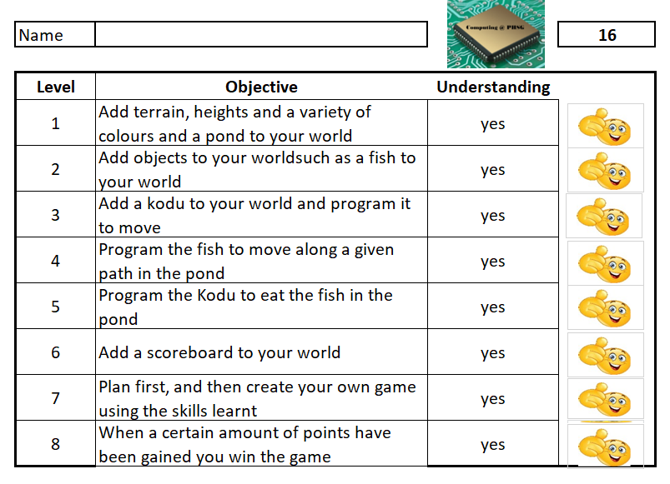

YEAR 9 FEEDBACK SHEET


