

PHSG GCSE
Revision guide
for students and Parents

Introduction
The aim of this booklet is to give both general advice and some subject specific guidance to aid our student’s preparation for both mock and real examinations.
From supporting your child to revise for examinations or making sure they are getting enough sleep, there is a lot you can do as parents/carers.
The information in this guide adds towards making this a very successful year and students having the best chance of achieving their potential in the GCSE examinations next summer.
It is important to also look at all the ways in which your child needs support through Year 11.

Stress
Stress is something that can build up as students approach both mock and real examinations. Here are a few hints and tips to help student beat stress.

Eating fresh ingredients and lots of fruit is really important. Juices filled with vitamin C, such as orange or grapefruit juice, are said to be good for your immune system so can help with stress. When you're busy and tired it can be tempting just to grab s snack, but make it a healthy one.
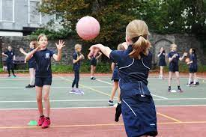
Doing sport at least once a week is the best way to reduce stress. It helps the body produce endorphins, which make us feel good. Even daily walks of 30 minutes can help reduce stress levels but it's even better to work out intensively. Even if you don't feel like it at the time you will feel the benefits afterwards.

It might sound simple, but sitting quietly for 10 minutes a day can really help with stress levels. If you've never tried meditation before, it's worth a go. Good breathing techniques can put you in a more relaxed state as they send oxygen surging through your bloodstream, helping to calm you down and beat the stress.

Short breaks between working can help you switch off. But longer breaks are important too. How about taking the weekend off to relax? Make time for fun and for yourself even if this means that you have to schedule time away from your work.


Teenagers tend to spend too much time on social media sites and answering messages. Sociability is fun – but too much of it, and too much computer time, can lead to more stress. Failing to switch off because of your electronic devices will only make you even more stressed.


Try to see the positive side. If you missed a deadline, try to appreciate what you learned from this mistake, now you know how to plan ahead. Things might seem bad, but if you try, there is usually something positive to be learned.


Listening to music can help calm you down and put you in a better frame of mind. If you're feeling stressed, putting on some calming music while you work could really help.

They say that laughter is the best medicine, and it's really true. Laughing out loud increases oxygen and blood flow which automatically reduces stress. Not taking life too seriously can help everyone live a better and easier life.

Resilience
Resilience is our ability to adapt and bounce back when things don't go as planned.
Resilient people don't wallow or dwell on failures; they acknowledge the situation, learn from their mistakes, and then move forward.
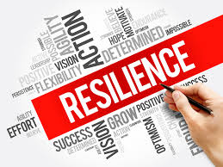
During Year 11 there will be periods where students may feel like they are struggling, it’s only through developing resilience and the attitude of not giving up that will allow them to overcome any barriers to success they encounter.
According to the research of leading psychologists, there are three elements that are essential to developing resilience.
1. Challenge – Resilient people view a difficulty as a challenge, not as a paralysing event. They look at their failures and mistakes as lessons to be learned from, and as opportunities for growth. They don't view them as a negative reflection on their abilities or self-worth.
2. Commitment – Resilient people are committed to their lives and their goals, and they have a compelling reason to get out of bed in the morning. Commitment isn't just restricted to their work – they commit to their relationships, their friendships, the causes they care about, and their religious or spiritual beliefs.
3. Personal Control – Resilient people spend their time and energy focusing on situations and events that they have control over. Because they put their efforts where they can have the most impact, they feel empowered and confident. Those who spend time worrying about uncontrollable events can often feel lost, helpless, and powerless to take action

General Revision Tips you can give your child:
Please bear in mind that some of these strategies will not be suitable for all students.
Create a Revision Timetable
Building a revision timetable can add structure to revision and help identify which GCSE subjects need to be prioritised to get better marks. Creating a revision timetable is a great way to organise study time, plus it also helps boost motivation to revise for the- examinations. Recognising a need for a revision timetable means that students have already made a great start to combat stress. Take the first step by setting some GCSE study goals to build a strong foundation for success.
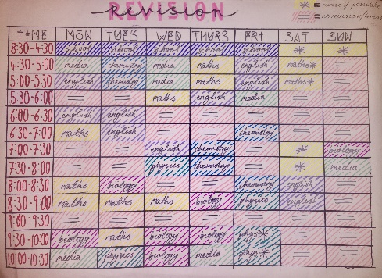
Practice, Practice, Practice
One of the biggest recommendations that past GCSE students suggest is to practise questions by doing as many GCSE past papers as possible. Practising past papers will help students to become familiar with the:
- Examination format
- Question style
- Time pressure
- Retrieve information quicker

Collaborate with Classmates in Groups
If students are finding coursework too much to tackle alone, then why not enlist the help and support of other students? They create or join online study groups and connect with thousands of GCSE students in any all of the subjects they are studying. This will allow them to fully prepare for their GCSEs as well as enrich their learning by exploring the thoughts and ideas of others. Interacting with other students will also help to improve communication and collaboration skills. And in addition, classmates can also test one another’s knowledge and level of progress.


Take Regular Study Breaks
Do you feel stressed, tired and that no new information is entering your head?
There is no point forcing teenagers to study for hours upon hours as this will not result in a positive outcome. Taking regular study breaks and exercising is proven to engage the brain in studying and improving examination performance in the long-run. Exercise is a powerful enabler which boosts the brain’s ability to be productive so don’t underestimate how important it is to take the stairs rather than the lift!
Understand Learning Styles
Everyone thinks that there is a best way to study but the reality is that each person is different. Once a student understands how they learn best; time of day, length of revision session, type of activities etc. They will find that their revision is more effective and efficient. Remembering and recalling new information will become much easier.

Variety is the Spice of Life!
Mix up study habits and methods by listening to podcasts, watching videos or documentaries, moving to new study area or even something as simple as using different colours for study notes. This is different to the other GCSE revision tips mentioned here as it encourages students to try a few different things to see what fits for them. Give it a go!


Use Thinking Maps to Connect Ideas
If a student finds it difficult to remember new study notes; Thinking maps may be the key to improving your memory. The theory behind thinking maps is that they can help making associations by connecting ideas, they help to memorise information easier and quicker. There are more benefits to using Thinking Maps for learning including being able to map out the curriculum, develop GCSE concepts in-depth and create sample examination answers.

On the day of an examination
The day of the examination can be the most stressful of the entire examination experience but there are ways which we minimise anxiety levels such as avoiding panicking friends and giving plenty of time to get to the test venue on time. Also, don’t underestimate the power of eating a healthy breakfast the day of any examination!

Adapt for Different Subjects
It may seem obvious but many students try to study for different subjects using the same study methods. Examination revision should take account of the difference between the subjects and the challenges they represent. For example, flashcards are an ideal study aid to help to prepare for a language examination where a student needs to remember key terms. Also, an online quiz is a great way to test maths skills with sample questions.

Apps for Students
Get the best student apps before anyone else.
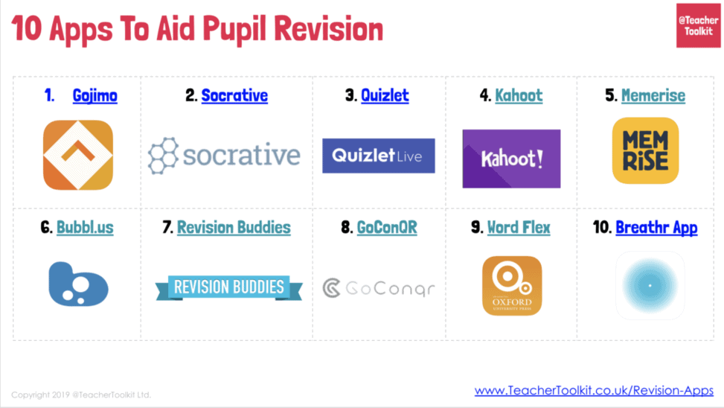

More information can also be found in the
SCHOOL SURVIVAL KIT (phsg.org)

KEEPING THE MOTIVATION UP
A MESSAGE FOR STUDENTS
● Don’t stop going to, or working in, lessons you find hard or dislike – talk to someone about any difficulties you are having – there is always a solution
● Revise your revision schedule if necessary and stick to it – even when you don’t feel like it. Don’t wait until you are in the mood – the further behind you get the less you will be in the mood (agree the schedule with your parents for a hassle-free life)
● Resist the temptation to bury your head in the sand if things are getting out of hand – talk to your parents/tutor/teachers/Head of House
● Ignore what friends and others are doing or saying – you are working for an easy life for YOU now and later – let your friends have the hassle of redoing coursework or even the full GCSE.
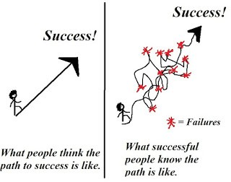

A MESSAGE FOR PARENTS

★ Agree the balance between work and social life and stick to the agreement. Again, flexibility is the key – if a special night comes up, agree that they can make up the work at a specified time

★ All students fall behind, feel demotivated or overwhelmed, or struggle with the balance of social, work and school demands at times.

★ When your child feels like this, berating and threatening them will have a negative effect. Talk to them about the issues, acknowledge their feelings and adopt a sensible attitude in wanting to find a solution

★ Be flexible – use the 80/20 rule. If your child is sticking to what they are supposed to be doing 80% of the time, they will be doing alright

★ If your child asks for your support, encourage them by helping them to see the difficulties in perspective. Teenagers often take an all or nothing ‘catastrophic’ approach to difficulties – “I’ve messed up this essay, I might as well give up.”

KEY TASKS ON THE DAY BEFORE THE EXAMINATION FOR STUDENTS

Make sure you know your timetable.
Get there early – catch the much earlier bus, leave the house a bit earlier.
Allow time for your brain to wake up – have a shower, eat breakfast
Do a final check of the subjects you will be doing that day – know the structure and how many sections there are. Make sure you have EVERYTHING you need and take spares – do not get into the stress of asking teachers for things you should have brought.
Take a pen you enjoy writing with – take 2 just in case – have all the right equipment with you for the examination,
During the examination – Don’t forget that it is natural to be nervous. It actually gives your brain the extra adrenalin it needs to make the final effort.
If your mind goes blank, don’t worry. Look at the question again, write down some notes – it’ll get your brain ticking over again.
Don’t start writing until you know what the instructions are and you are ready to write sense Make and keep to a time scale for each question depending on the number of marks (you will have done this in revision classes – stick to it).
If you only have 3 minutes left for a question, write the answer in note form – the examiner will give you marks for it.
Allow a little bit of time at the end to check through your work to see if any changes need making. Examiners have said that this can make the difference between a higher and lower grade.

ON THE EVE OF THE EXAMINATION
FOR PARENTS
★ Please don’t add to the stress levels by ‘rising to the bait’ when your child pushes the boundaries. Shelve the battles that don’t need winning just yet.
★ Help prepare your child for the examination – talk with them about when it starts, how long it lasts for, what are the main topics that might come up. They may have worked all day and have come down stairs to relax, make sure they have some down time the night before.



SUBJECTS

GCSE Art
How to support your child:
● We would like parents to ask their child to see their folder and sketchbook, check that work is being completed regularly and discuss with them their ideas and plans. You should see your child creating art work every week.
● Encouraging your child to attend Art club will help boost their grade. All levels of ability are welcome and students pushing for the highest grades will benefit as much as students who are behind and need to catch up.
● Discussing which artists your child is looking at in lessons and engaging in conversation about their art, helps students to feel confident about their work. Parents often have the best ideas even if the students don't want to admit it!
● During the trial examination and actual examination periods, your child may wish to complete their final outcome on a canvas, board or something similar. Whilst we provide general art materials in the Art department, we ask that parents support their child by providing such specialist items during examinations.
● Presentation is important, however, we do not want students to spend hours colouring their sketchbook pages to make it look pretty, this will not get them any additional marks.
● Encourage your child to do their best. Avoid tearing out pages or doodling in their books. See if their work is consistent, your child should be proud to show you their sketchbook.

GCSE Computer Science
How to support your child:
- Ensure they attempt all homework
- Ensure the students have the relevant resources
- Ensure students store and use all past examination papers that are shared throughout the year
- Test your child on their knowledge organiser for each unit of work
- Ensure that students have the relevant revision resources. These can all be accessed on TEAMS.

GCSE Drama
How to support your child
- Test your child on their knowledge organiser for each unit of work.
- Ensure that students have the relevant revision resources. These can all be accessed on TEAMS.
- Encourage your child to attend the extra rehearsal sessions available to ensure practical work is performance ready.

GCSE English Language and English Literature
How to Support to support your child
- Please refer the departmental guide (available on TEAMS or by request from Siobhan.Blundencurrie@phsg.tsat.uk) for full details of specific approaches to each of the questions on the examination papers.
- Ensure that students have the relevant revision resources. These can all be accessed on TEAMS.

For English Language:
- Ask your child about the vocabulary they have been learning
- Ask your child to explain ‘Layer Cake’ to you
- Ask your child about the Lola and the Obama
- Encourage reading for pleasure; have reading time set aside as a family

For English Literature:
- Ask your child about the texts they have studied: are they able to explain to you the function of each of the main characters?
- Take time to support their learning of quotations by testing them regularly in a ‘low-stakes’ environment (whilst washing dishes, or doing other chores, for example)
- Read a poem together and ask your child to talk to you about what they think it might mean and how they have come to this conclusion.

GCSE French
How to Support to support your child
- Test your child on their knowledge organiser for each unit of work
- Ensure that students have the relevant revision resources. These can all be accessed on TEAMS.

GCSE German
How to Support to support your child
- Test your child on their knowledge organiser for each unit of work
- Ensure that students have the relevant revision resources. These can all be accessed on TEAMS.

GCSE Geography
How to Support to support your child
- Due to the content heavy nature of this qualification students must start revising at the beginning of Year 11 and should focus on studying small sub-sections of units frequently.
- Ensure that students have the relevant revision resources. These can all be accessed on TEAMS.
- One of the most effective ways of revising is to complete past papers. These are available on TEAMS, you can then self-mark these using the answer papers that are also available in TEAMS.
- Test your child on their knowledge organiser for each unit of work
- Or use their own created revision cards from every lesson to ask questions.
- The students can also use Educake online to test themsleves on content knowledge.

GCSE History
How to Support to support your child:
- Test your child on their knowledge organiser for each unit of work
- Make use of the revision material to direct them to useful Youtube videos
- Help them to manage their revision time to ensure they are not ‘cramming’.
- Inform the History team if you feel your child requires additional support.
- Ensure that students have the relevant revision resources. These can all be accessed on TEAMS.

GCSE Mathematics
How to Support to support your child
- Ensure they are equipped for lessons including familiarity with the recommended calculator as this is the one they will use in the exams.
- Encourage them to engage in regular homework and revision using the materials provided.
- Encourage them to use teams to catch up on missed lessons so that there are no gaps in course coverage.
- Encourage them to ‘do, check, revise’ with past papers. Do a past paper, check the answers using online videos and then revise any topics that you were unsure of. Maths Genie has a wealth of GCSE papers for year 11.
- Encourage them to regularly in engage in short but frequent practise using independent learning (sparx for year 7-11 or integral for year 12+) websites like the Corbett Maths 5 a day programme, onmaths for self marking past papers or Maths Genie for topic booklets.
- Test your child on their knowledge organiser for each unit of work.

GCSE Music
How to Support to support your child
- Test your child on their knowledge organiser for each unit of work.
- Ensure that students have the relevant revision resources. These can all be accessed on TEAMS.

GCSE Religious Studies
How to Support to support your child
- Encourage them to look at the mark schemes and examiners’ reports to pick up extra knowledge, hints and tips.
- Test them on key vocabulary to support fluency with the vast amount of A01 content.
- Ensure that students have the relevant revision resources. These can all be accessed on TEAMS.
- Test your child on their knowledge organiser for each unit of work.

GCSE Science
How to Support to support your child
- Encourage them to use the resources on the TEAMS including the Science revision website
- Encourage them to read through the revision book and make notes
- Encourage them to practice examination questions
- Test your child on their knowledge organiser for each unit of work

GCSE Sports Science
How to support your child
- Check the progress of their coursework and ensure they meet assessment deadlines. Coursework maybe broken up into smaller sections that lead to a final overall assessed piece of work.
- Frequently check that they understand the keywords and can explain their meaning. Challenge them by asking if they can apply it to a sports performance.
- Test your child on their knowledge organiser for each unit of work.
- Ensure that students have the relevant revision resources. These can all be accessed on TEAMS.

GCSE Design and Technology (Graphics, Resistant materials and Textiles)
How to support your child
- We would like parents to ask their child to see their folder, check that work is being completed regularly and discuss with them their ideas and plans. You should see your child creating new content every week.
- Presentation is important, however, we do not want students to spend hours “colouring” their workbook pages to make it look pretty, this will not get them any additional marks. The content is the most important aspect of their workbooks.
- Encourage your child to do their best. See if their work is consistent, your child should be proud to show you their workbook.
- Test your child on their knowledge organiser for each unit of work.7 Ensure that students have the relevant revision resources. These can all be accessed on TEAMS.

