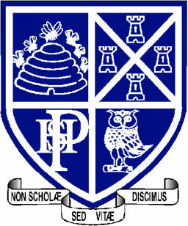 | Science  Department

Welcome to Year 7 Science!

Science is a broad, varied and interesting subject that hopefully you will love at Plymouth High School. Science is made up of 3 subjects; Biology (the study of life), Chemistry (the study of materials and molecules) and Physics (the study of forces and light). We teach these as 10 big ideas which you will meet every year from Year 7 right through to 13. There is a fourth aspect to Science that we study and this is practical skills. We will integrate practical skills into our lessons and assessments.

In order to prepare for Year Seven at PHSG the science department has put together some transition resources. We also want to see what interests you about science so we have included an opportunity for you to enjoy a science lecture and show us what you learnt.

Resources

- In the attachment there are a series of AQA Transition worksheets. These come with teacher notes to help your parent/guardian explain to you what to do.

- Royal Institution Christmas lectures
Click on the following link (https://www.rigb.org/christmas-lectures/watch) and choose a lecture that interests you (you can of course watch as many as you like!). There are lots to choose from. After you have watched your favourite lecture please write up what you found and hand it to your science teacher in your first science lesson. You can present this information in any way you like (poster, model, booklet, essay, comic strip etc.) but ensure you include the following;

- The title of the lecture
- What was the aim of the lecture?
- What did the scientist do to explain their theme?
- What did you learn?
- Why did you choose this lecture?
- Any fun facts
- Lots of colour and images

We hope you enjoy this small taste of secondary Science! See you in September,

The PHSG Science Department

