STUDENT AND PARENT
Teaching and Learning Bulletin
No. 2
Welcome to the second Teaching and Learning bulletin for students and parents.
The aim is to inform you once a term of the techniques that the teachers at PHSG are using in their lessons and the revision/memory strategies that we are encouraging the students to use in order to learn and recall information and methods that we teach them every day.
In this issue I will share with you:
- More on memory
- Questioning
- Acting on Feedback
For more information about PHSG and Thinking click here: Plymouth High School for Girls - Thinking Schools Academy Trust (phsg.org)

Memory

Taken from “What we need to know about short- and long-term memory”. Edited from the TES article January 2018.

How what we know about memory connects to teaching
The purpose of school - indeed, the purpose of all learning - is to change long-term memory. In particular, our students would almost certainly learn more if we used three fairly well-established facts about memory in the design of our teaching.

1. Students can be intensively engaged in something with little or no resulting change in long-term memory
For novices, going through worked examples can often be more effective than solving problems unaided, because the “cognitive load” involved in solving problems can overwhelm short-term memory, so that little learning takes place. While students do remember more of what they have to think hard about, there is a limit, beyond which learning is actually reduced.
As students gain expertise, it makes sense to reduce the support given, for example, by asking them to fill in missing steps and at a later stage solve entire problems

2. What matters for long-term learning is not retrieval strength but storage strength - how well something has been learned
Most people think that when we learn something, such as a telephone number or an address, unless the information is used regularly, then the memory fades and is eventually lost (this model is called the “theory of disuse”). But it seems that once something has been learned, the memory is never really lost. Many people cannot recall the postcode for their childhood home, and assume that it has been forgotten. However, if they were presented with a list of five postcodes, they would immediately be able to recognise the one that was correct.
To be sure that something has been learned, we should be finding out what students know some time after teaching. In other words, we should be testing our students on what they have been learning at frequent, regular intervals. Frequent testing has an additional benefit, which is that successfully retrieving something from memory increases storage strength, and the harder something is to retrieve, the greater the increase in storage strength. The best time to do practice testing is just as students are beginning to forget things.

3. The more confident someone is that an incorrect answer is, in fact, correct, the more likely they are not to repeat the error if they are corrected
Every teacher I have ever met says that it is OK to make mistakes, but very few teachers believe that making mistakes - and being corrected - is better for long-term learning than not making mistakes.
Lots of practice testing, with feedback on errors, is therefore likely to substantially increase students’ long-term recall of what they are learning.
The benefits of testing come from the retrieval practice that students get when they take the test, and the hypercorrection effect when they find out answers they thought were correct were in fact incorrect. In other words, the best person to mark a test is the person who just took it.

Application of the science
Learning will always be a somewhat mysterious process that happens inside the heads of our students when they are in our classrooms. But by understanding the distinction between short-term and long-term memory, teachers can think about how to design and present classroom activities in ways that limit the cognitive load for students. Then, with regular practice testing, where students correct their own work and do not even have to tell the teacher how well they did, we can improve how much of what happens in classrooms our students remember - which is, after all, the whole point.

Questioning
Using effective questioning in our classrooms brings a host of benefits, as it:
- Encourages students to engage with their work and each other.
- Helps students to think out loud.
- Facilitates learning through active discussion.
- Empowers students to feel confident about their ideas.
- Improves speaking and listening skills.
- Builds critical thinking skills.
- Teaches respect for other people’s opinions.
- Helps students to clarify their understanding.
- Motivates students and develops an interest of a topic.
- Allows teachers to check students’ understanding.
Open and closed questions are both beneficial for different purposes. While open questions give students the opportunity to provide detail and reasoning, closed questions are useful for quick fact checks and moving the lesson forward.
Therefore, we aim to vary our questions and use both open and closed questions depending on the reason for the question being ask. For example, if you want to quickly check that a student has remembered a fact, ask a question like “Louise, who was the King of France when the Industrial Revolution began?”. Conversely, if you want a student to provide their thoughts on something, and initiate a class discussion on a certain topic, use an open question like “Ben, what do you think the West Egg and East Egg signify in The Great Gatsby?”.
Cold calling is when the teacher chooses who to respond and it could be anyone in the room so requires all students to be listening, thinking and engaged. An example might run like this:
- Ask the question: Ok, everyone let’s see. What’s a good way to work out 12 x 17?
- Give thinking time: (No hands up, no calling out; scan the room as they think, keeping the focus)
- Select someone to respond: Right, so Kelly what were you thinking? (warm, invitational). “I think it’s 204.”
- Respond to the answers. Yes, that’s the right answer. What was your method? “I did 10 x 17 and then 2 x 17 and added them up”
- Select and another student: Great. And Abdi what about you. What method did you use? “I did 10 x 12 makes 120 7 x 12 is 84 and then add them for 204”. Well done – how does that compare to Kelly’s answer?
Acting on Feedback
Students are often asked to redraft an essay in English, history or religious studies.
Feedback should focus on moving the learning forward, targeting the specific learning gaps that pupils exhibit. Specifically, high quality feedback may focus on the task, subject, and self-regulation strategies.
Feedback can:
• focus on different content;
• be delivered in different methods;
• be directed to different people;
• be delivered at different times
Written methods of feedback, including written comments, marks, and scores, can improve pupil attainment.
Verbal methods of feedback can improve pupil attainment and may be more time-efficient when compared to some forms of written feedback as it is often immediate.
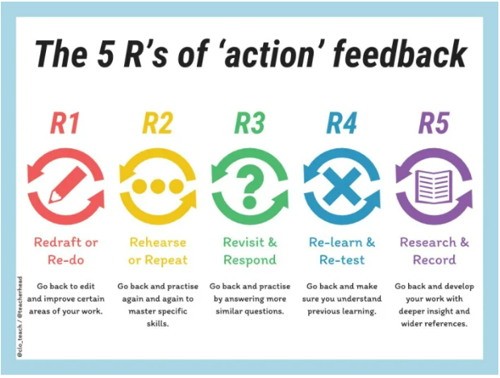
IN THE NEXT ISSUE
Habits of Mind
Revision techniques in preparation for the summer examination series

