STUDENT AND PARENT
Teaching and Learning Bulletin
No. 4
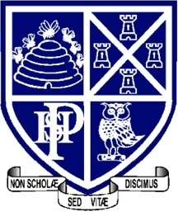
Welcome to the fourth Teaching and Learning bulletin for students and parents.
The aim is to inform you once a term of the techniques that the teachers at PHSG are using in their lessons and the revision/memory strategies that we are encouraging the students to use in order to learn and recall information and methods that we teach them every day.
In this issue I will share with you:
- Thinking hats
- Thinking maps

For more information about PHSG and Thinking click here : Plymouth High School for Girls - Thinking Schools Academy Trust (phsg.org)

Thinking hats
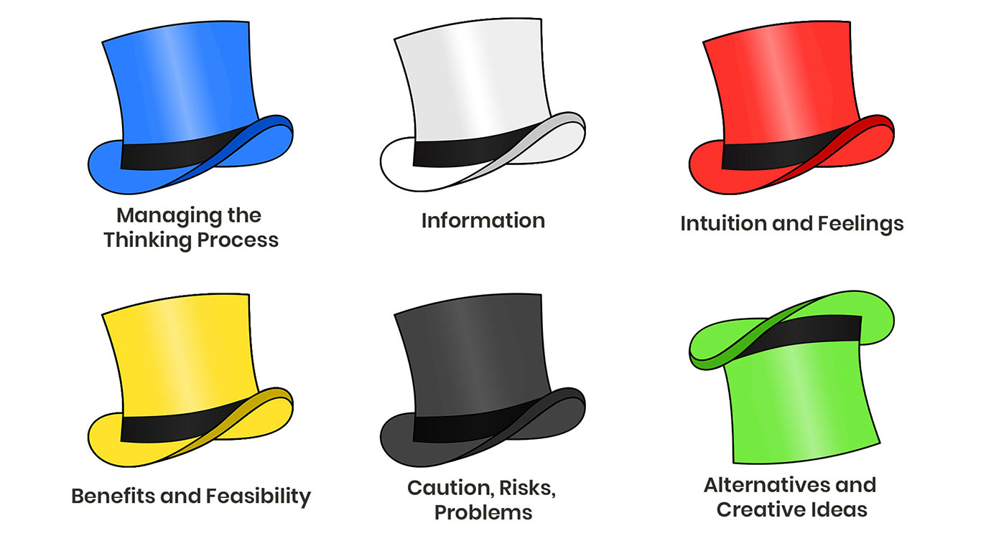
The six thinking hats were first published in 1985 by the respected psychologist Dr. Edward de Bono. The inspiration for writing the book came from structuring creative thinking, which often leads to confusion and disagreement, especially in groups of people.
The "hats" allow for organized and effective group thinking.

An example of how we run a six thinking hats exercise in a lesson
Six Thinking Hats is the perfect technique to look at decision-making from different perspectives. It introduces an organised parallel thinking process and it helps participants to be more mindfully involved and focused during discussion.
This technique can be applied in many ways, both in groups and as individuals. After deciding on the problem or situation you need to discuss, try these approaches:

In groups
The teacher will start by assigning a moderator for the group who will wear the blue hat. The moderator should set an agenda prior to the meeting and be familiar with the Six Thinking Hats concept.
Then, each participant should have an easy way to see what perspective they have to take depending on what hat they have. A name tag with their respective hat colour or a sign on the table in front of them should do the job.
Make sure everyone has a way to record their ideas, so they can clearly show which hat they were wearing at that particular time.
If the group is large, break it into smaller groups. You can assign a hat to each group to discuss their approach, or you can have all groups wear the same hat to discuss the same perspective before proceeding to the next hat.
It’s a good idea to rotate the hats between each group to foster as many new ideas as possible and make everyone think about the issue from different perspectives.
In order to improve teamwork and collaboration, you can also make each group and sub-group wear only one hat at a time.

Individually
When you deal with an issue, but you have to solve it alone, it’s best to use a template which has every hat along with a section to record your notes.
The straightforward way to do this is to work your way through each hat one at a time while making notes from each point of view.
Try not to jump around switching from one hat to another before you are done with it — that can get confusing.

Example
Let’s imagine that you are holding a meeting in where you’re discussing the introduction of a new service or product to the market. Here’s how the Six Thinking Hats exercise will go:
- The White Hat will ask, “What are the facts that we know?” and will present the known facts such as sales figures, market research, and other data.
- The Red Hat will ask, “What are your gut reactions?” and will base the arguments on feelings, hunches, and instincts.
- The Black Hat will ask, “What risks should we keep in mind?” and will present a rather pessimistic perspective, talking about disadvantages, risks, and problems.
- The Yellow Hat will ask, “Why should we be optimistic?” and will be the opposite of the black hat, presenting the advantages, benefits, and opportunities.
- The Green Hat will ask, “How can we create opportunities?” and will be the creative perspective, coming up with ideas and possibilities.
- The Blue Hat will ask “What systems or processes will be needed?” and will be in charge of the overview, summary, and planning.

Thinking maps
The Thinking Maps is a set of 8 visual patterns that correlate to specific cognitive processes. They are used across all grades and content areas to build the critical thinking, problem-solving, comprehension, and communication skills necessary for academic success in every domain.
Thinking maps are classified into eight different types. Each type of thinking map relates a fundamental cognitive skill with the visual representation.

A circle map is always used for students brainstorming. This type of Thinking Map is a tremendous strategy for a rapid student assessment. The best part is that the students can create a circle map by themselves to brainstorm. The structure of a circle map includes a smaller circle inside a bigger circle enclosed in a square. The smaller circle includes the name of the concept to be defined. Words or expressions used for defining this name are written in the exterior circle. The outermost square is used for writing the source of information or the "references." A frame of reference is used with each type of map.

A flow map is used to help students with organizing a series of events. A flow map shows how things are linked with one another. By using sub-stages, a flow map can show even more information about those links. The sub-stages may contain “actions” that took place within each part of the event being defined. Flow maps are used to illustrate the stages of a system or cycle. They could also help people step by step to get access to some destinations or entrances. They are not always constructed in a straight line. The life cycle of a plant or water cycle is often illustrated in a circular “flow map.”

A Bubble Map is used for defining qualities of a particular object, person, event or idea. A Bubble Map is useful for developing students' proficiency to use descriptive words and identify qualities. A bubble map can be created by drawing a circle in the middle, with the name of the thing described; whereas, the outside circles would contain the adjectival phrases or adjectives. Bubble maps could help students think more deeply about a specific topic so that the students might point out and summarize the related adjectives for the topic, such as space. It is also useful for the learners to explain a character or situation from a fictional storybook in the classroom.

Double Bubble Maps are used to specify similarities and differences between two things or concepts. A double bubble map can be built by drawing two large circles in the middle with the two names or concepts being compared. The exterior bubbles would demonstrate the characteristics of the two names or concepts. A double bubble map is more organized and visualized than a Venn diagram because the bullet points are separately listed. School students mostly use these maps for literature analysis, such as describing what events or characteristics lead to the success of one character or a group over the other.

Tree Maps are used to classify objects, ideas, persons or events. A tree map can be built by drawing a top line with the topic or category name. Underneath would be the sub-categories, with the specific members of each group. Some aspects may belong to multiple groups. The concepts grouped utilizing a tree map are more abstract or conceptual. The main objective of creating a tree map is to identify the details to help organize one's ideas. Overall, a tree map is helpful to order the details and sum them up. To create a tree diagram, simply draw lines between nodes representing different concepts. The lines should be thick at the beginning and thin toward the end. When drawing a tree diagram, keep in mind that the root node represents the most general concept, and the leaves represent the least specific concepts.

Multi-Flow Maps are used to describe causes and effects. These maps help students with the analysis of a concept by considering its outcomes. A multi-flow map can be created by drawing a rectangle in the middle with the name of the event that took place. The rectangles towards the left would have the list of the causes of the event. In contrast, the rectangles towards the right of the middle rectangle would contain the event's outcomes.

Brace Maps enable learners to analyse the structure of an object by demonstrating the relationship of a physical object with its parts. A brace map can be created by drawing a line on the left corner with the name of the physical object. Then the lines towards the right side would contain the names of the most important parts of the object. There would be more lines towards the right corner of the brace map describing the sub-parts of each important part. In schools, science teachers can use brace maps to teach about the parts of a plant. The plant is divided into different parts, and each part contains more things.

A bridge map is used to demonstrate metaphors and analogies. It mainly helps to show the link between the concrete and the abstract. A bridge map is most commonly used for scientific concepts, mathematical relationships and historic events. While using a bridge map, one must specify the “relating factors” between the items being compared. The item at the top of each pair relates with the item at the underside. The things with the same relationship will be mentioned on the right side of the bridge with 'As.' The bridge can have more relating factors. For example, teachers can use a bridge map to teach children the connections between nutrition terms and daily food. An apple is a source of iron and fibre 'as' an orange is a source of vitamin C can be delivered effectively using a bridge map. Bridge maps show how different aspects of the Internet relate to each other. To create a bridge map, start with a simple diagram showing the relationship between two concepts. Then add additional diagrams to show how those concepts connect to other concepts. Finally, use arrows to show the direction of influence.

IN THE NEXT ISSUE
Acting on Feedback

