STUDENT AND PARENT
Teaching and Learning Bulletin
No. 1
Welcome to the first Teaching and Learning bulletin for students and parents.
The aim is to inform you once a term of the techniques that the teachers at PHSG are using in their lessons and the revision/memory strategies that we are encouraging the students to use in order to learn and recall information and methods that we teach them every day.
In this issue I will share with you:
- What is a thinking school?
- What is retrieval practice
- Memory, self-testing and revision
- Frames of reference for thinking maps
- Knowledge Banks
For more information about PHSG and Thinking click here : Plymouth High School for Girls - Thinking Schools Academy Trust (phsg.org)
What is a thinking school?
“an educational community in which all members share a common commitment to giving regular, careful thought to everything that takes place. This will involve learning how to think, reflectively, critically and creatively, and employing these skills and techniques in the co-construction of a meaningful curriculum and associated activities. Successful outcomes will be reflected in students across a wide range of abilities demonstrating independent and co-operative learning skills, high levels of achievement, and both enjoyment and satisfaction in learning. Benefits will also be shown in ways which all members of the community interact with and show consideration for each other and in the positive psychological well-being of both students and staff. Burden 2006
At Plymouth High, we are looking for ways to support students in their thinking. It is important for all students to consider their long-term memory and the strategies they can use to improve this. There are many studies which show that students who are aware of their thinking and ways of improving their memory will also improve in their learning and progress over a period of time.
Below are the strategies we are using in lessons with students, please encourage discussion about these at home and how they can be used to support learning

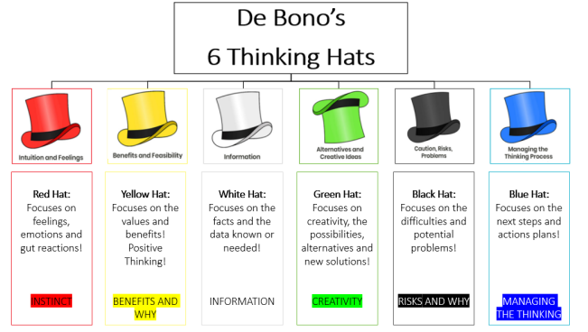

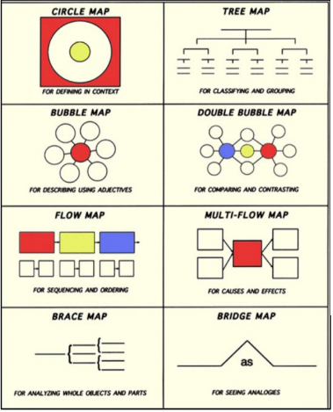
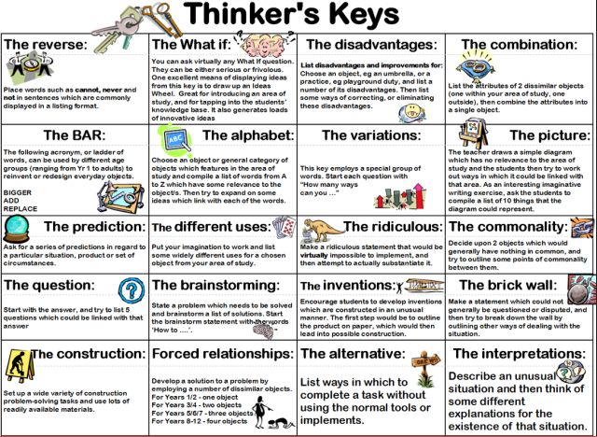

Retrieval Practice
Students need a chance to forget information before they try to retrieve it.
Increasing time to forget the content will reduce initial short-term performance but long-term learning will significantly increase due to having to retrieve information under more difficult conditions. (Bjork and Bjork, 1975).
See Ebbinghaus’ Forgetting Curve below.
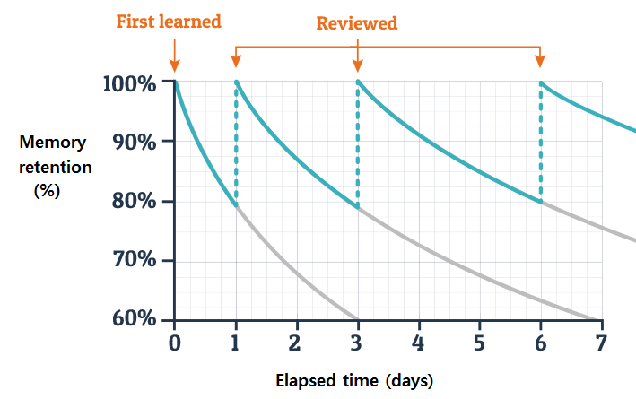

Retrieval Practice occurs in every lesson from year 7 through to year 13.
It can take the form of:
- a series of questions for the students to answer
- fill in the gaps
- complete the sentences with key vocabulary
- “brain dump” into a thinking map
Retrieval should be quick and self-marked by the student.
Students are expected to then spend time reviewing and revising content or methods that they have not recalled in preparation for the next retrieval that will check understanding and recall of the same content.

Memory, Self-testing and revision
Taken from Self-Testing Toolkit | EEF (educationendowmentfoundation.org.uk)
Much of the most recent research on learning has been centred on the fact that the brain retains information longer if the learning is repeated frequently and if the recall of the information involves a mechanism for self-testing. That is, we need to encourage our people to revise things over and over again to embed it into their long-term memory and to try very hard to recall the information through some kind of testing, rather than by reading the answer straight away.
The key factor for success is that the student does not only revise what they are studying at that time, but also what they have studied previously throughout the course.

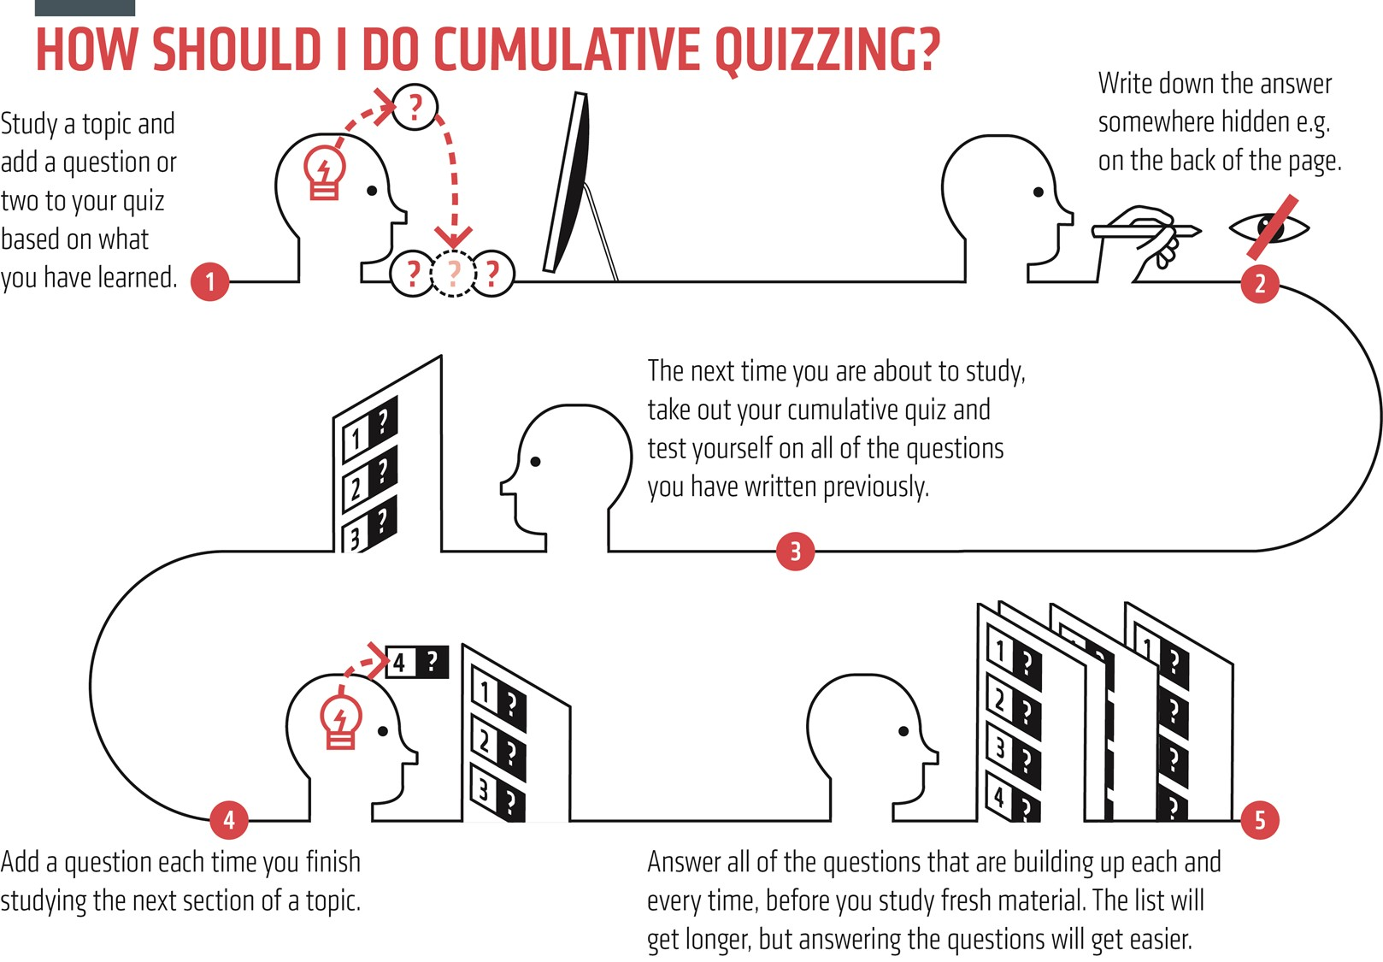

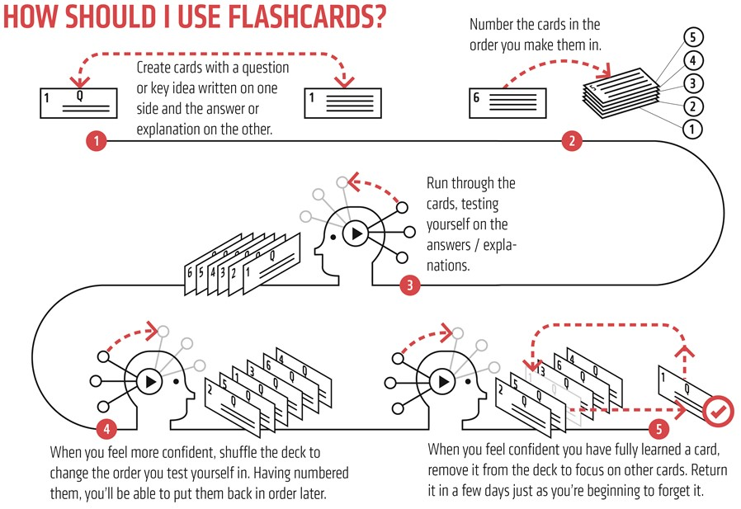

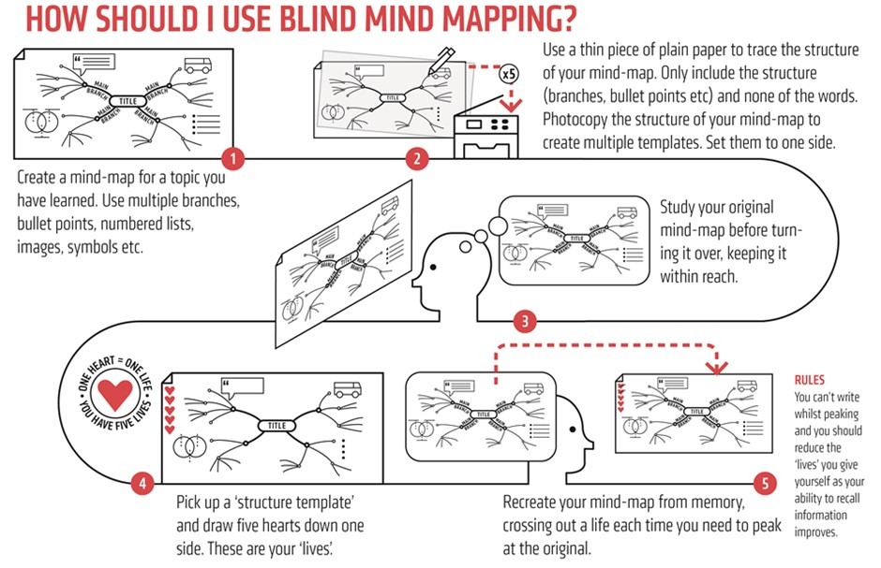
Frame of Reference for Thinking Maps

A frame of reference should be used with any thinking map.
It is a meta-cognitive frame asking students to “think about their thinking”.
They will be asked to step back from the map they have created to think about what influenced their thinking.
Why is this important?
- Increases rigour by adding credibility to the maps
- Has students think deeper about content – think about their thinking
- Encourages students to think about where did you get the information?
- Encourages students to think about what is influencing the information on the map?
A Frame of Reference is a metacognitive frame that is essential for all Thinking Map, it can include some of the following

- How do you know what you know about this topic?
- Did your information come from a specific source?
- Is this information being influenced by a specific point of view?
- Who could use this information?
- Why is this information important?
- Elaborate with extra information
- Include personal experiences
- Supporting examples
- Incorporate evidence
- Further explanation
- Expert opinions

Some users of thinking maps advocate the use of colour in a thinking map to help with the frame of reference thinking.

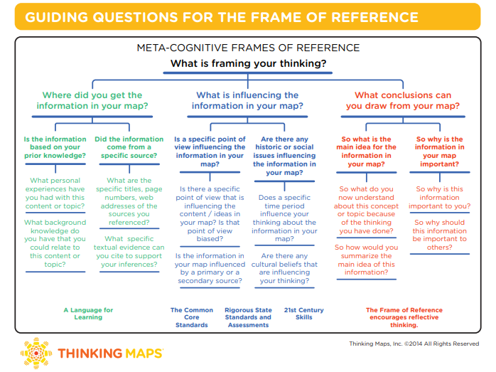

Knowledge Banks
For students to succeed in a particular area, they must have a foundation of factual knowledge, understand those facts in the context of a conceptual framework and organise knowledge in order to facilitate retrieval and application (Bransford et al, 2000)
A knowledge bank is the information in the curriculum summarised into an accessible framework - it does not replace the curriculum but secures access to it.
Retrieval practice is bringing knowledge to mind from memory. Using knowledge banks to make clear to our students what the most important information in our subject is, gives us a real opportunity to repeatedly and actively retrieve this information. The outcome will be automatised knowledge and more capacity free in working memory to focus on other elements of the task
Why use Knowledge Banks?
Working memory is slow and what we want is for students to be able to recall key information and methods quickly so that in an examination they can focus on how to answer the question to the best of their abilities without having to recall key facts, dates, people, quotes, formulae etc

Effective use knowledge banks?
- Used regularly in lessons
- To inform the “salient slide” at the end of each lesson
- Faded Models to self-test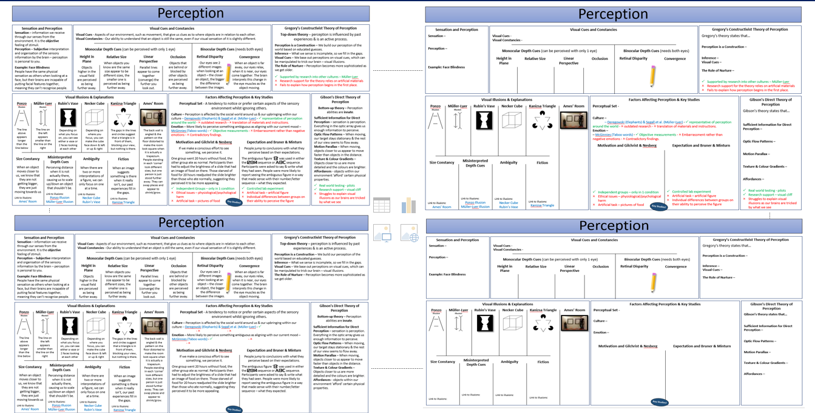
- To zoom in and out (place one box in the centre of an A3 sheet and elaborate)-make connections to prior knowledge
- To inform all low stakes quiz responses
- To inform assessment feedback tasks
- To support in cases of student absence

IN THE NEXT ISSUE
More on memory
Questioning
Acting on Feedback

